Exhibit 10.1

Table of Contents

UNITED STATES

SECURITIES AND EXCHANGE COMMISSION

Washington, D.C. 20549

Form 10-Q

(Mark One)

- QUARTERLY REPORT PURSUANT TO SECTION 13 OR 15(d) OF THE SECURITIES EXCHANGE ACT OF 1934

For the quarterly period ended November 2, 2024

OR

- TRANSITION REPORT PURSUANT TO SECTION 13 OR 15(d) OF THE SECURITIES EXCHANGE ACT OF 1934 Commission File Number 000-41886

CITI TRENDS, INC.

(Exact name of registrant as specified in its charter)

Delaware | 52-2150697
(State or other jurisdiction of | (I.R.S. Employer
incorporation or organization) | Identification No.)
104 Coleman Boulevard
Savannah, Georgia | 31408
(Address of principal executive offices) | (Zip Code)

Registrant’s telephone number, including area code (912) 236-1561

Securities registered pursuant to Section 12(b) of the Act:

Title of each class |  | Trading symbol |  | Name of each exchange on which registered
Common Stock, $0.01 par value |  | CTRN |  | NASDAQ Stock Market

Indicate by check mark whether the registrant (1) has filed all reports required to be filed by Section 13 or 15(d) of the Securities Exchange Act of 1934 during the preceding 12 months (or for such shorter period that the registrant was required to file such reports), and (2) has been subject to such filing requirements for the past 90 days. Yes ☒ No ☐

Indicate by check mark whether the registrant has submitted electronically every Interactive Data File required to be submitted pursuant to Rule 405 of Regulation S-T (§232.405 of this chapter) during the preceding 12 months (or for such shorter period that the registrant was required to submit such files). Yes ☒ No ☐

Indicate by check mark whether the registrant is a large accelerated filer, an accelerated filer, a non-accelerated filer, a smaller reporting company, or an emerging growth company. See the definitions of “large accelerated filer,” “accelerated filer,” “smaller reporting company” and “emerging growth company” in Rule 12b-2 of the Exchange Act.

Large Accelerated Filer ☐

Accelerated Filer ☒

Non-Accelerated Filer ☐

Smaller Reporting Company ☐

Emerging Growth Company ☐

If an emerging growth company, indicate by check mark if the registrant has elected not to use the extended transition period for complying with any new or revised financial accounting standards provided pursuant to Section 13(a) of the Exchange Act. ☐

Indicate by check mark whether the registrant is a shell company (as defined in Rule 12b-2 of the Exchange Act). Yes ☐ No ☒ As of November 29, 2024, the registrant had 8,710,024 outstanding shares of common stock, $0.01 par value per share.

Table of Contents

 |  |  |  |  |  |  |  |  |  |  |  |  |  |  |  | CITI TRENDS, INC.
 |  |  |  |  |  |  |  |  |  |  |  |  |  |  |  |  |  |  | FORM 10-Q
 |  |  |  |  |  |  |  |  |  |  |  |  |  | TABLE OF CONTENTS |  |  |  |  |  |  |  |  |  |  |  |  |  | PAGE
 |  |  |  |  |  |  |  |  |  |  |  |  |  |  |  |  |  |  |  |  |  |  |  |  |  |  |  | NUMBER
PART I |  |  |  |  | FINANCIAL INFORMATION
Item 1 |  |  |  |  | Financial Statements (unaudited)
 |  |  |  |  | Condensed Consolidated Balance Sheets |  |  |  |  |  |  |  |  |  |  |  |  |  |  |  |  |  |  |  |  |  |  | 3
 |  |  |  |  | Condensed Consolidated Statements of Operations |  |  |  |  |  |  |  |  |  |  |  |  |  |  |  |  |  |  |  |  |  |  | 4
 |  |  |  |  | Condensed Consolidated Statements of Cash Flows |  |  |  |  |  |  |  |  |  |  |  |  |  |  |  |  |  |  |  |  |  |  | 5
 |  |  |  |  | Condensed Consolidated Statements of Stockholders’ Equity |  |  |  |  |  |  |  |  |  |  |  |  |  |  |  |  |  |  |  |  |  |  | 6
 |  |  |  |  | Notes to the Condensed Consolidated Financial Statements |  |  |  |  |  |  |  |  |  |  |  |  |  |  |  |  |  |  |  |  |  |  | 7
Item 2 |  |  |  |  | Management’s Discussion and Analysis of Financial Condition and Results of Operations |  |  |  |  |  |  |  |  |  |  |  |  |  |  |  |  |  |  |  |  |  |  | 11
Item 3 |  |  |  |  | Quantitative and Qualitative Disclosures About Market Risk |  |  |  |  |  |  |  |  |  |  |  |  |  |  |  |  |  |  |  |  |  |  | 16
Item 4 |  |  |  |  | Controls and Procedures |  |  |  |  |  |  |  |  |  |  |  |  |  |  |  |  |  |  |  |  |  |  | 16
PART II |  |  |  |  | OTHER INFORMATION
Item 1 |  |  |  |  | Legal Proceedings |  |  |  |  |  |  |  |  |  |  |  |  |  |  |  |  |  |  |  |  |  |  | 17
Item 1A |  |  |  |  | Risk Factors |  |  |  |  |  |  |  |  |  |  |  |  |  |  |  |  |  |  |  |  |  |  | 17
Item 2 |  |  |  |  | Unregistered Sales of Equity Securities and Use of Proceeds |  |  |  |  |  |  |  |  |  |  |  |  |  |  |  |  |  |  |  |  |  |  | 17
Item 3 |  |  |  |  | Defaults Upon Senior Securities |  |  |  |  |  |  |  |  |  |  |  |  |  |  |  |  |  |  |  |  |  |  | 17
Item 4 |  |  |  |  | Mine Safety Disclosures |  |  |  |  |  |  |  |  |  |  |  |  |  |  |  |  |  |  |  |  |  |  | 17
Item 5 |  |  |  |  | Other Information |  |  |  |  |  |  |  |  |  |  |  |  |  |  |  |  |  |  |  |  |  |  | 17
Item 6 |  |  |  |  | Exhibits |  |  |  |  |  |  |  |  |  |  |  |  |  |  |  |  |  |  |  |  |  |  | 18
 |  |  |  |  | SIGNATURES |  |  |  |  |  |  |  |  |  |  |  |  |  |  |  |  |  |  |  |  |  |  | 19
 |  |  |  |  |  |  |  | 2

Table of Contents

PART I - FINANCIAL INFORMATION

Item 1. Financial Statements.

Citi Trends, Inc.

Condensed Consolidated Balance Sheets

(Unaudited)

(in thousands, except share data)

 |  | November 2, |  |  |  |  | February 3,
 |  |  | 2024 |  |  |  | 2024
Assets
Current assets:
Cash and cash equivalents | $ |  | 38,872 |  | $ |  | 79,706
Inventory |  |  | 127,514 |  |  |  | 130,432
Prepaid and other current assets |  |  | 13,145 |  |  |  | 10,838
Income tax receivable |  |  | 3,581 |  |  |  | 4,123
Total current assets |  |  | 183,112 |  |  |  | 225,099
Property and equipment, net of accumulated depreciation of $294,363 and $276,446 as of November 2,
2024 and February 3, 2024, respectively |  |  | 48,878 |  |  |  | 56,231
Operating lease right of use assets |  |  | 218,899 |  |  |  | 231,281
Deferred income taxes |  |  | 15,301 |  |  |  | 5,105
Other assets |  |  | 886 |  |  |  | 1,005
Total assets |  | $ | 467,076 |  |  | $ | 518,721
Liabilities and Stockholders’ Equity
Current liabilities:
Accounts payable | $ |  | 82,791 |  | $ |  | 100,366
Operating lease liabilities |  |  | 49,390 |  |  |  | 45,842
Accrued expenses |  |  | 16,106 |  |  |  | 16,466
Accrued compensation |  |  | 9,731 |  |  |  | 6,846
Layaway deposits |  |  | 1,548 |  |  |  | 384
Total current liabilities |  |  | 159,566 |  |  |  | 169,904
Noncurrent operating lease liabilities |  |  | 175,767 |  |  |  | 188,810
Other long-term liabilities |  |  | 1,473 |  |  |  | 2,301
Total liabilities |  |  | 336,806 |  |  |  | 361,015
Stockholders’ equity:
Common stock, $0.01 par value. Authorized 32,000,000 shares; 16,434,037 shares issued as of
November 2, 2024 and 16,354,714 shares issued as of February 3, 2024; 8,630,024 shares outstanding
as of November 2, 2024 and 8,550,701 shares outstanding as of February 3, 2024 |  |  | 162 |  |  |  | 160
Paid in capital |  |  | 107,239 |  |  |  | 105,686
Retained earnings |  |  | 290,080 |  |  |  | 319,071
Treasury stock, at cost; 7,804,013 shares held as of November 2, 2024 and February 3, 2024 |  |  | (267,211) |  |  |  | (267,211)
Total stockholders’ equity |  |  | 130,270 |  |  |  | 157,706
Commitments and contingencies (Note 7)
Total liabilities and stockholders’ equity | $ |  | 467,076 |  | $ |  | 518,721

See accompanying notes to the condensed consolidated financial statements (unaudited).

3

Table of Contents

Citi Trends, Inc.

Condensed Consolidated Statements of Operations

(Unaudited)

(in thousands, except per share amounts)

 |  |  |  |  |  | Thirteen Weeks Ended
 |  |  |  | November 2, |  |  |  |  |  | October 28,
 |  |  |  |  | 2024 |  |  |  |  |  | 2023
 | Net sales |  | $ |  | 179,066 |  |  |  | $ |  | 179,520
 | Cost of sales (exclusive of depreciation) |  |  |  | (107,833) |  |  |  |  |  | (110,942)
Selling, general and administrative expenses |  |  |  |  | (74,730) |  |  |  |  |  | (69,654)
 | Depreciation |  |  |  | (4,755) |  |  |  |  |  | (4,749)
Asset impairment |  |  |  |  | (574) |  |  |  |  |  | (178)
 | Loss from operations |  |  |  | (8,826) |  |  |  |  |  | (6,003)
Interest income |  |  |  |  | 482 |  |  |  |  |  | 894
 | Interest expense |  |  |  | (79) |  |  |  |  |  | (76)
 | Loss before income taxes |  |  |  | (8,423) |  |  |  |  |  | (5,185)
 | Income tax benefit |  |  |  | 1,271 |  |  |  |  |  | 1,322
 | Net loss |  | $ |  | (7,152) |  |  |  | $ |  | (3,863)
Basic net loss per common share |  |  | $ |  | (0.86) |  |  | $ |  |  | (0.47)
 | Diluted net loss per common share |  | $ |  | (0.86) |  |  |  | $ |  | (0.47)
 | Weighted average number of shares outstanding
 | Basic |  |  |  | 8,356 |  |  |  |  |  | 8,238
 | Diluted |  |  |  | 8,356 |  |  |  |  |  | 8,238
 | Citi Trends, Inc.
 | Condensed Consolidated Statements of Operations
 | (Unaudited)
 | (in thousands, except per share amounts)
 |  |  |  |  |  | Thirty-Nine Weeks Ended
 |  |  |  |  | November 2, |  |  |  |  |  | October 28,
 |  |  |  |  | 2024 |  |  |  |  |  | 2023
 | Net sales |  |  | $ | 541,907 |  |  |  |  | $ | 532,762
 | Cost of sales (exclusive of depreciation) |  |  |  | (343,710) |  |  |  |  |  | (331,827)
 | Selling, general and administrative expenses |  |  |  | (222,721) |  |  |  |  |  | (210,004)
 | Depreciation |  |  |  | (14,331) |  |  |  |  |  | (14,138)
 | Asset impairment |  |  |  | (1,835) |  |  |  |  |  | (178)
 | Loss from operations |  |  |  |  | (40,690) |  |  |  |  | (23,385)
 | Interest income |  |  |  | 1,942 |  |  |  |  |  | 2,804
 | Interest expense |  |  |  | (238) |  |  |  |  |  | (228)
 | Loss before income taxes |  |  |  | (38,986) |  |  |  |  |  | (20,809)
 | Income tax benefit |  |  |  | 9,995 |  |  |  |  |  | 5,279
 | Net loss |  |  | $ | (28,991) |  |  |  |  | $ | (15,530)
Basic net loss per common share |  |  |  | $ | (3.49) |  |  | $ |  |  | (1.89)
 | Diluted net loss per common share |  |  | $ | (3.49) |  |  |  |  | $ | (1.89)
 | Weighted average number of shares outstanding
 | Basic |  |  |  | 8,315 |  |  |  |  |  | 8,215
 | Diluted |  |  |  | 8,315 |  |  |  |  |  | 8,215

See accompanying notes to the condensed consolidated financial statements (unaudited).

4

Table of Contents

Citi Trends, Inc.

Condensed Consolidated Statements of Cash Flows

(Unaudited)

(in thousands)

 |  | Thirty-Nine Weeks Ended
 |  | November 2, |  |  |  | October 28,
 |  | 2024 |  |  |  | 2023
Operating activities:
Net loss | $ | (28,991) |  | $ |  | (15,530)
Adjustments to reconcile net loss to net cash used in operating activities:
Depreciation |  | 14,331 |  |  |  | 14,138
Asset impairment |  | 1,835 |  |  |  | 178
Non-cash operating lease costs |  | 36,708 |  |  |  | 38,494
Loss on disposal of property and equipment |  | 24 |  |  |  | 23
Deferred income taxes |  | (10,197) |  |  |  | (4,304)
Insurance proceeds related to operating activities |  | — |  |  |  | 3,482
Non-cash stock-based compensation expense |  | 2,434 |  |  |  | 3,002
Gain on insurance related to operating activities |  | — |  |  |  | (3,482)
Changes in assets and liabilities:
Inventory |  | 2,918 |  |  |  | (23,933)
Prepaid and other current assets |  | (2,307) |  |  |  | 1,711
Other assets |  | 120 |  |  |  | 133
Accounts payable |  | (17,898) |  |  |  | 2,322
Accrued expenses and other long-term liabilities |  | (35,916) |  |  |  | (45,515)
Accrued compensation |  | 2,885 |  |  |  | (1,821)
Income tax receivable/payable |  | 542 |  |  |  | (2,691)
Layaway deposits |  | 1,164 |  |  |  | 925
Net cash used in operating activities |  | (32,348) |  |  |  | (32,868)
Investing activities:
Purchases of property and equipment |  | (7,606) |  |  |  | (11,568)
Insurance proceeds related to investing activities |  | — |  |  |  | 1,518
Net cash used in investing activities |  | (7,606) |  |  |  | (10,050)
Financing activities:
Cash used to settle withholding taxes on the vesting of nonvested restricted stock |  | (880) |  |  |  | (851)
Net cash used in financing activities |  | (880) |  |  |  | (851)
Net decrease in cash and cash equivalents |  | (40,834) |  |  |  | (43,769)
Cash and cash equivalents:
Beginning of period |  | 79,706 |  |  |  | 103,495
End of period | $ | 38,872 |  |  | $ | 59,726
Supplemental disclosures of cash flow information:
Cash paid for interest | $ | 125 |  | $ |  | 119
Cash (refunds) payments of income taxes
Cash (refunds) payments of income taxes | $ | (340) |  |  | $ | 1,545
Supplemental disclosures of non-cash investing activities:
Accrual for purchases of property and equipment | $ | 374 |  | $ |  | 841

See accompanying notes to the condensed consolidated financial statements (unaudited).

5

Table of Contents

Citi Trends, Inc.

Condensed Consolidated Statements of Stockholders’ Equity

(Unaudited)

(in thousands, except share amounts)

 | Common Stock |  |  |  |  |  | Paid in |  |  | Retained |  | Treasury Stock
 | Shares |  | Amount |  |  |  | Capital |  |  | Earnings |  | Shares |  |  | Amount |  |  | Total
Balances — February 3, 2024 | 16,354,714 |  | $ | 160 |  | $ | 105,686 |  | $ | 319,071 |  | 7,804,013 |  | $ | (267,211) |  | $ | 157,706
Vesting of nonvested shares | — |  |  | 1 |  |  | — |  |  | — |  | — |  |  | — |  |  | 1
Issuance of nonvested shares | 2,811 |  |  | — |  |  | — |  |  | — |  | — |  |  | — |  |  | —
Forfeiture of nonvested shares | (5,178) |  |  | — |  |  | — |  |  | — |  | — |  |  | — |  |  | —
Stock-based compensation expense | — |  |  | — |  |  | 884 |  |  | — |  | — |  |  | — |  |  | 884
Net share settlement of nonvested shares | (11,618) |  |  | — |  |  | (333) |  |  | — |  | — |  |  | — |  |  | (333)
Net loss | — |  |  | — |  |  | — |  |  | (3,426) |  | — |  |  | — |  |  | (3,426)
Balances — May 4, 2024 | 16,340,729 |  | $ | 161 |  | $ | 106,237 |  | $ | 315,645 |  | 7,804,013 |  | $ | (267,211) |  | $ | 154,832
Vesting of nonvested shares | — |  |  | 1 |  |  | — |  |  | — |  | — |  |  | — |  |  | 1
Issuance of nonvested shares | 110,870 |  |  | — |  |  | — |  |  | — |  | — |  |  | — |  |  | —
Issuance of vested shares | 16,373 |  |  | — |  |  | — |  |  | — |  | — |  |  | — |  |  | —
Forfeiture of nonvested shares | (24,845) |  |  | — |  |  | — |  |  | — |  | — |  |  | — |  |  | —
Stock-based compensation expense | — |  |  | — |  |  | 694 |  |  | — |  | — |  |  | — |  |  | 694
Net share settlement of nonvested shares | (23,771) |  |  | — |  |  | (524) |  |  | — |  | — |  |  | — |  |  | (524)
Net loss | — |  |  | — |  |  | — |  |  | (18,413) |  | — |  |  | — |  |  | (18,413)
Balances — August 3, 2024 | 16,419,356 |  | $ | 162 |  | $ | 106,407 |  | $ | 297,232 |  | 7,804,013 |  | $ | (267,211) |  | $ | 136,590
Issuance of nonvested shares under incentive plan | 19,698 |  |  | — |  |  | — |  |  | — |  | — |  |  | — |  |  | —
Forfeiture of nonvested shares | (3,757) |  |  | — |  |  | — |  |  | — |  | — |  |  | — |  |  | —
Stock-based compensation expense | — |  |  | — |  |  | 856 |  |  | — |  | — |  |  | — |  |  | 856
Net share settlement of nonvested shares | (1,260) |  |  | — |  |  | (24) |  |  | — |  | — |  |  | — |  |  | (24)
Net loss | — |  |  | — |  |  | — |  |  | (7,152) |  | — |  |  | — |  |  | (7,152)
Balances — November 2, 2024 | 16,434,037 |  | $ | 162 |  | $ | 107,239 |  | $ | 290,080 |  | 7,804,013 |  | $ | (267,211) |  | $ | 130,270
 | Common Stock |  |  |  |  |  | Paid in |  |  | Retained |  | Treasury Stock
 | Shares |  | Amount |  |  |  | Capital |  |  | Earnings |  | Shares |  |  | Amount |  |  | Total
Balances — January 28, 2023 | 16,158,494 |  | $ | 160 |  | $ | 102,445 |  | $ | 331,050 |  | 7,804,013 |  | $ | (267,211) |  | $ | 166,444
Vesting of nonvested shares | — |  |  | 1 |  |  | — |  |  | — |  | — |  |  | — |  |  | 1
Issuance of nonvested shares | 1,500 |  |  | — |  |  | — |  |  | — |  | — |  |  | — |  |  | —
Forfeiture of nonvested shares | (9,647) |  |  | — |  |  | — |  |  | — |  | — |  |  | — |  |  | —
Stock-based compensation expense | — |  |  | — |  |  | 935 |  |  | — |  | — |  |  | — |  |  | 935
Net share settlement of nonvested shares | (33,432) |  |  | (1) |  |  | (782) |  |  | — |  | — |  |  | — |  |  | (783)
Net income | — |  |  | — |  |  | — |  |  | (6,635) |  | — |  |  | — |  |  | (6,635)
Balances — April 29, 2023 | 16,116,915 |  | $ | 160 |  | $ | 102,598 |  | $ | 324,415 |  | 7,804,013 |  | $ | (267,211) |  | $ | 159,962
Issuance of nonvested shares | 259,136 |  |  | — |  |  | — |  |  | — |  | — |  |  | — |  |  | —
Forfeiture of nonvested shares | (6,581) |  |  | — |  |  | — |  |  |  |  | — |  |  | — |  |  | —
Stock-based compensation expense | — |  |  | — |  |  | 1,049 |  |  | — |  | — |  |  | — |  |  | 1,049
Net share settlement of nonvested shares | (1,400) |  |  | — |  |  | (26) |  |  | — |  | — |  |  | — |  |  | (26)
Net loss | — |  |  | — |  |  | — |  |  | (5,032) |  | — |  |  | — |  |  | (5,032)
Balances — July 29, 2023 | 16,368,070 |  | $ | 160 |  | $ | 103,621 |  | $ | 319,383 |  | 7,804,013 |  | $ | (267,211) |  | $ | 155,953
Forfeiture of nonvested shares | (17,787) |  |  | — |  |  | — |  |  | — |  | — |  |  | — |  |  | —
Stock-based compensation expense | — |  |  | — |  |  | 1,018 |  |  | — |  | — |  |  | — |  |  | 1,018
Net share settlement of nonvested shares | (1,925) |  |  | — |  |  | (42) |  |  | — |  | — |  |  | — |  |  | (42)
Net income | — |  |  | — |  |  | — |  |  | (3,863) |  | — |  |  | — |  |  | (3,863)
Balances — October 28, 2023 | 16,348,358 |  | $ | 160 |  | $ | 104,597 |  | $ | 315,520 |  | 7,804,013 |  | $ | (267,211) |  | $ | 153,066

See accompanying notes to the condensed consolidated financial statements (unaudited).

6

Table of Contents

Citi Trends, Inc.

Notes to the Condensed Consolidated Financial Statements (unaudited)

November 2, 2024

- Significant Accounting Policies

Basis of Presentation

Citi Trends, Inc. and its subsidiary (the “Company”) is a leading specialty value retailer of apparel, accessories and home trends for way less spend primarily for African American and multicultural families. As of November 2, 2024, the Company operated 593 stores in urban, suburban and rural markets in 33 states.

The condensed consolidated financial statements are prepared in accordance with U.S. generally accepted accounting principles (“U.S. GAAP”) for interim reporting and are unaudited. In the opinion of management, the condensed consolidated financial statements reflect all adjustments, which are normal and recurring in nature, necessary for fair financial statement presentation. The condensed consolidated balance sheet as of February 3, 2024 is derived from the audited financial statements in the Company’s Annual Report on Form 10-K for the fiscal year ended February 3, 2024 (the “2023 Form 10-K”). These condensed consolidated financial statements should be read in conjunction with the audited consolidated financial statements and notes thereto included in the 2023 Form 10-K. Results of a period shorter than a full year may not be indicative of results expected for the entire year as a result of the seasonality of our business, among other things.

Fiscal Year

The following contains references to fiscal years 2024 and 2023, which represent fiscal years ending or ended on February 1, 2025 and February 3, 2024, respectively. Fiscal 2024 has a 52-week accounting period, and fiscal 2023 had a 53-week accounting period.

- Cash and Cash Equivalents/Concentration of Credit Risk

For purposes of the condensed consolidated balance sheets and condensed consolidated statements of cash flows, the Company considers all highly liquid investments with maturities at date of purchase of three months or less to be cash equivalents. Financial instruments that potentially subject the Company to a concentration of credit risk consist principally of cash and cash equivalents. The Company places its cash and cash equivalents in what it believes to be high credit quality banks and institutional money market funds. The Company maintains cash accounts that exceed federally insured limits.

- Earnings per Share

Basic earnings per common share amounts are calculated using the weighted average number of common shares outstanding for the period. Diluted earnings per common share amounts are calculated using the weighted average number of common shares outstanding plus the additional dilution for all potentially dilutive securities, such as nonvested restricted stock. During loss periods, diluted loss per share amounts are based on the weighted average number of common shares outstanding because the inclusion of common stock equivalents would be antidilutive.

The dilutive effect of stock-based compensation arrangements is accounted for using the treasury stock method. The Company includes as assumed proceeds the amount of compensation cost attributed to future services and not yet recognized. For the third quarter of 2024 and 2023, there were 258,000 and 318,000 shares of nonvested restricted stock, respectively, excluded from the calculation of diluted earnings per share because of antidilution. For the thirty-nine weeks ended November 2, 2024 and October 28, 2023, there were 242,000 and 259,000 shares of nonvested restricted stock, respectively, excluded from the calculation of diluted earnings per share because of antidilution.

7

Table of Contents

The following table provides a reconciliation of the weighted average number of common shares outstanding used to calculate basic earnings per share to the number of common shares and common stock equivalents outstanding used in calculating diluted earnings per share:

 | Thirteen Weeks Ended
 | November 2, 2024 |  | October 28, 2023
Weighted average number of common shares outstanding (basic) | 8,356,085 |  | 8,237,729
Incremental shares from assumed vesting of nonvested restricted stock | — |  | —
Weighted average number of common shares and common stock equivalents outstanding (diluted) | 8,356,085 |  | 8,237,729
 | Thirty-Nine Weeks Ended
 | November 2, 2024 |  | October 28, 2023
Weighted average number of common shares outstanding (basic) | 8,315,090 |  | 8,214,907
Incremental shares from assumed vesting of nonvested restricted stock | — |  | —
Weighted average number of common shares and common stock equivalents outstanding (diluted) | 8,315,090 |  | 8,214,907

4. Revolving Credit Facility

In October 2011, the Company entered into a five-year, $50 million credit facility with Bank of America. The facility was amended in August 2015 and May 2020 to extend the maturity dates. The facility was further amended in April 2021 to modify terms and extend the maturity date to April 15, 2026. In May 2023, the facility was amended to replace the London Interbank Offered Rate (“LIBOR”) with the Secured Overnight Financing Rate (“SOFR”). The amended facility provides a $75 million credit commitment and a $25 million uncommitted “accordion” feature that under certain circumstances could allow the Company to increase the size of the facility to $100 million. The facility is secured by the Company’s inventory, accounts receivable and related assets, but not its real estate, fixtures and equipment, and it contains one financial covenant, a fixed charge coverage ratio, which is applicable and tested only in certain circumstances. The facility has an unused commitment fee of 0.20% and permits the payment of cash dividends subject to certain limitations. Borrowings under the credit facility bear interest (a) for SOFR Loans, at a rate equal to the SOFR Rate plus a SOFR adjustment equal to 0.10% plus either 1.25%, 1.50% or 1.75%, or (b) for Base Rate Loans, at a rate equal to the highest of

- the prime rate, (ii) the Federal Funds Rate plus 0.5% or (iii) the Eurodollar Rate plus 1.0%, plus, in each case either 0.25%, 0.50% or 0.75%, based in any such case on the average daily availability for borrowings under the facility.

As of November 2, 2024, the Company had no borrowings under the credit facility and $1.4 million of letters of credit outstanding.

- Impairment of Assets

If facts and circumstances indicate that a long-lived asset or operating lease right-of-use asset may be impaired, the carrying value is reviewed. If this review indicates that the carrying value of the asset will not be recovered as determined based on projected undiscounted cash flows related to the asset over its remaining life, the carrying value of the asset is reduced to its estimated fair value. In the third quarter of 2024, non-cash impairment expense related to underperforming stores totaled $0.6 million, comprised of $0.3 million for leasehold improvements and fixtures and equipment, and $0.3 million for operating lease right of use assets. In the third quarter of 2023, non-cash impairment expense related to underperforming stores totaled $0.2 million, primarily for leasehold improvements and fixtures and equipment.

- Income Taxes

The provision for income taxes for the interim period in 2024 is based on an estimate of the annual effective tax rate adjusted to reflect the impact of discrete items. Management judgment is required in projecting ordinary income to estimate the Company’s annual effective tax rate. For the first thirty-nine weeks of 2023 the Company used the discrete effective tax rate method to determine its tax expense based upon interim period results. The Company determined that since small changes in estimated ordinary income would result in significant changes in the estimated annual effective tax rate, the annual effective tax rate method would not have provided a reliable estimate for the first thirty-nine weeks of 2023.

As of November 2, 2024, we had approximately $15.3 million in net deferred tax assets (DTA). At this time, we consider it more likely than not that we will have sufficient taxable income in the future that will allow us to realize these DTAs. If we are not able to generate

8

Table of Contents

sufficient taxable income to realize these DTAs, a substantial valuation allowance to reduce our U.S. DTAs may be required, which would materially increase our expenses in the period the allowance is recognized and adversely affect our results of operations.

As of November 2, 2024, our net DTA includes approximately $9.3 million related to net operating loss (NOL) carryforwards that can be used to offset taxable income in future periods and reduce our income taxes payable in those future periods. NOL carryforwards may be subject to annual limitations under Internal Revenue Code Section 382 (Section 382) (or comparable provisions of foreign or state law) in the event that certain changes in ownership were to occur. In addition, tax credit carryforwards may be subject to annual limitations under Internal Revenue Code Section 383 (Section 383).

We are required to evaluate our NOL and tax credit carryforwards and whether certain changes in ownership have occurred as measured under Section 382 that would limit our ability to utilize a portion of our NOL and tax credit carryforwards. If it is determined that an ownership change has occurred, there may be annual limitations on the use of these NOL and tax credit carryforwards under Sections 382 and 383 (or comparable provisions of foreign or state law).

- Commitments and Contingencies

The Company from time to time is involved in various legal proceedings incidental to the conduct of its business, including claims by customers, landlords, employees or former employees. Once it becomes probable that the Company will incur costs in connection with a legal proceeding and such costs can be reasonably estimated, the Company establishes appropriate reserves.

While legal proceedings are subject to uncertainties and the outcome of any such matter is not predictable, the Company is not aware of any legal proceedings pending or threatened against it that it expects to have a material adverse effect on its financial condition, results of operations or liquidity.

- Stock Repurchases

The Company periodically repurchases shares of its common stock under board-authorized repurchase programs. Such repurchases may be made in the open market, through block trades or through other negotiated transactions. There were no stock repurchases in the first thirty-nine weeks of 2024 or the first thirty-nine weeks of 2023.

At November 2, 2024, $50.0 million remained available under the Company’s stock repurchase authorization.

- Revenue

Revenue Recognition

The Company’s primary source of revenue is derived from the sale of clothing and accessories to its customers with the Company’s performance obligations satisfied immediately when the customer pays for their purchase and receives the merchandise. Sales taxes collected by the Company from customers are excluded from revenue. Revenue from layaway sales is recognized at the point in time when the merchandise is paid for and control of the goods is transferred to the customer, thereby satisfying the Company’s performance obligation. The Company defers revenue from the sale of gift cards and recognizes the associated revenue upon the redemption of the cards by customers to purchase merchandise.

Sales Returns

The Company allows customers to return merchandise for up to 30 days after the date of sale subject to certain conditions. Expected refunds to customers are recorded based on estimated margin using historical return information.

Disaggregation of Revenue

The Company’s retail operations represent a single operating segment based on the way the Company manages its business. Operating decisions and resource allocation decisions are made at the Company level in order to maintain a consistent retail store presentation. The Company’s retail stores sell similar products, use similar processes to sell those products and sell their products to similar classes of customers.

9

Table of Contents

In the following table, the Company’s revenue from contracts with customers is disaggregated by “CITI” or major merchandise category. The percentage of net sales for each CITI with the merchandise assortment was approximately:

 | Thirteen Weeks Ended |  |  |  |  |  | Thirty-Nine Weeks Ended
 | November 2, |  |  | October 28, |  |  | November 2, |  |  | October 28,
 | 2024 |  |  | 2023 |  |  | 2024 |  |  | 2023
Ladies | 27 | % |  | 26 | % |  | 28 | % |  | 27 | %
Kids | 24 | % |  | 24 | % |  | 23 | % |  | 22 | %
Mens | 17 | % |  | 17 | % |  | 16 | % |  | 17 | %
Accessories & Beauty | 16 | % |  | 17 | % |  | 16 | % |  | 18 | %
Home & Lifestyle | 10 | % |  | 7 | % |  | 10 | % |  | 8 | %
Footwear | 6 | % |  | 9 | % |  | 7 | % |  | 8 | %

- Leases

The Company leases its retail store locations, distribution centers, and certain office space and equipment. Leases for store locations are typically for a term of five years with options to extend for one or more five-year periods.

The Company analyzes all leases at inception to determine if a right-of-use asset and lease liability should be recognized. Leases with an initial term of 12 months or less and leases with mutual termination clauses are not included on the condensed consolidated balance sheets. The lease liability is measured at the present value of future lease payments as of the lease commencement date.

Total lease cost is comprised of operating lease costs, short-term lease costs and variable lease costs, which include rent paid as a percentage of sales, common area maintenance, real estate taxes and insurance for the Company’s real estate leases. Lease costs consisted of the following (in thousands):

 |  |  | Thirteen Weeks Ended |  |  |  |  |  |  |  |  | Thirty-Nine Weeks Ended
 |  | November 2, 2024 |  |  |  | October 28, 2023 |  |  |  |  | November 2, 2024 |  |  |  |  | October 28, 2023
Operating lease cost |  | $ | 16,441 |  | $ |  | 15,521 |  | $ |  |  | 46,232 |  |  | $ |  | 46,930
Variable lease cost |  |  | 1,997 |  |  |  | 2,628 |  |  |  |  | 8,160 |  |  |  |  | 8,406
Short term lease cost |  |  | 250 |  |  |  | 393 |  |  |  |  | 1,344 |  |  |  |  | 1,171
Total lease cost |  | $ | 18,688 |  |  | $ | 18,542 |  |  |  | $ | 55,736 |  |  |  | $ | 56,507
Future minimum lease payments as of November 2, 2024 are as follows (in thousands):
 | Fiscal Year |  |  |  |  |  |  |  |  |  |  | Lease Costs
 | Remainder of 2024 |  |  |  |  |  |  |  | $ |  |  | 16,535
 | 2025 |  |  |  |  |  |  |  |  |  |  | 58,464
 | 2026 |  |  |  |  |  |  |  |  |  |  | 47,423
 | 2027 |  |  |  |  |  |  |  |  |  |  | 36,204
 | 2028 |  |  |  |  |  |  |  |  |  |  | 28,253
 | Thereafter |  |  |  |  |  |  |  |  |  |  | 108,800
 | Total future minimum lease payments |  |  |  |  |  |  |  |  |  |  | 295,679
 | Less: imputed interest |  |  |  |  |  |  |  |  |  |  | (70,522) |  |  | (1)
 | Total present value of lease liabilities |  |  |  |  |  |  |  | $ |  |  | 225,157 |  |  | (2)

- Calculated using the discount rate for each lease.

- Includes short-term and long-term portions of operating lease liabilities.

10

Table of Contents

Certain operating leases provide for fixed monthly rents, while others provide for contingent rents computed as a percentage of net sales and others provide for a combination of both fixed monthly rents and contingent rents computed as a percentage of net sales.

Supplemental cash flows and other information related to operating leases are as follows (in thousands, except for weighted average amounts):

 |  | Thirty-Nine Weeks Ended
 |  | November 2, 2024 |  |  | October 28, 2023
Cash paid for operating leases | $ | 46,735 |  | $ | 52,734
Right of use assets obtained in exchange for new operating lease liabilities | $ | 25,182 | $ |  | 22,322
Weighted average remaining lease term (years) - operating leases |  | 7.31 |  |  | 7.60
Weighted average discount rate - operating leases |  | 5.47% |  |  | 4.90%

- Recent Accounting Pronouncements

In November 2023, the FASB issued ASU 2023-07, “Segment Reporting (Topic 280): Improvements to Reportable Segment Disclosures” (“ASU 2023-07”), which expands reportable segment disclosure requirements primarily through enhanced disclosures about significant segment expenses. ASU 2023-07 requires disclosure of (i) significant segment expenses that are regularly provided to the CODM and included within the segment measure of profit or loss, (ii) an amount and description of its composition for other segment items to reconcile to segment profit or loss, and (iii) the title and position of the Company’s CODM. The ASU does not change how a public entity identifies its operating segments, aggregates them, or applies the quantitative thresholds to determine its reportable segments. The new standard will be effective on a retrospective basis for fiscal years beginning after December 15, 2023, and interim periods within fiscal years beginning after December 15, 2024, with early adoption permitted. The Company is currently evaluating the ASU to determine the impact of the amended guidance.

In December 2023, the FASB issued ASU 2023-09, “Income Taxes (Topic 740): Improvements to Income Tax Disclosures” (“ASU 2023-09”). The amendments in ASU 2023-09 require public entities, on an annual basis, to provide disclosure of specific categories in the rate reconciliation, as well as disclosure of income taxes paid disaggregated by jurisdiction. The new standard will be effective on a prospective basis for fiscal years beginning after December 15, 2024 and interim periods therein, with early adoption permitted. The Company is currently evaluating the ASU to determine the impact of the amended guidance.

Item 2. Management’s Discussion and Analysis of Financial Condition and Results of Operations.

Forward-Looking Statements

Except for specific historical information, many of the matters discussed in this Form 10-Q may express or imply projections of revenues or expenditures, statements of plans and objectives for future operations, growth or initiatives, statements of future economic performance, capital allocation expectations or statements regarding the outcome or impact of pending or threatened litigation. These, and similar statements, are forward-looking statements concerning matters that involve risks, uncertainties and other factors that may cause the actual performance of the Company to differ materially from those expressed or implied by these statements. All forward-looking information should be evaluated in the context of these risks, uncertainties and other factors. The words “believe,” “anticipate,” “project,” “plan,” “expect,” “estimate,” “objective,” “forecast,” “goal,” “intend,” “could,” “will likely result,” or “will continue” and similar words and expressions generally identify forward-looking statements, although not all forward-looking statements contain such language. The Company believes the assumptions underlying these forward-looking statements are reasonable; however, any of the assumptions could be inaccurate, and therefore, actual results may differ materially from those projected in the forward-looking statements.

The factors that may result in actual results differing from such forward-looking information include, but are not limited to: uncertainties relating to general economic conditions, including inflation, energy and fuel costs, unemployment levels, and any deterioration whether caused by acts of war, terrorism, political or social unrest (including any resulting store closures, damage or loss of inventory) or other factors; changes in market interest rates and market levels of wages; impacts of natural disasters such as hurricanes; uncertainty and economic impact of pandemics, epidemics or other public health emergencies; transportation and distribution delays or interruptions; changes in freight rates; the Company’s ability to attract and retain workers; the Company’s ability to negotiate effectively the cost and purchase of merchandise; inventory risks due to shifts in market demand; the Company’s ability to gauge fashion trends and changing consumer preferences; consumer confidence and changes in consumer spending patterns; competition within the industry; competition in our markets; the duration and extent of any economic stimulus programs; changes in product

mix; interruptions in suppliers’ businesses; the impact of the cyber disruption we identified on January 14, 2023, including legal, reputational, financial and contractual

11

Table of Contents

risks resulting from the disruption, and other risks related to cybersecurity, data privacy and intellectual property; the results of pending or threatened litigation; temporary changes in demand due to weather patterns; seasonality of the Company’s business; changes in market interest rates and market level wages; delays associated with building, opening, remodeling and operating new stores; delays associated with building, opening or expanding new or existing distribution centers; and other factors described in the section titled “Item 1A. Risk Factors” and elsewhere in the Company’s Annual Report on Form 10-K for the fiscal year ended February 3, 2024, and in Part II, “Item 1A. Risk Factors” and elsewhere in the Company’s Quarterly Reports on Form 10-Q and any amendments thereto and in the other documents the Company files with the SEC, including reports on Form 8-K.

Readers are cautioned not to place undue reliance on these forward-looking statements, which speak only as of the date of this Form 10-Q. Except as may be required by law, the Company undertakes no obligation to update or revise publicly any forward-looking statements contained herein to reflect events or circumstances occurring after the date of this Form 10-Q or to reflect the occurrence of unanticipated events. Readers are advised, however, to read any further disclosures the Company may make on related subjects in its public disclosures or documents filed with the SEC, including reports on Form 8-K.

Executive Overview

We are a leading specialty value retailer of apparel, accessories and home trends for way less spend primarily for African American and multicultural families. Our high-quality and trend-right merchandise offerings at everyday low prices are designed to appeal to the fashion and trend preferences of value-conscious customers. As of November 2, 2024, we operated 593 stores in urban, suburban and rural markets in 33 states.

Uncertainties and Challenges

General Economic Conditions

We expect that our operations in the short-term will continue to be influenced by general economic conditions, including on-going inflationary pressures, which are particularly impactful to the communities we serve. Given the macro-economic environment, we expect low-income families to remain under pressure and to tightly manage their discretionary spend through the remainder of fiscal 2024. In addition, we continue to monitor the impacts on our business of unemployment levels, wage inflation, interest rates, inflation rates, housing costs, energy costs, consumer confidence, consumer perception of economic conditions, costs to source our merchandise and supply chain disruptions.

Seasonality and Weather Patterns

The nature of our business is seasonal. Historically, sales in the first and fourth quarters have been higher than sales achieved in the second and third quarters of the fiscal year. In addition, sales of clothing are directly impacted by the timing of the seasons to which the clothing relates. While we have expanded our product offerings to include more non-apparel goods, traffic to our stores is still influenced by weather patterns to some extent.

Cyber Disruption (January 2023)

As previously disclosed, in January 2023, we experienced a disruption of our back office and distribution center IT systems, (the “January 2023 cyber disruption”). In the first thirty-nine weeks of fiscal 2023, we recognized $1.7 million of costs related to the cyber disruption in Selling, general and administrative expenses on our Statement of Operations.

Several putative class action lawsuits have been filed against the Company and several inquiries have been made to the Company with respect to the January 2023 cyber disruption. At November 2, 2024, we had an accrual of $0.7 million for estimated losses in connection with these matters recorded in Accrued expenses on our Balance Sheet. For additional information regarding these lawsuits, see Note 7 of the Annual Report on Form 10-K for the fiscal year ended February 3, 2024.

Basis of Presentation

Net sales consist of store sales and layaway fees, net of returns by customers. Cost of sales consists of the cost of products we sell and associated freight costs. Depreciation is not considered a component of cost of sales and is included as a separate line item in the consolidated statements of operations. Selling, general and administrative expenses are comprised of store costs, including payroll and occupancy costs, corporate and distribution center costs and advertising costs.

12

Table of Contents

The following discussion contains references to fiscal years 2024 and 2023, which represent fiscal years ending or ended on February 1, 2025 and February 3, 2024, respectively. Fiscal 2024 has a 52-week accounting period and fiscal 2023 had a 53-week accounting period. This discussion and analysis should be read with the unaudited condensed consolidated financial statements and the notes thereto contained in Part 1, Item 1 of this Report.

Results of Operations

The following discussion of the Company’s financial performance is based on the unaudited condensed consolidated financial statements set forth herein. Expenses and, to a greater extent, operating income, vary by quarter. Results of a period shorter than a full year may not be indicative of results expected for the entire year as a result of the seasonality of our business, among other things.

Key Operating Statistics

We measure performance using key operating statistics. One of the main performance measures we use is comparable store sales growth. In fiscal years following those with 53 fiscal weeks, the prior year period is shifted by one week to compare similar retail calendar weeks. Additionally, for 2024, we updated our definition of a comparable store. We now define a comparable store as a store that has been open for at least 14 full consecutive months without closure for more than seven days within the same fiscal month. Remodeled or relocated stores are considered comparable stores if the selling square footage is not changed significantly, the store is not closed for more than five days in any fiscal month and the store remains in the same trade area. This change aligns more with industry standards in regard to measuring “comp store” sales performance. This change is effective for fiscal year 2024 and forward. For fiscal year 2024, the definition change results in six stores becoming comparable stores in 2024, which would not have become a comparable store until 2025 under the prior definition. The revised definition would result in no change to the full year 2023 comparable store sales results of 5.3%.

We also use other operating statistics, most notably average sales per store, to measure our performance. As we typically occupy existing space in established shopping centers rather than sites built specifically for our stores, store square footage (and therefore sales per square foot) varies by store. We focus on overall store sales volume as the critical driver of profitability. In addition to sales, we measure cost of sales as a percentage of sales and store operating expenses, with a particular focus on labor, as a percentage of sales. These results translate into store level contribution, which we use to evaluate overall performance of each individual store. Finally, we monitor corporate and distribution center expenses against budgeted amounts.

Thirteen Weeks Ended November 2, 2024 and October 28, 2023

Net Sales. Sales comparisons for 2024 to the prior year are affected by the shift in the calendar caused by last year having 53 weeks. Net sales decreased $0.4 million, or 0.3%, to $179.1 million in the third quarter of 2024 from $179.5 million in the third quarter of 2023. The shift in the retail calendar contributed $7.0 million to revenue for the thirteen weeks ended November 2, 2024. Comparable store sales, on a comparable weeks basis, increased 5.7%, resulting in an increase of $9.6 million in sales. Net store opening and closing activity resulted in a net decrease of $2.8 million in sales.

Cost of Sales (exclusive of depreciation). Cost of sales (exclusive of depreciation) decreased $3.1 million, or 2.7%, to $107.8 million in the third quarter of 2024 from $110.9 million in the third quarter of 2023. Cost of sales as a percentage of sales decreased to 60.2% in the third quarter of 2024 from 61.8% in the third quarter of 2023. The 160 basis points decrease was driven by a 40 basis points decrease in shrink (driven by physical inventory results), and a decrease of 120 basis points in other cost of sales.

Selling, General and Administrative Expenses. Selling, general and administrative expenses increased $5.1 million, or 7.3%, to $74.7 million in the third quarter of 2024 from $69.7 million in the third quarter of 2023. The increase was driven by corporate expense (primarily payroll and professional fees) of $2.2 million, including $1.6 million of one-time expenses for strategic initiatives, occupancy expense of $1.0 million, and third quarter 2023 gain on insurance of $2.0 million. As a percentage of sales, Selling, general and administrative expenses increased to 41.7% in the third quarter of 2024 from 38.8% in the third quarter of 2023, primarily driven by the aforementioned items.

Depreciation. Depreciation expense increased $0.1 million, or 0.1%, to $4.8 million in the third quarter of 2024 from $4.7 million in the third quarter of 2023.

Impairment. Non-cash impairment expense related to underperforming stores totaled $0.6 million in the third quarter of 2024, comprised of $0.3 million for leasehold improvements and fixtures and equipment, and $0.3 million for operating lease right of use assets. Non-cash impairment expense related to underperforming stores totaled $0.2 million in the third quarter of 2023 primarily due to leasehold improvements and fixtures and equipment.

13

Table of Contents

Income Tax Benefit. Income tax benefit was $1.3 million in the third quarter of 2024 and in the third quarter of 2023. The effective tax rate for the third quarter of 2024 and 2023 was 15.1% and 25.5%, respectively. The difference is attributable to fluctuations in permanent items during the third quarter of 2024.

Net Loss. Net loss was $7.2 million in the third quarter of 2024 compared to net loss of $3.9 million in the third quarter of 2023 due to the factors discussed above.

Thirty-Nine Weeks Ended November 2, 2024 and October 28, 2023

Net Sales. Sales comparisons for 2024 to the prior year are affected by the shift in the retail calendar caused by last year having 53 weeks. Net sales increased $9.1 million, or 1.7%, to $541.9 million in the first thirty-nine weeks of 2024 from $532.8 million in the same period of 2023. The shift in the retail calendar contributed $3.1 million to revenue for the thirty-nine weeks ended November 2, 2024. Comparable store sales, on a comparable weeks basis, increased 2.3%, resulting in an increase of $3.2 million in sales. Net store opening and closing activity resulted in a net decrease of $6.2 million in sales.

Cost of Sales (exclusive of depreciation). Cost of sales (exclusive of depreciation) increased $11.9 million, or 3.6%, to $343.7 million in the first thirty-nine weeks of 2024 from $331.8 million in the same period of 2023. Cost of sales as a percentage of sales increased to 63.4% in the first thirty-nine weeks of 2024 from 62.3% in the same period of 2023. The 110 basis points increase was driven by an increase of 120 basis points of markdowns and a 100 basis points increase in shrink, partially offset by a decrease of 50 basis points of freight and a decrease of 60 basis points in other cost of sales.

Selling, General and Administrative Expenses. Selling, general and administrative expenses increased $12.7 million, or 6.1%, to $222.7 million in the first thirty-nine weeks of 2024 from $210.0 million in the same period of 2023. The increase was primarily driven by one-time CEO transition related expenses of $3.2 million, corporate expenses (primarily payroll, insurance and professional fees) of $6.5 million, stores selling and advertising expense of $4.7 million, and distribution center costs of $0.3 million, partially offset by lower incentive compensation expense of $2.0 million. As a percentage of sales, Selling, general and administrative expenses increased to 41.1% in the first thirty-nine weeks of 2024 from 39.4% in the first thirty-nine weeks of 2023, due to the aforementioned items.

Depreciation. Depreciation expense increased $0.2 million, or 1.4%, to $14.3 million in the first thirty-nine weeks of 2024 from $14.1 million in the same period last year.

Impairment. Non-cash impairment expense related to underperforming stores totaled $1.8 million in the first thirty-nine weeks of 2024, comprised of $0.9 million for leasehold improvements and fixtures and equipment, and $0.9 million for operating lease right of use assets. Non-cash impairment expense related to underperforming stores totaled $0.2 million in the first thirty-nine weeks of 2023, comprised primarily of leasehold improvements and fixtures and equipment.

Income Tax Benefit. Income tax benefit was $10.0 million in the first thirty-nine weeks of 2024 compared to $5.3 million in the first thirty-nine weeks of 2023. The effective tax rate for the thirty-nine weeks of 2024 and 2023 was 25.6% and 25.4%, respectively.

Net (Loss) Income. Net loss was $29.0 million in the first thirty-nine weeks of 2024 compared to net loss of $15.5 million in the same period of 2023 due to the factors discussed above.

Liquidity and Capital Resources

Capital Allocation

Our capital allocation strategy is to maintain adequate liquidity to prioritize investments in opportunities to profitably grow our business and maintain current operations, then to return excess cash to shareholders through our repurchase programs. Our quarter-end cash and cash equivalents balance was $38.9 million compared to cash and cash equivalents of $59.7 million at the end of the third quarter last year. Until required for other purposes, we maintain cash and cash equivalents in deposit or money market accounts.

Our principal sources of liquidity consist of: (i) cash and cash equivalents on hand; (ii) short-term trade credit arising from customary payment terms and trade practices with our vendors; (iii) cash generated from operations on an ongoing basis; and (iv) a revolving credit facility with a $75 million credit commitment.

Inventory

Our quarter-end inventory balance was $127.5 million, down 1.7% compared to $129.7 million at the end of the third quarter last year.

14

Table of Contents

Capital Expenditures

Capital expenditures in the first thirty-nine weeks of 2024 were $7.6 million, a decrease of $4.0 million over the first thirty-nine weeks of 2023, as we pared back our investments in new stores and remodels. We anticipate capital expenditures in fiscal 2024 to be in the range of $14 million to $18 million, primarily for the opening of one new store and remodeling existing stores, combined with ongoing investments in our systems.

Stock Repurchases

We did not repurchase any shares of our common stock in the first thirty-nine weeks of fiscal 2024 or fiscal 2023. See Part II of this Report and Note 8 to the Financial Statements for more information.

Revolving Credit Facility

We have a revolving credit facility that matures in April 2026 and provides a $75 million credit commitment and a $25 million uncommitted “accordion” feature. Additional details of the credit facility are in Note 4 to the Financial Statements. At the end of the third quarter of 2024, we had no borrowings under the credit facility and $1.4 million in letters of credit outstanding.

Cash Flows

Cash Flows From Operating Activities. Net cash used in operating activities was $32.3 million in the first thirty-nine weeks of 2024 compared to $32.9 million in the same period of 2023. Sources of cash for the first thirty-nine weeks of 2024 included (1) net loss adjusted for non-cash items totaling $16.1 million (compared to net loss adjusted for non-cash items of $36.0 million in the first thirty-nine weeks of 2023); (2) a decrease in inventory of $2.9 million in the first thirty-nine weeks of 2024 (compared to an increase of $23.9 million in the first thirty-nine weeks of 2023); (3) a decrease in accrued compensation of $2.9 million (compared to an increase of $1.8 million in the first thirty-nine weeks of 2023); and (4) an increase in layaway deposits of $1.2 million in the first thirty-nine weeks of 2024 (compared to an increase of $0.9 million in the same period last year).

Significant uses of cash from operating activities in the first thirty-nine weeks of 2024 included (1) a $35.9 million decrease in accrued expenses and other long-term liabilities (compared to a $45.5 million decrease in the first thirty-nine weeks of 2023) due primarily to payments of operating lease liabilities; (2) a $17.9 million decrease in accounts payable (compared to a $2.3 million decrease in the first thirty-nine weeks of 2023); and (3) a $2.3 million increase in prepaid and other current assets (compared to a $1.7 million dollar decrease in the same period last year).

Cash Flows From Investing Activities. Cash used in investing activities was $7.6 million in the first thirty-nine weeks of 2024 compared to cash used of $10.1 million in the same period last year. Cash used in the first thirty-nine weeks of fiscal 2024 and fiscal 2023 consisted of purchases of property and equipment.

Cash Flows From Financing Activities. Cash used in financing activities was $0.9 million in the first thirty-nine weeks of 2024 compared to $0.9 million in the same period last year. Cash used in the first thirty-nine weeks of fiscal 2024 and fiscal 2023 consisted of payments to settle withholding taxes on restricted stock that vested.

Cash Requirements and Commitments

Our principal cash requirements consist of (1) inventory purchases; (2) capital expenditures to invest in our infrastructure; and (3) operational needs, including salaries, occupancy costs, taxes and other operating costs. We may also use cash to fund any share repurchases, make any required debt payments and satisfy other contractual obligations. Historically, we have met these cash requirements using cash flow from operations and short-term trade credit. As of November 2, 2024, our contractual commitments for operating leases totaled $225.2 million (with $49.4 million due within 12 months). See Note 10 to the Financial Statements for more information regarding lease commitments.

Critical Accounting Policies

The preparation of our condensed consolidated financial statements in conformity with accounting principles generally accepted in the United States of America requires management to make estimates and assumptions that affect the reported amounts of assets and liabilities and the disclosure of contingent assets and liabilities at the date of the financial statements and the reported amounts of revenues and expenses during the reporting period. Actual results could differ from those estimates.

15

Table of Contents

There have been no material changes to the Critical Accounting Policies outlined in our Annual Report on Form 10-K for the fiscal year ended February 3, 2024.

Item 3. Quantitative and Qualitative Disclosures About Market Risk.

There have been no material changes in our market risk during the thirty-nine weeks ended November 2, 2024 compared to the disclosures in Part II, Item 7A of our Annual Report on Form 10-K for the fiscal year ended February 3, 2024.

Item 4. Controls and Procedures.

We have carried out an evaluation under the supervision and with the participation of management, including the principal executive officer and the principal financial officer, of the effectiveness of the design and operation of our disclosure controls and procedures as of November 2, 2024 pursuant to Rules 13a-15 and 15d-15 of the Exchange Act. Based on that evaluation, the principal executive officer and the principal financial officer concluded that our disclosure controls and procedures are effective to provide reasonable assurance that information required to be disclosed by us in reports that we file or submit under the Exchange Act is recorded, processed, summarized and reported within the time periods specified in the SEC’s rules and forms, and that such information has been accumulated and communicated to our management, including the officers who certify our financial reports, as appropriate, to allow timely decisions regarding the required disclosures.

Our disclosure controls and procedures are designed to provide reasonable assurance that the controls and procedures will meet their objectives. Management recognizes that any controls and procedures, no matter how well designed and operated, can provide only reasonable assurance of achieving the desired control objectives.

There were no changes in our internal control over financial reporting that occurred during the fiscal quarter ended November 2, 2024 that have materially affected, or are reasonably likely to materially affect, our internal control over financial reporting.

16

Table of Contents

PART II — OTHER INFORMATION

Item 1. Legal Proceedings.

We are from time to time involved in various legal proceedings incidental to the conduct of our business, including claims by customers, landlords, employees or former employees. Once it becomes probable that we will incur costs in connection with a legal proceeding and such costs can be reasonably estimated, we establish appropriate reserves. While legal proceedings are subject to uncertainties and the outcome of any such matter is not predictable, we are not aware of any legal proceedings pending or threatened against us that we expect to have a material adverse effect on our financial condition, results of operations or liquidity.

Item 1A. Risk Factors.

There have been no material changes to the Risk Factors described under the section “ITEM 1A. RISK FACTORS” in our Annual Report on Form 10-K for the fiscal year ended February 3, 2024.

Item 2. Unregistered Sales of Equity Securities, and Use of Proceeds.

Information on Share Repurchases

The Company did not repurchase any shares in the third quarter of 2024. At November 2, 2024, $50.0 million remained available under the Company’s stock repurchase authorization.

Item 3. Defaults Upon Senior Securities.

Not applicable.

Item 4. Mine Safety Disclosures.

Not applicable.

Item 5. Other Information.

Not applicable.

17

Table of Contents

Item 6. Exhibits.

3.1 Third Amended and Restated Certificate of Incorporation (incorporated by reference to Exhibit 3.1 to the Company’s Current Report on Form 8-K filed with the SEC on June 7, 2018).

3.2 Certificate of Change of Registered Agent and/or Registered Office (incorporated by reference to Exhibit 3.1 to the Company’s Current Report on Form 8-K filed with the SEC on October 31, 2022).

3.3 Fourth Amended and Restated Bylaws (incorporated by reference to Exhibit 3.2 to the Company’s Current Report on Form 8-K filed with the SEC on October 31, 2022).

3.4 Certificate of Elimination of the Series A Junior Participating Preferred Stock of Citi Trends, Inc. (incorporated by reference to Exhibit 3.1 to the Company’s Current Report on Form 8-K filed with the SEC on May 7, 2024).

10.1 Employment Non-Compete, Non-Solicit and Confidentiality Agreement, between Citi Trends, Inc. and Kyle Koenig dated as of March 24,

2018.+*

31.1 Certification of Principal Executive Officer, Pursuant to Rule 13a-14(a) of the Securities Exchange Act of 1934, Adopted Pursuant to Section 302 of the Sarbanes-Oxley Act of 2002.+

31.2 Certification of Principal Financial Officer, Pursuant to Rule 13a-14(a) of the Securities Exchange Act of 1934, Adopted Pursuant to Section 302 of the Sarbanes-Oxley Act of 2002.+

32.1 Certifications Pursuant to 18 U.S.C. Section 1350, as adopted pursuant to Section 906 of the Sarbanes-Oxley Act of 2002.+†

- Inline XBRL Document Set for the condensed consolidated financial statements and accompanying notes in Part I, Item 1, “Financial Statements” of this Quarterly Report on Form 10-Q.+

  - Inline XBRL for the cover page of this Quarterly Report on Form 10-Q, included in the Exhibit 101 Inline XBRL Document Set.+

- Included herewith.

- Indicates management contract for compensatory plan or arrangement.

- Pursuant to Securities and Exchange Commission Release No. 33-8238, this certification will be treated as “accompanying” this Quarterly Report on Form 10-Q and not “filed” as part of such report for purposes of Section 18 of the Securities Exchange Act of 1934, or otherwise subject to the liability of Section 18 of the Securities Exchange Act of 1934 and this certification will not be deemed to be incorporated by reference into any filing under the Securities Act of 1933 or the Securities Exchange Act of 1934, except to the extent that the registrant specifically incorporates it by reference.

18

Table of Contents

SIGNATURES

Pursuant to the requirements of the Securities Exchange Act of 1934, the Registrant has duly caused this report to be signed on its behalf by the undersigned, thereunto duly authorized, and the undersigned also has signed this report in her capacity as the Registrant’s Chief Financial Officer (Principal Financial Officer).

CITI TRENDS, INC.

Date: December 11, 2024

By: | /s/ Heather Plutino
Name:
Name: | Heather Plutino
Title: | Chief Financial Officer

19

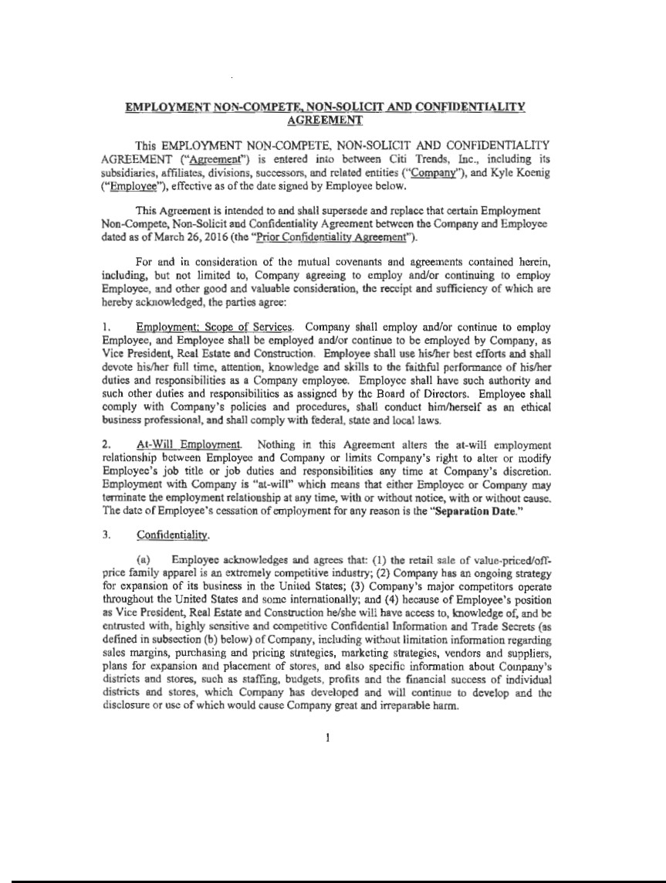

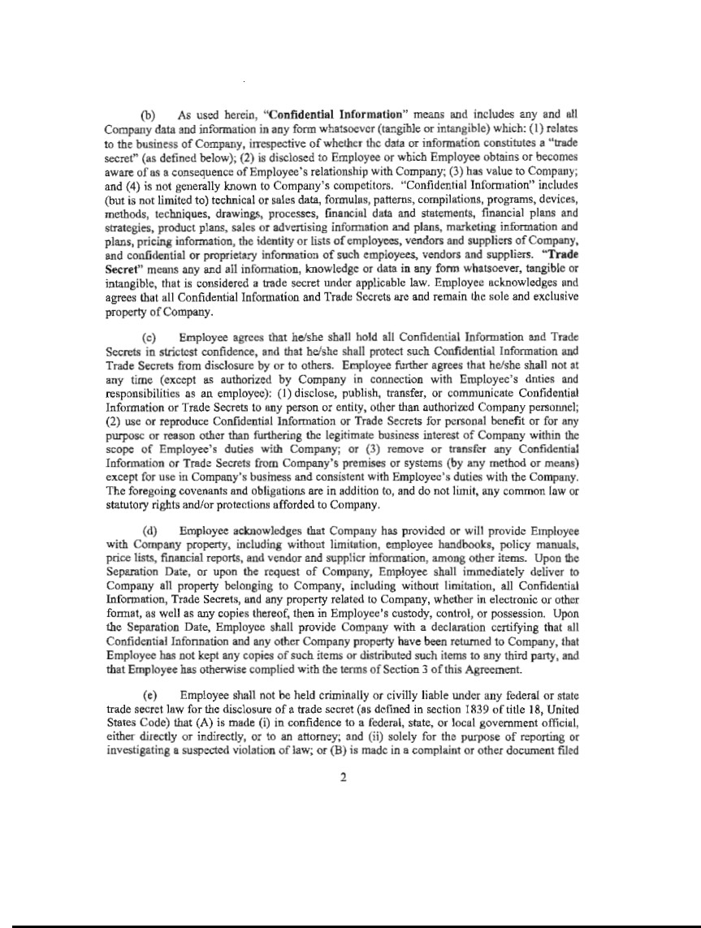

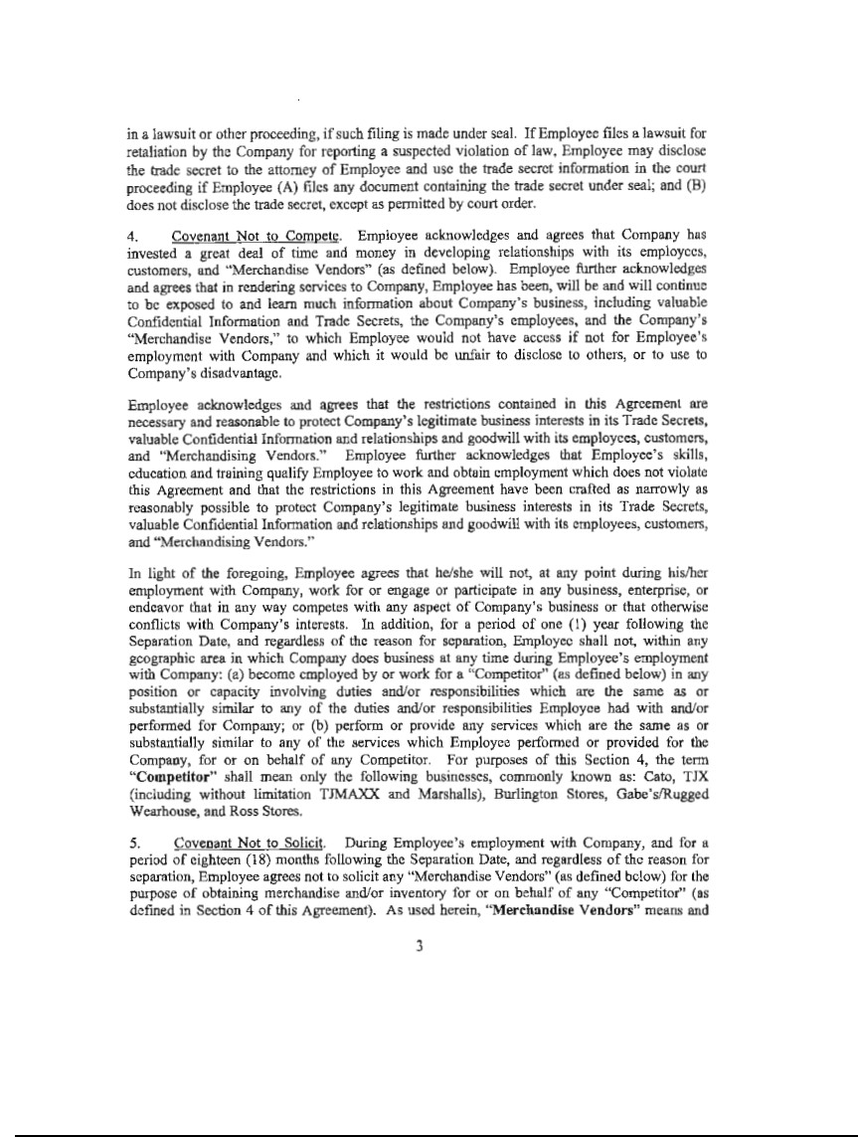

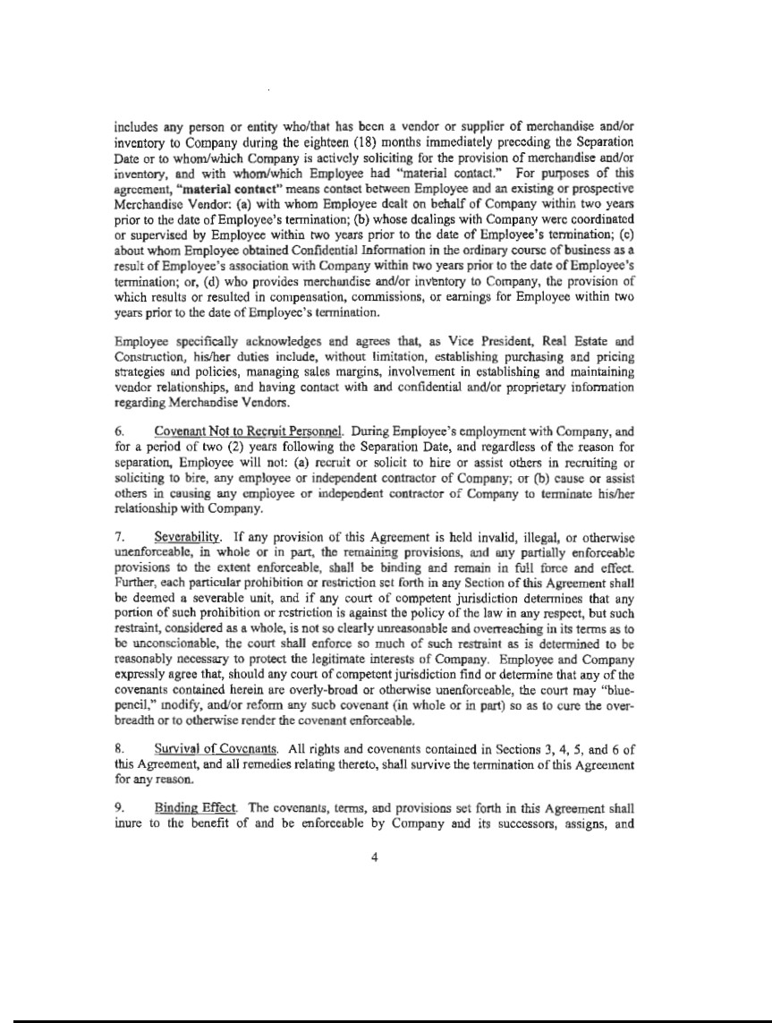

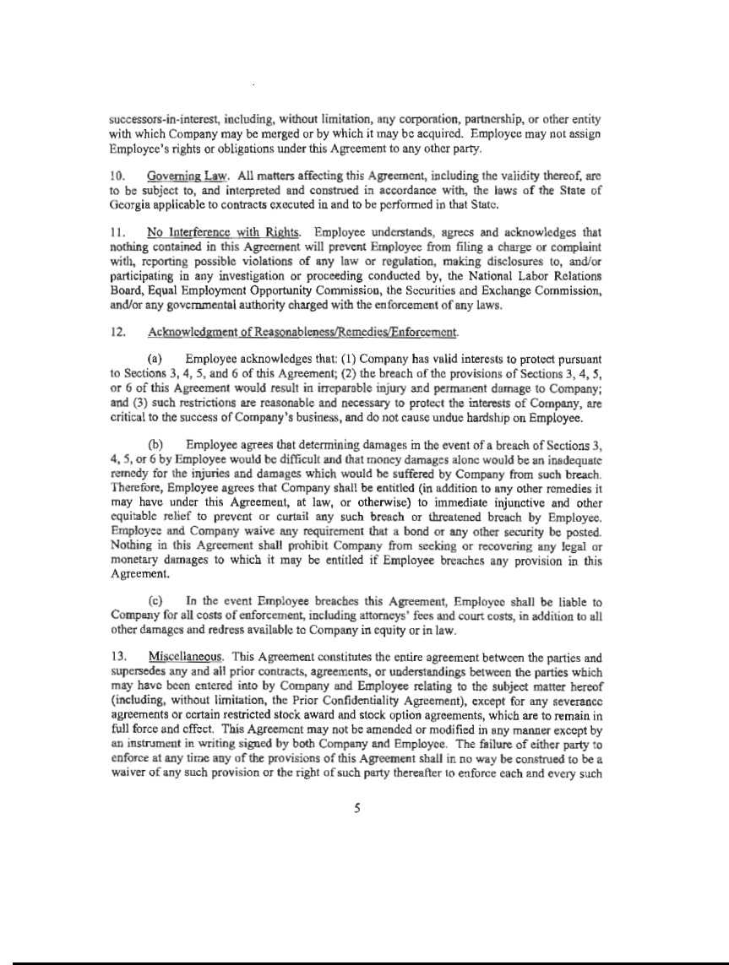

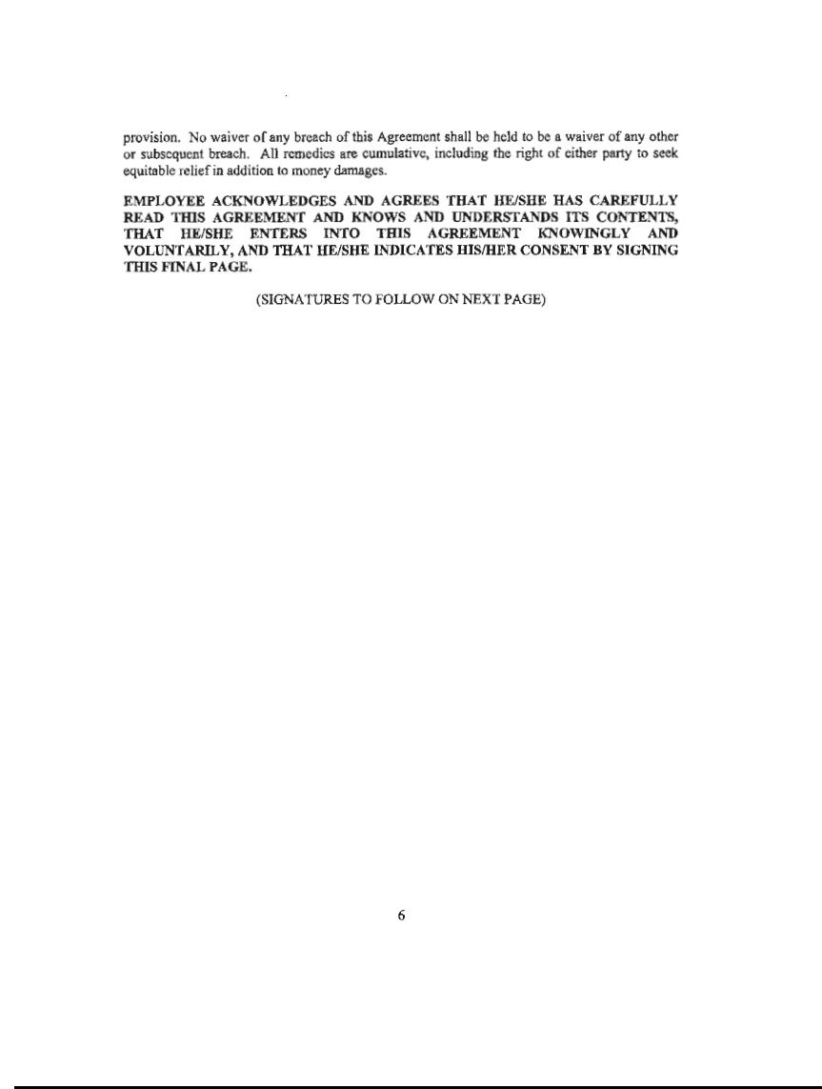

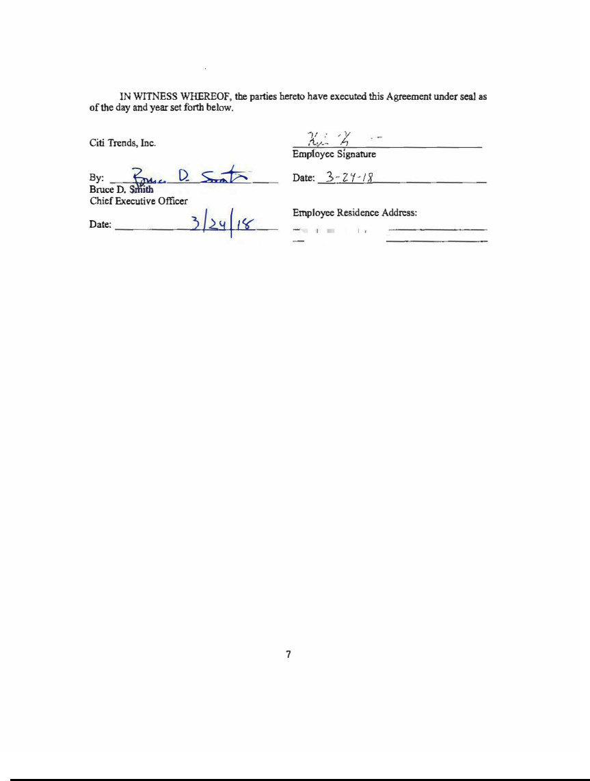

Exhibit 31.1

CERTIFICATION

I, Kenneth D. Seipel, certify that:

- I have reviewed this Quarterly Report on Form 10-Q for the period ended November 2, 2024 of Citi Trends, Inc.;

- Based on my knowledge, this report does not contain any untrue statement of a material fact or omit to state a material fact necessary to make the statements made, in light of the circumstances under which such statements were made, not misleading with respect to the period covered by this report;

- Based on my knowledge, the financial statements, and other financial information included in this report, fairly present in all material respects the financial condition, results of operations and cash flows of the registrant as of, and for, the periods presented in this report;

- The registrant’s other certifying officer and I are responsible for establishing and maintaining disclosure controls and procedures (as defined in Exchange Act Rules 13a-15(e) and 15d-15(e)) and internal control over financial reporting (as defined in Exchange Act Rules 13a-15(f) and 15d-15(f)) for the registrant and have:

  - designed such disclosure controls and procedures, or caused such disclosure controls and procedures to be designed under our supervision, to ensure that material information relating to the registrant, including its consolidated subsidiaries, is made known to us by others within those entities, particularly during the period in which this report is being prepared;

  - designed such internal control over financial reporting, or caused such internal control over financial reporting to be designed under our supervision, to provide reasonable assurance regarding the reliability of financial reporting and the preparation of financial statements for external purposes in accordance with generally accepted accounting principles;

  - evaluated the effectiveness of the registrant’s disclosure controls and procedures and presented in this report our conclusions about the effectiveness of the disclosure controls and procedures, as of the end of the period covered by this report based on such evaluation; and

  - disclosed in this report any change in the registrant’s internal control over financial reporting that occurred during the registrant’s most recent fiscal quarter (the registrant’s fourth fiscal quarter in the case of an annual report) that has materially affected, or is reasonably likely to materially affect, the registrant’s internal control over financial reporting; and

- The registrant’s other certifying officer and I have disclosed, based on our most recent evaluation of internal control over financial reporting, to the registrant’s auditors and the audit committee of the registrant’s board of directors (or persons performing the equivalent functions):

  - all significant deficiencies and material weaknesses in the design or operation of internal control over financial reporting which are reasonably likely to adversely affect the registrant’s ability to record, process, summarize and report financial information; and

  - any fraud, whether or not material, that involves management or other employees who have a significant role in the registrant’s internal control over financial reporting.

Date: December 11, 2024

/s/ Kenneth D. Seipel

Kenneth D. Seipel

Chief Executive Officer

(Principal Executive Officer)

Exhibit 31.2

CERTIFICATION

I, Heather Plutino, certify that:

- I have reviewed this Quarterly Report on Form 10-Q for the period ended November 2, 2024 of Citi Trends, Inc.;

- Based on my knowledge, this report does not contain any untrue statement of a material fact or omit to state a material fact necessary to make the statements made, in light of the circumstances under which such statements were made, not misleading with respect to the period covered by this report;

- Based on my knowledge, the financial statements, and other financial information included in this report, fairly present in all material respects the financial condition, results of operations and cash flows of the registrant as of, and for, the periods presented in this report;

- The registrant’s other certifying officer and I are responsible for establishing and maintaining disclosure controls and procedures (as defined in Exchange Act Rules 13a-15(e) and 15d-15(e)) and internal control over financial reporting (as defined in Exchange Act Rules 13a-15(f) and 15d-15(f)) for the registrant and have:

  - designed such disclosure controls and procedures, or caused such disclosure controls and procedures to be designed under our supervision, to ensure that material information relating to the registrant, including its consolidated subsidiaries, is made known to us by others within those entities, particularly during the period in which this report is being prepared;

  - designed such internal control over financial reporting, or caused such internal control over financial reporting to be designed under our supervision, to provide reasonable assurance regarding the reliability of financial reporting and the preparation of financial statements for external purposes in accordance with generally accepted accounting principles;

  - evaluated the effectiveness of the registrant’s disclosure controls and procedures and presented in this report our conclusions about the effectiveness of the disclosure controls and procedures, as of the end of the period covered by this report based on such evaluation; and

  - disclosed in this report any change in the registrant’s internal control over financial reporting that occurred during the registrant’s most recent fiscal quarter (the registrant’s fourth fiscal quarter in the case of an annual report) that has materially affected, or is reasonably likely to materially affect, the registrant’s internal control over financial reporting; and

- The registrant’s other certifying officer and I have disclosed, based on our most recent evaluation of internal control over financial reporting, to the registrant’s auditors and the audit committee of the registrant’s board of directors (or persons performing the equivalent functions):

  - all significant deficiencies and material weaknesses in the design or operation of internal control over financial reporting which are reasonably likely to adversely affect the registrant’s ability to record, process, summarize and report financial information; and

  - any fraud, whether or not material, that involves management or other employees who have a significant role in the registrant’s internal control over financial reporting.

Date: December 11, 2024

/s/ Heather Plutino

Heather Plutino

Chief Financial Officer

(Principal Financial Officer)

Exhibit 32.1

Certifications pursuant to Section 906 of the Sarbanes-Oxley Act of 2002 (18 U.S.C. § 1350, as adopted).

I, Kenneth D. Seipel, Chief Executive Officer of Citi Trends, Inc.,

and

I, Heather Plutino, Chief Financial officer of Citi Trends, Inc., certify that:

- We have reviewed this quarterly report on Form 10-Q of Citi Trends, Inc. for the period ended November 2, 2024;

- Based on our knowledge, this quarterly report fully complies with the requirements of Section 13(a) or Section 15(d) of the Securities Exchange Act of 1934, as amended; and

- Based on our knowledge, the financial statements, and other information included in this quarterly report, fairly present in all material respects the financial condition and results of operations of the registrant as of, and for, the periods presented in this quarterly report.

Date: December 11, 2024

/s/ Kenneth D. Seipel

Kenneth D. Seipel

Chief Executive Officer

(Principal Executive Officer)

Date: December 11, 2024

/s/ Heather Plutino

Heather Plutino

Chief Financial Officer

(Principal Financial Officer)

A signed original of this written statement required by Section 906 has been provided to Citi Trends, Inc. and will be retained by Citi Trends, Inc. and furnished to the Securities and Exchange Commission or its staff upon request.

