Table of Contents
​
UNITED STATES
SECURITIES AND EXCHANGE COMMISSION
Washington, D.C. 20549
​
Form 10-Q
(Mark One)
​

​ | ​
​ | ​
☒ | QUARTERLY REPORT PURSUANT TO SECTION 13 OR 15(d) OF THE SECURITIES EXCHANGE ACT OF 1934
​
For the quarterly period ended August 3, 2024
​
OR
​

​ | ​
​ | ​
☐ | TRANSITION REPORT PURSUANT TO SECTION 13 OR 15(d) OF THE SECURITIES EXCHANGE ACT OF 1934
​
Commission File Number 000-41886
​
CITI TRENDS, INC.
(Exact name of registrant as specified in its charter)
​

​ | ​ | ​
​ | ​ | ​
Delaware | ​ | 52-2150697
(State or other jurisdiction of | ​ | (I.R.S. Employer
incorporation or organization) | ​ | Identification No.)
​ | ​ | ​
104 Coleman Boulevard | ​ | ​
Savannah, Georgia | ​ | 31408
(Address of principal executive offices) | ​ | (Zip Code)
​
Registrant’s telephone number, including area code (912) 236-1561
​
​
Securities registered pursuant to Section 12(b) of the Act:
​

​ | ​ | ​ | ​ | ​
Title of each class | ​ | Trading symbol | ​ | Name of each exchange on which registered
Common Stock, $0.01 par value | ​ | CTRN | ​ | NASDAQ Stock Market
​
Indicate by check mark whether the registrant (1) has filed all reports required to be filed by Section 13 or 15(d) of the Securities Exchange Act of 1934 during the preceding 12 months (or for such shorter period that the registrant was required to file such reports), and (2) has been subject to such filing requirements for the past 90 days. Yes ☒ No ☐
​
Indicate by check mark whether the registrant has submitted electronically every Interactive Data File required to be submitted pursuant to Rule 405 of Regulation S-T (§232.405 of this chapter) during the preceding 12 months (or for such shorter period that the registrant was required to submit such files). Yes ☒ No ☐
​
Indicate by check mark whether the registrant is a large accelerated filer, an accelerated filer, a non-accelerated filer, a smaller reporting company, or an emerging growth company. See the definitions of “large accelerated filer,” “accelerated filer,” “smaller reporting company” and “emerging growth company” in Rule 12b-2 of the Exchange Act.
​ | ​
Large Accelerated Filer ☐ Accelerated Filer ☒ | Non-Accelerated Filer ☐
​ | ​
Smaller Reporting Company ☐ | Emerging Growth Company ☐
​
If an emerging growth company, indicate by check mark if the registrant has elected not to use the extended transition period for complying with any new or revised financial accounting standards provided pursuant to Section 13(a) of the Exchange Act. ☐
​
Indicate by check mark whether the registrant is a shell company (as defined in Rule 12b-2 of the Exchange Act). Yes ☐ No ☒
​
As of August 30, 2024, the registrant had 8,615,343 outstanding shares of common stock, $0.01 par value per share.
​
​
Table of Contents
CITI TRENDS, INC.
FORM 10-Q
TABLE OF CONTENTS
​ | ​
​ | ​ | PAGE
​ | ​ | NUMBER
PART I | FINANCIAL INFORMATION | ​
​ | ​ | ​
Item 1 | Financial Statements (unaudited) | ​
​ | ​ | ​
​ | Condensed Consolidated Balance Sheets | 3
​ | ​ | ​
​ | Condensed Consolidated Statements of Operations | 4
​ | ​ | ​
​ | Condensed Consolidated Statements of Cash Flows | 5
​ | ​ | ​
​ | Condensed Consolidated Statements of Stockholders’ Equity | 6
​ | ​ | ​
​ | Notes to the Condensed Consolidated Financial Statements | 7
​ | ​ | ​
Item 2 | Management’s Discussion and Analysis of Financial Condition and Results of Operations | 11
​ | ​ | ​
Item 3 | Quantitative and Qualitative Disclosures About Market Risk | 16
​ | ​ | ​
Item 4 | Controls and Procedures | 16
​ | ​ | ​
PART II | OTHER INFORMATION | ​
​ | ​ | ​
Item 1 | Legal Proceedings | 17
​ | ​ | ​
Item 1A | Risk Factors | 17
​ | ​ | ​
Item 2 | Unregistered Sales of Equity Securities and Use of Proceeds | 17
​ | ​ | ​
Item 3 | Defaults Upon Senior Securities | 17
​ | ​ | ​
Item 4 | Mine Safety Disclosures | 17
​ | ​ | ​
Item 5 | Other Information | 17
​ | ​ | ​
Item 6 | Exhibits | 18
​ | ​ | ​
​ | SIGNATURES | 19
​
​
2
Table of Contents
PART I - FINANCIAL INFORMATION
​
Item 1. Financial Statements.
​
Citi Trends, Inc.
Condensed Consolidated Balance Sheets
(Unaudited)
(in thousands, except share data)
​

​ | ​ | ​ | ​ | ​ | ​ | ​ | ​ | ​
​ |  | August 3, |  |  | February 3,
​ |  | 2024 |  |  | 2024
Assets | ​ | ​ | ​ | ​ | ​ | ​ | ​ | ​
Current assets: | ​ | ​ | ​ | ​ | ​ | ​ | ​ | ​
Cash and cash equivalents | ​ | $ | 59,302 | ​ | $ | 79,706 | ​ | ​
Inventory | ​ |  | 134,996 | ​ |  | 130,432 | ​ | ​
Prepaid and other current assets | ​ |  | 16,922 | ​ |  | 10,838 | ​ | ​
Income tax receivable | ​ |  | 3,896 | ​ |  | 4,123 | ​ | ​
Total current assets | ​ |  | 215,116 | ​ |  | 225,099 | ​ | ​
Property and equipment, net of accumulated depreciation of $291,466 and $276,446 as of August 3, 2024 and February 3, 2024, respectively | ​ |  | 51,702 | ​ |  | 56,231 | ​ | ​
Operating lease right of use assets | ​ | ​ | 225,278 | ​ | ​ | 231,281 | ​ | ​
Deferred income taxes | ​ |  | 13,715 | ​ |  | 5,105 | ​ | ​
Other assets | ​ |  | 920 | ​ |  | 1,005 | ​ | ​
Total assets | ​ | $ | 506,731 | ​ | $ | 518,721 | ​ | ​
​ | ​ | ​ | ​ | ​ | ​ | ​ | ​ | ​
Liabilities and Stockholders’ Equity | ​ | ​ | ​ | ​ | ​ | ​ | ​ | ​
Current liabilities: | ​ | ​ | ​ | ​ | ​ | ​ | ​ | ​
Accounts payable | ​ | $ | 110,540 | ​ | $ | 100,366 | ​ | ​
Operating lease liabilities | ​ | ​ | 49,071 | ​ | ​ | 45,842 | ​ | ​
Accrued expenses | ​ |  | 17,056 | ​ |  | 16,466 | ​ | ​
Accrued compensation | ​ |  | 7,724 | ​ |  | 6,846 | ​ | ​
Layaway deposits | ​ |  | 1,092 | ​ |  | 384 | ​ | ​
Total current liabilities | ​ |  | 185,483 | ​ |  | 169,904 | ​ | ​
Noncurrent operating lease liabilities | ​ |  | 182,869 | ​ |  | 188,810 | ​ | ​
Other long-term liabilities | ​ |  | 1,789 | ​ |  | 2,301 | ​ | ​
Total liabilities | ​ |  | 370,141 | ​ |  | 361,015 | ​ | ​
​ | ​ | ​ | ​ | ​ | ​ | ​ | ​ | ​
Stockholders’ equity: | ​ | ​ | ​ | ​ | ​ | ​ | ​ | ​
Common stock, $0.01 par value. Authorized 32,000,000 shares; 16,419,356 shares issued as of August 3, 2024 and 16,354,714 shares issued as of February 3, 2024; 8,615,343 shares outstanding as of August 3, 2024 and 8,550,701 shares outstanding as of February 3, 2024 | ​ |  | 162 | ​ |  | 160 | ​ | ​
Paid in capital | ​ |  | 106,407 | ​ |  | 105,686 | ​ | ​
Retained earnings | ​ |  | 297,232 | ​ |  | 319,071 | ​ | ​
Treasury stock, at cost; 7,804,013 shares held as of August 3, 2024 and February 3, 2024 | ​ |  | (267,211) | ​ |  | (267,211) | ​ | ​
Total stockholders’ equity | ​ |  | 136,590 | ​ |  | 157,706 | ​ | ​
​ | ​ | ​ | ​ | ​ | ​ | ​ | ​ | ​
Commitments and contingencies (Note 7) | ​ | ​ | ​ | ​ | ​ | ​ | ​ | ​
Total liabilities and stockholders’ equity | ​ | $ | 506,731 | ​ | $ | 518,721 | ​ | ​
​
​
See accompanying notes to the condensed consolidated financial statements (unaudited).
​
​
3
Table of Contents
Citi Trends, Inc.
Condensed Consolidated Statements of Operations
(Unaudited)
(in thousands, except per share amounts)
​

​ | ​ | ​ | ​ | ​ | ​ | ​ | ​
​ | ​ | Thirteen Weeks Ended |  |  |  |  | ​
​ | ​ | August 3, |  | ​ | July 29, |  | ​
​ |  | 2024 |  |  | 2023
Net sales | ​ | $ | 176,552 | ​ | $ | 173,554 | ​
​ | ​ | ​ | ​ | ​ | ​ | ​ | ​
Cost of sales (exclusive of depreciation) | ​ | ​ | (121,624) | ​ | ​ | (107,226) | ​
Selling, general and administrative expenses | ​ | ​ | (73,780) | ​ | ​ | (69,543) | ​
Depreciation | ​ | ​ | (4,782) | ​ | ​ | (4,708) | ​
Asset impairment | ​ | ​ | (1,261) | ​ | ​ | — | ​
Loss from operations | ​ | ​ | (24,895) | ​ | ​ | (7,923) | ​
Interest income | ​ | ​ | 611 | ​ | ​ | 887 | ​
Interest expense | ​ | ​ | (80) | ​ | ​ | (77) | ​
Loss before income taxes | ​ | ​ | (24,364) | ​ | ​ | (7,113) | ​
Income tax benefit | ​ | ​ | 5,951 | ​ | ​ | 2,081 | ​
Net loss | ​ | $ | (18,413) | ​ | $ | (5,032) | ​
​ | ​ | ​ | ​ | ​ | ​ | ​ | ​
Basic net loss per common share | ​ | $ | (2.21) | ​ | $ | (0.61) | ​
Diluted net loss per common share | ​ | $ | (2.21) | ​ | $ | (0.61) | ​
​ | ​ | ​ | ​ | ​ | ​ | ​ | ​
Weighted average number of shares outstanding | ​ | ​ | ​ | ​ | ​ | ​ | ​
Basic | ​ | ​ | 8,337 | ​ | ​ | 8,225 | ​
Diluted | ​ | ​ | 8,337 | ​ | ​ | 8,225 | ​
​
Citi Trends, Inc.
Condensed Consolidated Statements of Operations
(Unaudited)
(in thousands, except per share amounts)
​

​ | ​ | ​ | ​ | ​ | ​ | ​
​ | ​ | Twenty-Six Weeks Ended
​ | ​ | August 3, |  | ​ | July 29,
​ |  | 2024 |  |  | 2023
Net sales | ​ | $ | 362,841 | ​ | $ | 353,242
​ | ​ | ​ | ​ | ​ | ​ | ​
Cost of sales (exclusive of depreciation) | ​ | ​ | (235,878) | ​ | ​ | (220,885)
Selling, general and administrative expenses | ​ | ​ | (147,991) | ​ | ​ | (140,350)
Depreciation | ​ | ​ | (9,576) | ​ | ​ | (9,389)
Asset impairment | ​ | ​ | (1,261) | ​ | ​ | —
Loss from operations | ​ | ​ | (31,865) | ​ | ​ | (17,382)
Interest income | ​ | ​ | 1,460 | ​ |  | 1,910
Interest expense | ​ | ​ | (158) | ​ |  | (152)
Loss before income taxes | ​ | ​ | (30,563) | ​ | ​ | (15,624)
Income tax benefit | ​ | ​ | 8,724 | ​ |  | 3,957
Net loss | ​ | $ | (21,839) | ​ | $ | (11,667)
​ | ​ | ​ | ​ | ​ | ​ | ​
Basic net loss per common share | ​ | $ | (2.63) | ​ | $ | (1.42)
Diluted net loss per common share | ​ | $ | (2.63) | ​ | $ | (1.42)
​ | ​ | ​ | ​ | ​ | ​ | ​
Weighted average number of shares outstanding | ​ | ​ | ​ | ​ | ​ | ​
Basic | ​ | ​ | 8,295 | ​ | ​ | 8,203
Diluted | ​ | ​ | 8,295 | ​ | ​ | 8,203
​
See accompanying notes to the condensed consolidated financial statements (unaudited).
​
4
Table of Contents
Citi Trends, Inc.
Condensed Consolidated Statements of Cash Flows
(Unaudited)
(in thousands)
​

​ | ​ | ​ | ​ | ​ | ​ | ​ | ​
​ | ​ | Twenty-Six Weeks Ended |  |  |  |  | ​
​ | ​ | August 3, |  | ​ | July 29, |  | ​
​ |  | 2024 |  |  | 2023
Operating activities: | ​ | ​ | ​ | ​ | ​ | ​ | ​
Net loss | ​ | $ | (21,839) | ​ | $ | (11,667) | ​
Adjustments to reconcile net loss to net cash used in operating activities: | ​ | ​ | ​ | ​ | ​ | ​ | ​
Depreciation | ​ | ​ | 9,576 | ​ | ​ | 9,389 | ​
Asset impairment | ​ | ​ | 1,261 | ​ | ​ | — | ​
Non-cash operating lease costs | ​ | ​ | 24,605 | ​ | ​ | 25,662 | ​
Loss on disposal of property and equipment | ​ | ​ | 18 | ​ | ​ | 23 | ​
Deferred income taxes | ​ | ​ | (8,610) | ​ | ​ | (3,208) | ​
Non-cash stock-based compensation expense | ​ | ​ | 1,578 | ​ | ​ | 1,984 | ​
Changes in assets and liabilities: | ​ | ​ | ​ | ​ | ​ | ​ | ​
Inventory | ​ | ​ | (4,564) | ​ | ​ | (28,679) | ​
Prepaid and other current assets | ​ | ​ | (6,084) | ​ | ​ | (3,764) | ​
Other assets | ​ | ​ | 85 | ​ | ​ | 100 | ​
Accounts payable | ​ | ​ | 10,030 | ​ | ​ | 12,437 | ​
Accrued expenses and other long-term liabilities | ​ | ​ | (21,865) | ​ | ​ | (31,237) | ​
Accrued compensation | ​ | ​ | 878 | ​ | ​ | 523 | ​
Income tax receivable/payable | ​ | ​ | 227 | ​ | ​ | (2,439) | ​
Layaway deposits | ​ | ​ | 708 | ​ | ​ | 915 | ​
Net cash used in operating activities | ​ | ​ | (13,996) | ​ | ​ | (29,961) | ​
Investing activities: | ​ | ​ | ​ | ​ | ​ | ​ | ​
Purchases of property and equipment | ​ | ​ | (5,552) | ​ | ​ | (6,905) | ​
Net cash used in investing activities | ​ | ​ | (5,552) | ​ | ​ | (6,905) | ​
Financing activities: | ​ | ​ | ​ | ​ | ​ | ​ | ​
Cash used to settle withholding taxes on the vesting of nonvested restricted stock | ​ | ​ | (856) | ​ | ​ | (809) | ​
Net cash used in financing activities | ​ | ​ | (856) | ​ | ​ | (809) | ​
Net decrease in cash and cash equivalents | ​ | ​ | (20,404) | ​ | ​ | (37,675) | ​
Cash and cash equivalents: | ​ | ​ | ​ | ​ | ​ | ​ | ​
Beginning of period | ​ | ​ | 79,706 | ​ | ​ | 103,495 | ​
End of period | ​ | $ | 59,302 | ​ | $ | 65,820 | ​
​ | ​ | ​ | ​ | ​ | ​ | ​ | ​
Supplemental disclosures of cash flow information: | ​ | ​ | ​ | ​ | ​ | ​ | ​
Cash paid for interest | ​ | $ | 83 | ​ | $ | 79 | ​
Cash (refunds) payments of income taxes | ​ | $ | (341) | ​ | $ | 1,519 | ​
Supplemental disclosures of non-cash investing activities: | ​ | ​ | ​ | ​ | ​ | ​ | ​
Accrual for purchases of property and equipment | ​ | $ | 214 | ​ | $ | 1,485 | ​
​
​
See accompanying notes to the condensed consolidated financial statements (unaudited).
​
​
​
5
Table of Contents
Citi Trends, Inc.
Condensed Consolidated Statements of Stockholders’ Equity
(Unaudited)
(in thousands, except share amounts)
​

​ | ​ | ​ | ​ | ​ | ​ | ​ | ​ | ​ | ​ | ​ | ​ | ​ | ​ | ​ | ​ | ​ | ​ | ​ | ​
​ | ​ | Common Stock |  |  |  | ​ | Paid in |  | ​ | Retained |  | ​ | Treasury Stock |  |  |  | ​ | ​ | ​
​ | ​ | Shares | ​ | Amount |  | ​ | Capital |  | ​ | Earnings |  | ​ | Shares | ​ | Amount |  | ​ | Total
Balances — February 3, 2024 |  | 16,354,714 | ​ | $ | 160 | ​ | $ | 105,686 | ​ | $ | 319,071 |  | 7,804,013 | ​ | $ | (267,211) | ​ | $ | 157,706
Vesting of nonvested shares | ​ | — | ​ | ​ | 1 | ​ | ​ | — | ​ | ​ | — | ​ | — | ​ | ​ | — | ​ | ​ | 1
Issuance of nonvested shares |  | 2,811 | ​ | ​ | — | ​ | ​ | — | ​ | ​ | — | ​ | — | ​ | ​ | — | ​ | ​ | —
Forfeiture of nonvested shares |  | (5,178) | ​ | ​ | — | ​ | ​ | — | ​ | ​ | — | ​ | — | ​ | ​ | — | ​ | ​ | —
Stock-based compensation expense | ​ | — | ​ | ​ | — | ​ | ​ | 884 | ​ | ​ | — | ​ | — | ​ | ​ | — | ​ | ​ | 884
Net share settlement of nonvested shares |  | (11,618) | ​ | ​ | — | ​ | ​ | (333) | ​ | ​ | — | ​ | — | ​ | ​ | — | ​ | ​ | (333)
Net loss | ​ | — | ​ | ​ | — | ​ | ​ | — | ​ | ​ | (3,426) | ​ | — | ​ | ​ | — | ​ | ​ | (3,426)
Balances — May 4, 2024 |  | 16,340,729 | ​ | $ | 161 | ​ | $ | 106,237 | ​ | $ | 315,645 |  | 7,804,013 | ​ | $ | (267,211) | ​ | $ | 154,832
Vesting of nonvested shares | ​ | — | ​ | ​ | 1 | ​ | ​ | — | ​ | ​ | — | ​ | — | ​ | ​ | — | ​ | ​ | 1
Issuance of nonvested shares |  | 110,870 | ​ | ​ | — | ​ | ​ | — | ​ | ​ | — | ​ | — | ​ | ​ | — | ​ | ​ | —
Issuance of vested shares | ​ | 16,373 | ​ | ​ | — | ​ | ​ | — | ​ | ​ | — | ​ | — | ​ | ​ | — | ​ | ​ | —
Forfeiture of nonvested shares |  | (24,845) | ​ | ​ | — | ​ | ​ | — | ​ | ​ | — | ​ | — | ​ | ​ | — | ​ | ​ | —
Stock-based compensation expense | ​ | — | ​ | ​ | — | ​ | ​ | 694 | ​ | ​ | — | ​ | — | ​ | ​ | — | ​ | ​ | 694
Net share settlement of nonvested shares |  | (23,771) | ​ | ​ | — | ​ | ​ | (524) | ​ | ​ | — | ​ | — | ​ | ​ | — | ​ | ​ | (524)
Net loss | ​ | — | ​ | ​ | — | ​ | ​ | — | ​ | ​ | (18,413) | ​ | — | ​ | ​ | — | ​ | ​ | (18,413)
Balances — August 3, 2024 |  | 16,419,356 | ​ | $ | 162 | ​ | $ | 106,407 | ​ | $ | 297,232 |  | 7,804,013 | ​ | $ | (267,211) | ​ | $ | 136,590
​ | ​ | ​ | ​ | ​ | ​ | ​ | ​ | ​ | ​ | ​ | ​ | ​ | ​ | ​ | ​ | ​ | ​ | ​ | ​
​
​
​

​ | ​ | ​ | ​ | ​ | ​ | ​ | ​ | ​ | ​ | ​ | ​ | ​ | ​ | ​ | ​ | ​ | ​ | ​ | ​
​ | ​ | Common Stock |  |  |  | ​ | Paid in |  | ​ | Retained |  | ​ | Treasury Stock |  |  |  | ​ | ​ | ​
​ | ​ | Shares | ​ | Amount |  | ​ | Capital |  | ​ | Earnings |  | ​ | Shares | ​ | Amount |  | ​ | Total
Balances — January 28, 2023 |  | 16,158,494 | ​ | $ | 160 | ​ | $ | 102,445 | ​ | $ | 331,050 |  | 7,804,013 | ​ | $ | (267,211) | ​ | $ | 166,444
Vesting of nonvested shares | ​ | — | ​ | ​ | 1 | ​ | ​ | — | ​ | ​ | — | ​ | — | ​ | ​ | — | ​ | ​ | 1
Issuance of nonvested shares | ​ | 1,500 | ​ | ​ | — | ​ | ​ | — | ​ | ​ | — | ​ | — | ​ | ​ | — | ​ | ​ | —
Forfeiture of nonvested shares |  | (9,647) | ​ | ​ | — | ​ | ​ | — | ​ | ​ | — | ​ | — | ​ | ​ | — | ​ | ​ | —
Stock-based compensation expense | ​ | — | ​ | ​ | — | ​ | ​ | 935 | ​ | ​ | — | ​ | — | ​ | ​ | — | ​ | ​ | 935
Net share settlement of nonvested shares |  | (33,432) | ​ | ​ | (1) | ​ | ​ | (782) | ​ | ​ | — | ​ | — | ​ | ​ | — | ​ | ​ | (783)
Net income | ​ | — | ​ | ​ | — | ​ | ​ | — | ​ | ​ | (6,635) | ​ | — | ​ | ​ | — | ​ | ​ | (6,635)
Balances — April 29, 2023 |  | 16,116,915 | ​ | $ | 160 | ​ | $ | 102,598 | ​ | $ | 324,415 |  | 7,804,013 | ​ | $ | (267,211) | ​ | $ | 159,962
Issuance of nonvested shares |  | 259,136 | ​ | ​ | — | ​ | ​ | — | ​ | ​ | — | ​ | — | ​ | ​ | — | ​ | ​ | —
Forfeiture of nonvested shares |  | (6,581) | ​ | ​ | — | ​ | ​ | — | ​ | ​ | ​ | ​ | — | ​ | ​ | — | ​ | ​ | —
Stock-based compensation expense | ​ | — | ​ | ​ | — | ​ | ​ | 1,049 | ​ | ​ | — | ​ | — | ​ | ​ | — | ​ | ​ | 1,049
Net share settlement of nonvested shares |  | (1,400) | ​ | ​ | — | ​ | ​ | (26) | ​ | ​ | — | ​ | — | ​ | ​ | — | ​ | ​ | (26)
Net loss | ​ | — | ​ | ​ | — | ​ | ​ | — | ​ | ​ | (5,032) | ​ | — | ​ | ​ | — | ​ | ​ | (5,032)
Balances — July 29, 2023 |  | 16,368,070 | ​ | $ | 160 | ​ | $ | 103,621 | ​ | $ | 319,383 |  | 7,804,013 | ​ | $ | (267,211) | ​ | $ | 155,953
​
​
See accompanying notes to the condensed consolidated financial statements (unaudited).
6
Table of Contents
Citi Trends, Inc.
Notes to the Condensed Consolidated Financial Statements (unaudited)
August 3, 2024
​
1. Significant Accounting Policies
Basis of Presentation
Citi Trends, Inc. and its subsidiary (the “Company”) is a leading specialty value retailer of apparel, accessories and home trends for way less spend primarily for African American and multicultural families. As of August 3, 2024, the Company operated 597 stores in urban, suburban and rural markets in 33 states.
​
The condensed consolidated financial statements are prepared in accordance with U.S. generally accepted accounting principles (“U.S. GAAP”) for interim reporting and are unaudited. In the opinion of management, the condensed consolidated financial statements reflect all adjustments, which are normal and recurring in nature, necessary for fair financial statement presentation. The condensed consolidated balance sheet as of February 3, 2024 is derived from the audited financial statements in the Company’s Annual Report on Form 10-K for the fiscal year ended February 3, 2024 (the “2023 Form 10-K”). These condensed consolidated financial statements should be read in conjunction with the audited consolidated financial statements and notes thereto included in the 2023 Form 10-K. Results of a period shorter than a full year may not be indicative of results expected for the entire year as a result of the seasonality of our business, among other things.
Fiscal Year
The following contains references to fiscal years 2024 and 2023, which represent fiscal years ending or ended on February 1, 2025 and February 3, 2024, respectively. Fiscal 2024 has a 52-week accounting period, and fiscal 2023 had a 53-week accounting period.
​
2. Cash and Cash Equivalents/Concentration of Credit Risk
For purposes of the condensed consolidated balance sheets and condensed consolidated statements of cash flows, the Company considers all highly liquid investments with maturities at date of purchase of three months or less to be cash equivalents. Financial instruments that potentially subject the Company to a concentration of credit risk consist principally of cash and cash equivalents. The Company places its cash and cash equivalents in what it believes to be high credit quality banks and institutional money market funds. The Company maintains cash accounts that exceed federally insured limits.
​
3. Earnings per Share
Basic earnings per common share amounts are calculated using the weighted average number of common shares outstanding for the period. Diluted earnings per common share amounts are calculated using the weighted average number of common shares outstanding plus the additional dilution for all potentially dilutive securities, such as nonvested restricted stock. During loss periods, diluted loss per share amounts are based on the weighted average number of common shares outstanding because the inclusion of common stock equivalents would be antidilutive.
​
The dilutive effect of stock-based compensation arrangements is accounted for using the treasury stock method. The Company includes as assumed proceeds the amount of compensation cost attributed to future services and not yet recognized. For the second quarter of 2024 and 2023, there were 178,000 and 328,000 shares of nonvested restricted stock, respectively, excluded from the calculation of diluted earnings per share because of antidilution. For the twenty-six weeks ended August 3, 2024 and July 29, 2023, there were 234,000 and 215,000 shares of nonvested restricted stock, respectively, excluded from the calculation of diluted earnings per share because of antidilution.
​
7
Table of Contents
The following table provides a reconciliation of the weighted average number of common shares outstanding used to calculate basic earnings per share to the number of common shares and common stock equivalents outstanding used in calculating diluted earnings per share:
​
​ | ​ | ​ | ​ | ​
​ | ​ | Thirteen Weeks Ended
​ |  | August 3, 2024 |  | July 29, 2023
Weighted average number of common shares outstanding (basic) | ​ | 8,336,629 | ​ | 8,224,762
Incremental shares from assumed vesting of nonvested restricted stock | ​ | — | ​ | —
Weighted average number of common shares and common stock equivalents outstanding (diluted) | ​ | 8,336,629 | ​ | 8,224,762
​
​
​ | ​ | ​ | ​ | ​
​ | ​ | Twenty-Six Weeks Ended
​ |  | August 3, 2024 |  | July 29, 2023
Weighted average number of common shares outstanding (basic) | ​ | 8,294,593 | ​ | 8,203,497
Incremental shares from assumed vesting of nonvested restricted stock | ​ | — | ​ | —
Weighted average number of common shares and common stock equivalents outstanding (diluted) | ​ | 8,294,593 | ​ | 8,203,497
​
​
​
​
4. Revolving Credit Facility
In October 2011, the Company entered into a five-year, $50 million credit facility with Bank of America. The facility was amended in August 2015 and May 2020 to extend the maturity dates. The facility was further amended in April 2021 to modify terms and extend the maturity date to April 15, 2026. In May 2023, the facility was amended to replace the London Interbank Offered Rate (“LIBOR”) with the Secured Overnight Financing Rate (“SOFR”). The amended facility provides a $75 million credit commitment and a $25 million uncommitted “accordion” feature that under certain circumstances could allow the Company to increase the size of the facility to $100 million. The facility is secured by the Company’s inventory, accounts receivable and related assets, but not its real estate, fixtures and equipment, and it contains one financial covenant, a fixed charge coverage ratio, which is applicable and tested only in certain circumstances. The facility has an unused commitment fee of 0.20% and permits the payment of cash dividends subject to certain limitations. Borrowings under the credit facility bear interest (a) for SOFR Loans, at a rate equal to the SOFR Rate plus a SOFR adjustment equal to 0.10% plus either 1.25%, 1.50% or 1.75%, or (b) for Base Rate Loans, at a rate equal to the highest of (i) the prime rate, (ii) the Federal Funds Rate plus 0.5% or (iii) the Eurodollar Rate plus 1.0%, plus, in each case either 0.25%, 0.50% or 0.75%, based in any such case on the average daily availability for borrowings under the facility.
​
As of August 3, 2024, the Company had no borrowings under the credit facility and $1.4 million of letters of credit outstanding.
​
5. Impairment of Assets
If facts and circumstances indicate that a long-lived asset or operating lease right-of-use asset may be impaired, the carrying value is reviewed. If this review indicates that the carrying value of the asset will not be recovered as determined based on projected undiscounted cash flows related to the asset over its remaining life, the carrying value of the asset is reduced to its estimated fair value. In the second quarter of 2024, non-cash impairment expense related to underperforming stores totaled $1.3 million, comprised of $0.7 million for leasehold improvements and fixtures and equipment, and $0.6 million for operating lease right of use assets. There was no impairment expense in the first twenty-six weeks of 2023.
​
6. Income Taxes
The provision for income taxes for the interim period in 2024 is based on an estimate of the annual effective tax rate adjusted to reflect the impact of discrete items. Management judgment is required in projecting ordinary income to estimate the Company’s annual effective tax rate. For the first half of 2023 the Company used the discrete effective tax rate method to determine its tax expense based upon interim period results. The Company determined that since small changes in estimated ordinary income would result in significant changes in the estimated annual effective tax rate, the annual effective tax rate method would not have provided a reliable estimate for the first twenty-six weeks of 2023.
As of August 3, 2024, we had approximately $13.7 million in net deferred tax assets (DTA). At this time, we consider it more likely than not that we will have sufficient taxable income in the future that will allow us to realize these DTAs. If we are not able to generate sufficient taxable income to realize these DTAs, a substantial valuation allowance to reduce our U.S. DTAs may be required, which would materially increase our expenses in the period the allowance is recognized and adversely affect our results of operations.
8
Table of Contents
As of August 3, 2024, our net DTA includes approximately $9.7 million related to net operating loss (NOL) carryforwards that can be used to offset taxable income in future periods and reduce our income taxes payable in those future periods. NOL carryforwards may be subject to annual limitations under Internal Revenue Code Section 382 (Section 382) (or comparable provisions of foreign or state law) in the event that certain changes in ownership were to occur. In addition, tax credit carryforwards may be subject to annual limitations under Internal Revenue Code Section 383 (Section 383).
We are required to evaluate our NOL and tax credit carryforwards and whether certain changes in ownership have occurred as measured under Section 382 that would limit our ability to utilize a portion of our NOL and tax credit carryforwards. If it is determined that an ownership change has occurred, there may be annual limitations on the use of these NOL and tax credit carryforwards under Sections 382 and 383 (or comparable provisions of foreign or state law).
7. Commitments and Contingencies
The Company from time to time is involved in various legal proceedings incidental to the conduct of its business, including claims by customers, landlords, employees or former employees. Once it becomes probable that the Company will incur costs in connection with a legal proceeding and such costs can be reasonably estimated, the Company establishes appropriate reserves.
While legal proceedings are subject to uncertainties and the outcome of any such matter is not predictable, the Company is not aware of any legal proceedings pending or threatened against it that it expects to have a material adverse effect on its financial condition, results of operations or liquidity.
8. Stock Repurchases
The Company periodically repurchases shares of its common stock under board-authorized repurchase programs. Such repurchases may be made in the open market, through block trades or through other negotiated transactions. There were no stock repurchases in the first half of 2024 or the first half of 2023.
At August 3, 2024, $50.0 million remained available under the Company’s stock repurchase authorization.
9. Revenue
Revenue Recognition
The Company’s primary source of revenue is derived from the sale of clothing and accessories to its customers with the Company’s performance obligations satisfied immediately when the customer pays for their purchase and receives the merchandise. Sales taxes collected by the Company from customers are excluded from revenue. Revenue from layaway sales is recognized at the point in time when the merchandise is paid for and control of the goods is transferred to the customer, thereby satisfying the Company’s performance obligation. The Company defers revenue from the sale of gift cards and recognizes the associated revenue upon the redemption of the cards by customers to purchase merchandise.
​
Sales Returns
The Company allows customers to return merchandise for up to 30 days after the date of sale subject to certain conditions. Expected refunds to customers are recorded based on estimated margin using historical return information.
​
Disaggregation of Revenue
The Company’s retail operations represent a single operating segment based on the way the Company manages its business. Operating decisions and resource allocation decisions are made at the Company level in order to maintain a consistent retail store presentation. The Company’s retail stores sell similar products, use similar processes to sell those products and sell their products to similar classes of customers.
​
9
Table of Contents
In the following table, the Company’s revenue from contracts with customers is disaggregated by “CITI” or major merchandise category. The percentage of net sales for each CITI with the merchandise assortment was approximately:
​
​ | ​ | ​ | ​ | ​ | ​ | ​ | ​ | ​ | ​ | ​ | ​ | ​
​ | Thirteen Weeks Ended |  |  |  |  | ​ | Twenty-Six Weeks Ended |  |  |  |  | ​
​ | August 3, |  |  | July 29, |  |  | August 3, |  |  | July 29, |  | ​
​ | 2024 |  |  | 2023 |  |  | 2024 |  |  | 2023 |  | ​
Ladies | 27 | % | ​ | 27 | % | ​ | 29 | % | ​ | 28 | % | ​
Kids | 22 | % | ​ | 21 | % | ​ | 22 | % | ​ | 22 | % | ​
Accessories & Beauty | 18 | % | ​ | 18 | % | ​ | 17 | % | ​ | 18 | % | ​
Mens | 17 | % | ​ | 17 | % | ​ | 16 | % | ​ | 16 | % | ​
Home & Lifestyle | 9 | % | ​ | 8 | % | ​ | 9 | % | ​ | 8 | % | ​
Footwear | 7 | % | ​ | 9 | % | ​ | 7 | % | ​ | 8 | % | ​
​
10. Leases
The Company leases its retail store locations, distribution centers, and certain office space and equipment. Leases for store locations are typically for a term of five years with options to extend for one or more five-year periods.
The Company analyzes all leases at inception to determine if a right-of-use asset and lease liability should be recognized. Leases with an initial term of 12 months or less and leases with mutual termination clauses are not included on the condensed consolidated balance sheets. The lease liability is measured at the present value of future lease payments as of the lease commencement date.
Total lease cost is comprised of operating lease costs, short-term lease costs and variable lease costs, which include rent paid as a percentage of sales, common area maintenance, real estate taxes and insurance for the Company’s real estate leases. Lease costs consisted of the following (in thousands):
​
​ | ​ | ​ | ​ | ​ | ​ | ​ | ​ | ​ | ​ | ​ | ​ | ​
​ | ​ | Thirteen Weeks Ended |  |  |  |  | ​ | Twenty-Six Weeks Ended
​ | ​ | August 3, 2024 |  | ​ | July 29, 2023 |  | ​ | August 3, 2024 |  | ​ | July 29, 2023
Operating lease cost | ​ | $ | 14,400 | ​ | $ | 15,617 | ​ | $ | 29,790 | ​ | $ | 31,408
Variable lease cost | ​ |  | 3,541 | ​ |  | 2,919 | ​ |  | 6,163 | ​ |  | 5,779
Short term lease cost | ​ |  | 381 | ​ |  | 385 | ​ |  | 1,094 | ​ |  | 778
Total lease cost | ​ | $ | 18,322 | ​ | $ | 18,921 | ​ | $ | 37,047 | ​ | $ | 37,965
​
Future minimum lease payments as of August 3, 2024 are as follows (in thousands):
​
​ | ​ | ​ | ​ | ​ | ​
Fiscal Year |  | Lease Costs
Remainder of 2024 |  | $ | 32,492 | ​ | ​
2025 | ​ | ​ | 57,477 | ​ | ​
2026 | ​ |  | 46,267 | ​ | ​
2027 | ​ |  | 34,974 | ​ | ​
2028 | ​ |  | 26,835 | ​ | ​
Thereafter | ​ |  | 106,517 | ​ | ​
Total future minimum lease payments | ​ | ​ | 304,562 | ​ | ​
Less: imputed interest | ​ | ​ | (72,622) | (1) | ​
Total present value of lease liabilities | ​ | $ | 231,940 | (2) | ​
​
 | (1) | Calculated using the discount rate for each lease.
 | (2) | Includes short-term and long-term portions of operating lease liabilities.
​
​
10
Table of Contents
Certain operating leases provide for fixed monthly rents, while others provide for contingent rents computed as a percentage of net sales and others provide for a combination of both fixed monthly rents and contingent rents computed as a percentage of net sales.
​
Supplemental cash flows and other information related to operating leases are as follows (in thousands, except for weighted average amounts):
​
​ | ​ | ​ | ​ | ​ | ​ | ​
​ |  | Twenty-Six Weeks Ended
​ | ​ | August 3, 2024 |  | ​ | July 29, 2023
Cash paid for operating leases |  | $ | 30,784 | ​ | $ | 36,865
Right of use assets obtained in exchange for new operating lease liabilities | ​ | $ | 19,307 | ​ | $ | 10,242
​ | ​ |  | ​ | ​ |  | ​
Weighted average remaining lease term (years) - operating leases | ​ |  | 7.38 | ​ |  | 7.73
Weighted average discount rate - operating leases | ​ | ​ | 5.35% | ​ | ​ | 4.72%
​
​
​
​
11. Recent Accounting Pronouncements
In November 2023, the FASB issued ASU 2023-07, “Segment Reporting (Topic 280): Improvements to Reportable Segment Disclosures” (“ASU 2023-07”), which expands reportable segment disclosure requirements primarily through enhanced disclosures about significant segment expenses. ASU 2023-07 requires disclosure of (i) significant segment expenses that are regularly provided to the CODM and included within the segment measure of profit or loss, (ii) an amount and description of its composition for other segment items to reconcile to segment profit or loss, and (iii) the title and position of the Company’s CODM. The ASU does not change how a public entity identifies its operating segments, aggregates them, or applies the quantitative thresholds to determine its reportable segments. The new standard will be effective on a retrospective basis for fiscal years beginning after December 15, 2023, and interim periods within fiscal years beginning after December 15, 2024, with early adoption permitted. The Company is currently evaluating the ASU to determine the impact of the amended guidance.
In December 2023, the FASB issued ASU 2023-09, “Income Taxes (Topic 740): Improvements to Income Tax Disclosures” (“ASU 2023-09”). The amendments in ASU 2023-09 require public entities, on an annual basis, to provide disclosure of specific categories in the rate reconciliation, as well as disclosure of income taxes paid disaggregated by jurisdiction. The new standard will be effective on a prospective basis for fiscal years beginning after December 15, 2024 and interim periods therein, with early adoption permitted. The Company is currently evaluating the ASU to determine the impact of the amended guidance.
​
Item 2. Management’s Discussion and Analysis of Financial Condition and Results of Operations.
Forward-Looking Statements
Except for specific historical information, many of the matters discussed in this Form 10-Q may express or imply projections of revenues or expenditures, statements of plans and objectives for future operations, growth or initiatives, statements of future economic performance, capital allocation expectations or statements regarding the outcome or impact of pending or threatened litigation. These, and similar statements, are forward-looking statements concerning matters that involve risks, uncertainties and other factors that may cause the actual performance of the Company to differ materially from those expressed or implied by these statements. All forward-looking information should be evaluated in the context of these risks, uncertainties and other factors. The words “believe,” “anticipate,” “project,” “plan,” “expect,” “estimate,” “objective,” “forecast,” “goal,” “intend,” “could,” “will likely result,” or “will continue” and similar words and expressions generally identify forward-looking statements, although not all forward-looking statements contain such language. The Company believes the assumptions underlying these forward-looking statements are reasonable; however, any of the assumptions could be inaccurate, and therefore, actual results may differ materially from those projected in the forward-looking statements.
The factors that may result in actual results differing from such forward-looking information include, but are not limited to: uncertainties relating to general economic conditions, including inflation, energy and fuel costs, unemployment levels, and any deterioration whether caused by acts of war, terrorism, political or social unrest (including any resulting store closures, damage or loss of inventory) or other factors; changes in market interest rates and market levels of wages; natural disasters such as hurricanes; uncertainty and economic impact of pandemics, epidemics or other public health emergencies; transportation and distribution delays or interruptions; changes in freight rates; the Company’s ability to attract and retain workers; the Company’s ability to negotiate effectively the cost and purchase of merchandise; inventory risks due to shifts in market demand; the Company’s ability to gauge fashion trends and changing consumer preferences; changes in consumer confidence and consumer spending patterns; competition within the industry; competition in our markets; the duration and extent of any economic stimulus programs; changes in product mix; interruptions in suppliers’ businesses; the impact of the cyber disruption we identified on January 14, 2023, including legal, reputational, financial and contractual risks resulting from the disruption, and other risks related to cybersecurity, data privacy and intellectual property; the results of pending or
11
Table of Contents
threatened litigation; temporary changes in demand due to weather patterns; seasonality of the Company’s business; delays associated with building, opening, remodeling and operating new stores; delays associated with building, opening or expanding new or existing distribution centers; and other factors described in the section titled “Item 1A. Risk Factors” and elsewhere in the Company’s Annual Report on Form 10-K for the fiscal year ended February 3, 2024, and in Part II, “Item 1A. Risk Factors” and elsewhere in the Company’s Quarterly Reports on Form 10-Q and any amendments thereto and in the other documents the Company files with the SEC, including reports on Form 8-K.
Readers are cautioned not to place undue reliance on these forward-looking statements, which speak only as of the date of this Form 10-Q. Except as may be required by law, the Company undertakes no obligation to update or revise publicly any forward-looking statements contained herein to reflect events or circumstances occurring after the date of this Form 10-Q or to reflect the occurrence of unanticipated events. Readers are advised, however, to read any further disclosures the Company may make on related subjects in its public disclosures or documents filed with the SEC, including reports on Form 8-K.
Executive Overview
We are a leading specialty value retailer of apparel, accessories and home trends for way less spend primarily for African American and multicultural families. Our high-quality and trend-right merchandise offerings at everyday low prices are designed to appeal to the fashion and trend preferences of value-conscious customers. As of August 3, 2024, we operated 597 stores in urban, suburban and rural markets in 33 states.
Uncertainties and Challenges
General Economic Conditions
We expect that our operations in the short-term will continue to be influenced by general economic conditions, including on-going inflationary pressures, which are particularly impactful to the communities we serve. Given the macro-economic environment, we expect low-income families to remain under pressure and to tightly manage their discretionary spend through the remainder of fiscal 2024. In addition, we continue to monitor the impacts on our business of unemployment levels, wage inflation, interest rates, inflation rates, housing costs, energy costs, consumer confidence, consumer perception of economic conditions, costs to source our merchandise and supply chain disruptions.
Seasonality and Weather Patterns
The nature of our business is seasonal. Historically, sales in the first and fourth quarters have been higher than sales achieved in the second and third quarters of the fiscal year. In addition, sales of clothing are directly impacted by the timing of the seasons to which the clothing relates. While we have expanded our product offerings to include more non-apparel goods, traffic to our stores is still influenced by weather patterns to some extent.
Cyber Disruption (January 2023)
As previously disclosed, in January 2023, we experienced a disruption of our back office and distribution center IT systems, (the “January 2023 cyber disruption”). In the first twenty-six weeks of fiscal 2023, we recognized $1.7 million of costs related to the cyber disruption in Selling, general and administrative expenses on our Statement of Operations.
Several putative class action lawsuits have been filed against the Company and several inquiries have been made to the Company with respect to the January 2023 cyber disruption. At August 3, 2024, we had an accrual of $0.7 million for estimated losses in connection with these matters recorded in Accrued expenses on our Balance Sheet. For additional information regarding these lawsuits, see Note 7 of the Annual Report on Form 10-K for the fiscal year ended February 3, 2024.
Basis of Presentation
Net sales consist of store sales and layaway fees, net of returns by customers. Cost of sales consists of the cost of products we sell and associated freight costs. Depreciation is not considered a component of cost of sales and is included as a separate line item in the consolidated statements of operations. Selling, general and administrative expenses are comprised of store costs, including payroll and occupancy costs, corporate and distribution center costs and advertising costs.
12
Table of Contents
The following discussion contains references to fiscal years 2024 and 2023, which represent fiscal years ending or ended on February 1, 2025 and February 3, 2024, respectively. Fiscal 2024 has a 52-week accounting period and fiscal 2023 had a 53-week accounting period. This discussion and analysis should be read with the unaudited condensed consolidated financial statements and the notes thereto contained in Part 1, Item 1 of this Report.
Results of Operations
The following discussion of the Company’s financial performance is based on the unaudited condensed consolidated financial statements set forth herein. Expenses and, to a greater extent, operating income, vary by quarter. Results of a period shorter than a full year may not be indicative of results expected for the entire year as a result of the seasonality of our business, among other things.
Key Operating Statistics
We measure performance using key operating statistics. One of the main performance measures we use is comparable store sales growth. In fiscal years following those with 53 fiscal weeks, the prior year period is shifted by one week to compare similar retail calendar weeks. Additionally, for 2024, we updated our definition of a comparable store. We now define a comparable store as a store that has been open for at least 14 full consecutive months without closure for more than seven days within the same fiscal month. Remodeled or relocated stores are considered comparable stores if the selling square footage is not changed significantly, the store is not closed for more than five days in any fiscal month and the store remains in the same trade area. This change aligns more with industry standards in regard to measuring “comp store” sales performance. This change is effective for fiscal year 2024 and forward. For fiscal year 2024, the definition change results in six stores becoming comparable stores in 2024, which would not have become a comparable store until 2025 under the prior definition. The revised definition would result in no change to the full year 2023 comparable store sales results of 5.3%.
We also use other operating statistics, most notably average sales per store, to measure our performance. As we typically occupy existing space in established shopping centers rather than sites built specifically for our stores, store square footage (and therefore sales per square foot) varies by store. We focus on overall store sales volume as the critical driver of profitability. In addition to sales, we measure cost of sales as a percentage of sales and store operating expenses, with a particular focus on labor, as a percentage of sales. These results translate into store level contribution, which we use to evaluate overall performance of each individual store. Finally, we monitor corporate and distribution center expenses against budgeted amounts.
Thirteen Weeks Ended August 3, 2024 and July 29, 2023
Net Sales. Sales comparisons for 2024 to the prior year are affected by the shift in the calendar caused by last year having 53 weeks. Net sales increased $3.0 million, or 1.7%, to $176.6 million in the second quarter of 2024 from $173.6 million in the second quarter of 2023. The shift in the retail calendar contributed $7.9 million to revenue for the thirteen weeks ended August 3, 2024. Comparable store sales, on a comparable weeks basis, decreased 1.7%, resulting in a decrease of $3.0 million in sales. Net store opening and closing activity resulted in a net decrease of $1.9 million in sales.
Cost of Sales (exclusive of depreciation). Cost of sales (exclusive of depreciation) increased $14.4 million, or 13.4%, to $121.6 million in the second quarter of 2024 from $107.2 million in the second quarter of 2023. Cost of sales as a percentage of sales increased to 68.9% in the second quarter of 2024 from 61.8% in the second quarter of 2023. The 710 basis points increase was driven by an increase of 510 basis points of markdowns (from a strategic inventory reset) and a 220 basis points increase in shrink (driven by physical inventory results and accrual rate adjustment), partially offset by a decrease of 20 basis points in other cost of sales.
Selling, General and Administrative Expenses. Selling, general and administrative expenses increased $4.2 million, or 6.1%, to $73.8 million in the second quarter of 2024 from $69.5 million in the second quarter of 2023. The increase was driven by one-time CEO transition related expenses of $1.4 million, corporate expense (primarily payroll, insurance and professional fees) of $3.8 million, and store selling and advertising expense of $1.0 million, partially offset by lower incentive compensation expense of $2.3 million. As a percentage of sales, Selling, general and administrative expenses increased to 41.8% in the second quarter of 2024 from 40.1% in the second quarter of 2023, primarily driven by the aforementioned items.
Depreciation. Depreciation expense increased $0.1 million, or 1.6%, to $4.8 million in the second quarter of 2024 from $4.7 million in the second quarter of 2023.
Impairment. Non-cash impairment expense related to underperforming stores totaled $1.3 million in the second quarter of 2024, comprised of $0.7 million for leasehold improvements and fixtures and equipment, and $0.6 million for operating lease right of use assets. There was no impairment expense in the second quarter of 2023.
13
Table of Contents
Income Tax Benefit. Income tax benefit was $6.0 million in the second quarter of 2024 compared to $2.1 million in the second quarter of 2023. The effective tax rate for the second quarter of 2024 and 2023 was 24.4% and 29.2%, respectively. The difference is attributable to a higher projected net loss for full year 2024.
Net Loss. Net loss was $18.4 million in the second quarter of 2024 compared to net loss of $5.0 million in the second quarter of 2023 due to the factors discussed above.
Twenty-Six Weeks Ended August 3, 2024 and July 29, 2023
Net Sales. Sales comparisons for 2024 to the prior year are affected by the shift in the retail calendar caused by last year having 53 weeks. Net sales increased $9.6 million, or 2.7%, to $362.8 million in the first twenty-six weeks of 2024 from $353.2 million in the same period of 2023. The shift in the retail calendar contributed $10.2 million to revenue for the twenty six weeks ended August 3, 2024. Comparable store sales, on a comparable weeks basis, increased 0.7%, resulting in an increase of $2.6 million in sales. Net store opening and closing activity resulted in a net decrease of $3.1 million in sales.
Cost of Sales (exclusive of depreciation). Cost of sales (exclusive of depreciation) increased $15.0 million, or 6.8%, to $235.9 million in the first twenty-six weeks of 2024 from $220.9 million in the same period of 2023. Cost of sales as a percentage of sales increased to 65.0% in the first twenty-six weeks of 2024 from 62.5% in the same period of 2023. The 250 basis points increase was driven by an increase of 180 basis points of markdowns (as mentioned above) and a 180 basis points increase in shrink (as mentioned above), partially offset by a decrease of 80 basis points of freight and a decrease of 20 basis points in other cost of sales.
Selling, General and Administrative Expenses. Selling, general and administrative expenses increased $7.6 million, or 5.4%, to $148.0 million in the first twenty-six weeks of 2024 from $140.4 million in the same period of 2023. The increase was primarily driven by one-time CEO transition related expenses of $1.4 million, corporate expenses (primarily payroll, insurance and professional fees) of $5.0 million, and stores selling and advertising expense of $2.5 million, partially offset by lower incentive compensation expense of $1.9 million. As a percentage of sales, Selling, general and administrative expenses increased to 40.8% in the first twenty-six weeks of 2024 from 39.7% in the first twenty-six weeks of 2023, due to the aforementioned items.
Depreciation. Depreciation expense increased $0.2 million, or 2.0%, to $9.6 million in the first twenty-six weeks of 2024 from $9.4 million in the same period last year.
Impairment. Non-cash impairment expense related to underperforming stores totaled $1.3 million in the first twenty-six weeks of 2024, comprised of $0.7 million for leasehold improvements and fixtures and equipment, and $0.6 million for operating lease right of use assets. There was no impairment expense in the first twenty-six weeks of 2023.
Income Tax Benefit. Income tax benefit was $8.7 million in the first twenty-six weeks of 2024 compared to $4.0 million in the first twenty-six weeks of 2023. The effective tax rate for the twenty-six weeks of 2024 and 2023 was 28.5% and 25.3%, respectively. The difference is attributable to a higher projected net loss for full year 2024.
Net (Loss) Income. Net loss was $21.8 million in the first twenty-six weeks of 2024 compared to net loss of $11.7 million in the same period of 2023 due to the factors discussed above.
Liquidity and Capital Resources
Capital Allocation
Our capital allocation strategy is to maintain adequate liquidity to prioritize investments in opportunities to profitably grow our business and maintain current operations, then to return excess cash to shareholders through our repurchase programs. Our quarter-end cash and cash equivalents balance was $59.3 million compared to cash and cash equivalents of $65.8 million at the end of the second quarter last year. Until required for other purposes, we maintain cash and cash equivalents in deposit or money market accounts.
Our principal sources of liquidity consist of: (i) cash and cash equivalents on hand; (ii) short-term trade credit arising from customary payment terms and trade practices with our vendors; (iii) cash generated from operations on an ongoing basis; and (iv) a revolving credit facility with a $75 million credit commitment.
14
Table of Contents
Inventory
Our quarter-end inventory balance was $135.0 million, roughly flat compared to $134.5 million at the end of the second quarter last year.
Capital Expenditures
Capital expenditures in the first twenty-six weeks of 2024 were $5.6 million, a decrease of $1.3 million over the first twenty-six weeks of 2023, as we pared back our investments in new stores and remodels. We anticipate capital expenditures in fiscal 2024 to be approximately $13 million, primarily for opening new stores and remodeling existing stores, combined with ongoing investments in our systems.
Stock Repurchases
We did not repurchase any shares of our common stock in the first twenty-six weeks of fiscal 2024 or fiscal 2023. See Part II of this Report and Note 8 to the Financial Statements for more information.
Revolving Credit Facility
We have a revolving credit facility that matures in April 2026 and provides a $75 million credit commitment and a $25 million uncommitted “accordion” feature. Additional details of the credit facility are in Note 4 to the Financial Statements. At the end of the second quarter of 2024, we had no borrowings under the credit facility and $1.4 million in letters of credit outstanding.
Cash Flows
Cash Flows From Operating Activities. Net cash used in operating activities was $14.0 million in the first twenty-six weeks of 2024 compared to $30.0 million in the same period of 2023. Sources of cash for the first twenty-six weeks of 2024 included net loss adjusted for non-cash expenses totaling $6.6 million (compared to net loss adjusted for non-cash items of $22.2 million in the first twenty-six weeks of 2023).
Significant uses of cash from operating activities in the first twenty-six weeks of 2024 included (1) a $21.9 million decrease in accrued expenses and other long-term liabilities (compared to a $31.2 million decrease in the first twenty-six weeks of 2023) due primarily to payments of operating lease liabilities; (2) a $6.1 million increase in prepaid and other current assets (compared to a $3.8 million dollar increase in the same period last year); and (3) a $4.6 million increase in inventory (compared to a $28.7 million increase in the same period last year).
Cash Flows From Investing Activities. Cash used in investing activities was $5.6 million in the first twenty-six weeks of 2024 compared to cash used of $6.9 million in the same period last year. Cash used in the first twenty-six weeks of fiscal 2024 and fiscal 2023 consisted of purchases of property and equipment.
Cash Flows From Financing Activities. Cash used in financing activities was $0.9 million in the first twenty-six weeks of 2024 compared to $0.8 million in the same period last year. Cash used in the first twenty-six weeks of fiscal 2024 and fiscal 2023 consisted of payments to settle withholding taxes on restricted stock that vested.
Cash Requirements and Commitments
Our principal cash requirements consist of (1) inventory purchases; (2) capital expenditures to invest in our infrastructure; and (3) operational needs, including salaries, occupancy costs, taxes and other operating costs. We may also use cash to fund any share repurchases, make any required debt payments and satisfy other contractual obligations. Historically, we have met these cash requirements using cash flow from operations and short-term trade credit. As of August 3, 2024, our contractual commitments for operating leases totaled $231.9 million (with $49.1 million due within 12 months). See Note 10 to the Financial Statements for more information regarding lease commitments.
Critical Accounting Policies
The preparation of our condensed consolidated financial statements in conformity with accounting principles generally accepted in the United States of America requires management to make estimates and assumptions that affect the reported amounts of assets and liabilities and the disclosure of contingent assets and liabilities at the date of the financial statements and the reported amounts of revenues and expenses during the reporting period. Actual results could differ from those estimates.
15
Table of Contents
There have been no material changes to the Critical Accounting Policies outlined in our Annual Report on Form 10-K for the fiscal year ended February 3, 2024.
Item 3. Quantitative and Qualitative Disclosures About Market Risk.
There have been no material changes in our market risk during the twenty-six weeks ended August 3, 2024 compared to the disclosures in Part II, Item 7A of our Annual Report on Form 10-K for the fiscal year ended February 3, 2024.
Item 4. Controls and Procedures.
We have carried out an evaluation under the supervision and with the participation of management, including the principal executive officer and the principal financial officer, of the effectiveness of the design and operation of our disclosure controls and procedures as of August 3, 2024 pursuant to Rules 13a-15 and 15d-15 of the Exchange Act. Based on that evaluation, the principal executive officer and the principal financial officer concluded that our disclosure controls and procedures are effective to provide reasonable assurance that information required to be disclosed by us in reports that we file or submit under the Exchange Act is recorded, processed, summarized and reported within the time periods specified in the SEC’s rules and forms, and that such information has been accumulated and communicated to our management, including the officers who certify our financial reports, as appropriate, to allow timely decisions regarding the required disclosures.
Our disclosure controls and procedures are designed to provide reasonable assurance that the controls and procedures will meet their objectives. Management recognizes that any controls and procedures, no matter how well designed and operated, can provide only reasonable assurance of achieving the desired control objectives.
There were no changes in our internal control over financial reporting that occurred during the fiscal quarter ended August 3, 2024 that have materially affected, or are reasonably likely to materially affect, our internal control over financial reporting.
​
16
Table of Contents
PART II — OTHER INFORMATION
Item 1. Legal Proceedings.
We are from time to time involved in various legal proceedings incidental to the conduct of our business, including claims by customers, landlords, employees or former employees. Once it becomes probable that we will incur costs in connection with a legal proceeding and such costs can be reasonably estimated, we establish appropriate reserves. While legal proceedings are subject to uncertainties and the outcome of any such matter is not predictable, we are not aware of any legal proceedings pending or threatened against us that we expect to have a material adverse effect on our financial condition, results of operations or liquidity.
Item 1A. Risk Factors.
There have been no material changes to the Risk Factors described under the section “ITEM 1A. RISK FACTORS” in our Annual Report on Form 10-K for the fiscal year ended February 3, 2024.
Item 2. Unregistered Sales of Equity Securities, and Use of Proceeds.
​
Information on Share Repurchases
The Company did not repurchase any shares in the second quarter of 2024. At August 3, 2024, $50.0 million remained available under the Company’s stock repurchase authorization.
​
Item 3. Defaults Upon Senior Securities.
Not applicable.
Item 4. Mine Safety Disclosures.
Not applicable.
Item 5. Other Information.
Not applicable.
​
17
Table of Contents
Item 6. Exhibits.
​
​ | ​
3.1 | ​ | Third Amended and Restated Certificate of Incorporation (incorporated by reference to Exhibit 3.1 to the Company’s Current Report on Form 8-K filed with the SEC on June 7, 2018).
​ | ​ | ​
3.2 | ​ | Certificate of Change of Registered Agent and/or Registered Office (incorporated by reference to Exhibit 3.1 to the Company’s Current Report on Form 8-K filed with the SEC on October 31, 2022).
​ | ​ | ​
3.3 | ​ | Fourth Amended and Restated Bylaws (incorporated by reference to Exhibit 3.2 to the Company’s Current Report on Form 8-K filed with the SEC on October 31, 2022).
​ | ​ | ​
3.4 | ​ | Certificate of Elimination of the Series A Junior Participating Preferred Stock of Citi Trends, Inc. (incorporated by reference to Exhibit 3.1 to the Company’s Current Report on Form 8-K filed with the SEC on May 7, 2024).
​ | ​ | ​
4.1 | ​ | Second Amendment to the Stockholder Protection Rights Agreement, dated as of May 7, 2024, between Citi Trends, Inc. and Equiniti Trust Company, LLC, as Rights Agent (incorporated by reference to Exhibit 4.3 to the Company’s Current Report on Form 8-K filed with the SEC on May 7, 2024).
​ | ​ | ​
10.1 | ​ | Separation Agreement, dated May 31, 2024, to be effective as of June 1, 2024, between David N. Makuen and Citi Trends, Inc. (incorporated by reference to Exhibit 10.1 to the Company’s Current Report on Form 8-K filed with the SEC on May 31, 2024).*
​ | ​ | ​
10.2 | ​ | Amendment to the Citi Trends, Inc. 2021 Incentive Plan, incorporated by reference to Appendix A of the Company’s Definitive Proxy Statement on Schedule 14A filed on May 8, 2024.*
​ | ​ | ​
10.3 | ​ | Employment Non-Compete, Non-Solicit and Confidentiality Agreement, between Citi Trends, Inc. and Kyle Koenig dated as of March 24, 2018.+*
​ | ​ | ​
10.4 | ​ | Severance Agreement, between Citi Trends, Inc. and Kyle Koenig dated as of March 24, 2018.+*
​ | ​ | ​
10.5 | ​ | Employment Non-Compete, Non-Solicit and Confidentiality Agreement, between Citi Trends, Inc. and Katrina George dated as of September 6, 2024.+*
​ | ​ | ​
10.6 | ​ | Severance Agreement, between Citi Trends, Inc. and Katrina George dated as of September 6, 2024.+*
​ | ​ | ​
31.1 | ​ | Certification of Principal Executive Officer, Pursuant to Rule 13a-14(a) of the Securities Exchange Act of 1934, Adopted Pursuant to Section 302 of the Sarbanes-Oxley Act of 2002.+
​ | ​ | ​
31.2 | ​ | Certification of Principal Financial Officer, Pursuant to Rule 13a-14(a) of the Securities Exchange Act of 1934, Adopted Pursuant to Section 302 of the Sarbanes-Oxley Act of 2002.+
​ | ​ | ​
32.1 | ​ | Certifications Pursuant to 18 U.S.C. Section 1350, as adopted pursuant to Section 906 of the Sarbanes-Oxley Act of 2002.+†
​ | ​ | ​
101 | ​ | Inline XBRL Document Set for the condensed consolidated financial statements and accompanying notes in Part I, Item 1, “Financial Statements” of this Quarterly Report on Form 10-Q.+
​ | ​ | ​
104 | ​ | Inline XBRL for the cover page of this Quarterly Report on Form 10-Q, included in the Exhibit 101 Inline XBRL Document Set.+
+ Included herewith.
* Indicates management contract for compensatory plan or arrangement.
† Pursuant to Securities and Exchange Commission Release No. 33-8238, this certification will be treated as “accompanying” this Quarterly Report on Form 10-Q and not “filed” as part of such report for purposes of Section 18 of the Securities Exchange Act of 1934, or otherwise subject to the liability of Section 18 of the Securities Exchange Act of 1934 and this certification will not be deemed to be incorporated by reference into any filing under the Securities Act of 1933 or the Securities Exchange Act of 1934, except to the extent that the registrant specifically incorporates it by reference.
​
18
Table of Contents
SIGNATURES
Pursuant to the requirements of the Securities Exchange Act of 1934, the Registrant has duly caused this report to be signed on its behalf by the undersigned, thereunto duly authorized, and the undersigned also has signed this report in her capacity as the Registrant’s Chief Financial Officer (Principal Financial Officer).
​
​ | ​ | ​
​ | CITI TRENDS, INC.
​ | ​
Date: September 11, 2024 | ​
​ | ​ | ​
​ | By: | /s/ Heather Plutino
​ | Name: | Heather Plutino
​ | Title: | Chief Financial Officer
​
​
​
19
Exhibit 10.3
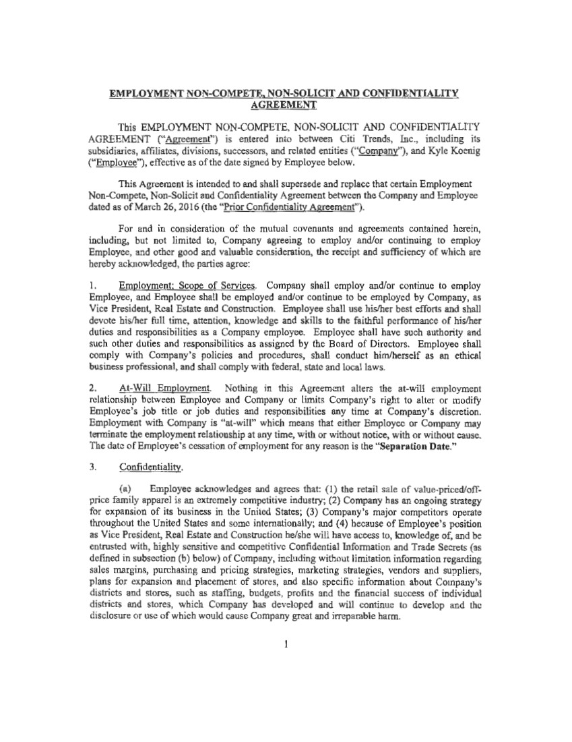 | EMPLOYMENT NON-COMPETE. NON-SOLICIT AND CONFIDENTIALITY AGREEMENT This EMPLOYMENT NON-COMPETE, NON-SOLICIT AND CONFIDENTIALITY AGREEMENT ("Agreement''} is entered into between Citi Trends, Inc., including its subsidiaries, affiliates, divisions, successors, and related entities ("Company"), and Kyle Koenig ("Employee"), effective as of the date signed by Employee below. This Agreement is intended to and shall supersede and replace that certain Employment Non-Compete, Non-Solicit and Confidentiality Agreement between the Company and Employee dated as ofMarch 26, 2016 (the "Prior Confidentiality Agreement''). For and in consideration of the mutual covenants and agreements contained herein, including, but not limited to, Company agreeing to employ and/or continuing to employ Employee, and other good and valuable consideration, the receipt and sufficiency of which are hereby acknowledgeq, the parties agree: l . Employment; Scope of Services. Company shall employ and/or continue to employ Employee, and Employee shall be employed and/or continue to be employed by Company, as Vice President, Real Estate and Construction. Employee shall use his/her best efforts and shall devote his/her full time, attention, knowledge and skills to the faithful performance of his/her duties and responsibilities as a Company employee. Employee shall have such authority and such other duties and responsibilities as assigned by the Board of Directors. Employee shall comply with Company's policies and procedures, shall conduct him/herself as an ethical business professional, and shall comply with federal, state and local laws. 2. At-Will Employment. Nothing in this Agreement alters the at-will employment relationship between Employee and Company or limits Company's right to alter or modify Employee's job title or job duties and responsibilities any time at Company's discretion. Employment with Company is "at-will" which means that either Employee or Company may tenninate the employment relationship at any time, with or without notice, with or without cause. The date of Employee's cessation of employment for any reason is the "Separation Date." 3. Confidentiality. (a) Employee acknowledges and agrees that: (1) the retail sale of value-priced/off-price family apparel is an extremely competitive industry; (2) Company has an ongoing strategy for expansion of its business in the United States; (3) Company's major competitors operate throughout the United States and some internationally; and (4) because of Employee's position as Vice President, Real Estate and Construction be/she will have access to, knowledge of, and be entrusted with, highly sensitive and competitive Confidential lnfonnation and Trade Secrets (as defined in subsection (b) below) of Company, including without limitation infonnation regarding sales margins, purchasing and pricing strategies, marketing strategies, vendors and suppliers, plans for expansion and placement of stores, and also specific infonnation about Company's districts and stores, such as staffing, budgets, profits and the financial success of individual districts and stores, which Company has developed and will continue to develop and the disclosure or use of which would cause Company great and irreparable harm.
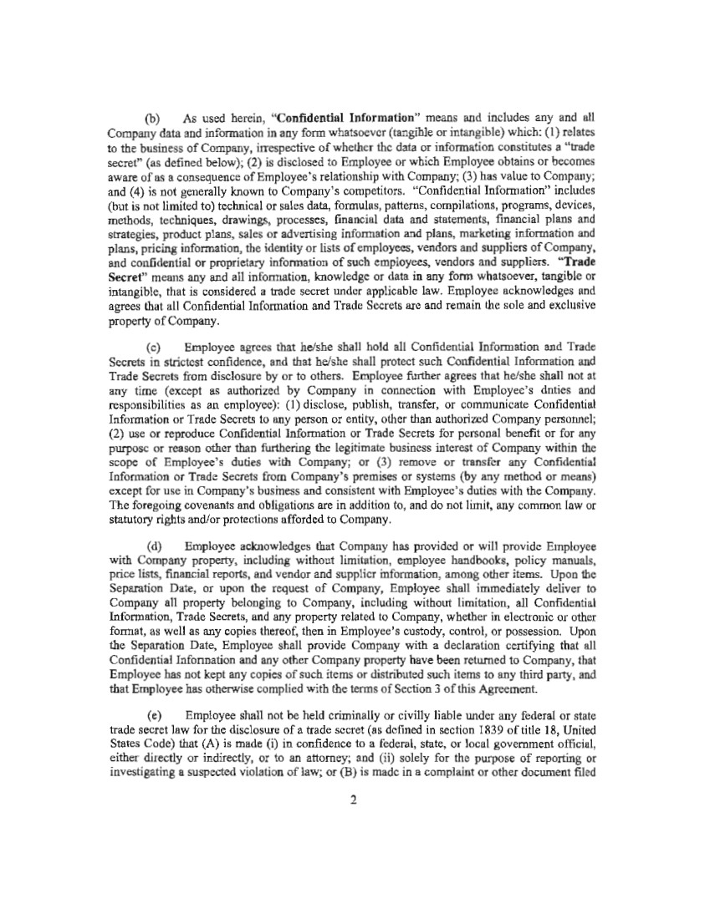 | (b) As used herein, "Confidential Information" means and includes any and all Company data and information in any form whatsoever (tangible or intangible) which: (1) relates to the business of Company, irrespective of whether the data or information constitutes a "trade secret" (as defined below); (2) is disclosed to Employee or which Employee obtains or becomes aware of as a consequence of Employee's relationship with Company; (3) has value to Company; and (4) is not generally known to Company's competitors. "Confidential lnfonnation" includes (but is not limited to) technical or sales data, formulas, patterns, compilations, programs, devices, methods, techniques, drawings, processes, financial data and statements, financial plans and strategies, product plans, sales or advertising information and plans, marketing information and plans, pricing information, the identity or lists of employees, vendors and suppliers of Company, and confidential or proprietary information of such employees, vendors and suppliers. "Trade Secret" means any and all information, knowledge or data in any form whatsoever, tangible or intangible, that is considered a trade secret under applicable law. Employee acknowledges and agrees that all Confidential Information and Trade Secrets are and remain the sole and exclusive property of Company. (c) Employee agrees that he/she shall hold all Confidential Information and Trade Secrets in strictest confidence, and that he/she shall protect such Confidential Information and Trade Secrets from disclosure by or to others. Employee further agrees that he/she shall not at any time (except as authorized by Company in connection with Employee's duties and responsibilities as an employee): (1) disclose, publish, transfer, or communicate Confidential Infonnation or Trade Secrets to any person or entity, other than authorized Company personnel; (2) use or reproduce Confidential lnformation or Trade Secrets for personal benefit or for any purpose or reason other than furthering the legitimate business interest of Company within the scope of Employee's duties with Company; or (3) remove or transfer any Confidential Information or Trade Secrets from Company's premises or systems (by any method or means) except for use in Company's business and consistent with Employee's duties with the Company. The foregoing covenants and obligations are in addition to, and do not limit, any common law or statutory rights and/or protections afforded to Company. (d) Employee acknowledges that Company has provided or will provide Employee with Company property, including without limitation, employee handbooks, policy manuals, price lists, financial reports, and vendor and supplier information, among other items. Upon the Separation Date, or upon the request of Company, Employee shall immediately deliver to Company all property belonging to Company, including without limitation, all Confidential lnfonnation, Trade Secrets, and any property related to Company, whether in electronic or other fom1at, as well as any copies thereof, then in Employee's custody, control, or possession. Upon the Separation Date, Employee shall provide Company with a declaration certifying that all Confidential Infonnation and any other Company property have been returned to Company, that Employee has not kept any copies of such items or distributed such items to any third party, and that Employee has otherwise complied with the tenns of Section 3 of this Agreement. (e) Employee shall not be held criminally or civilly liable W1der any federal or state trade secret law for the disclosure of a trade secret (as defined in section 1839 of title 18, United States Code) that (A) is made (i) in confidence to a federal, state, or local government official, either directly or indirectly, or to an attorney; and (ii) solely for the purpose of reporting or investigating a suspected violation of law; or (B) is made in a complaint or other document filed 2
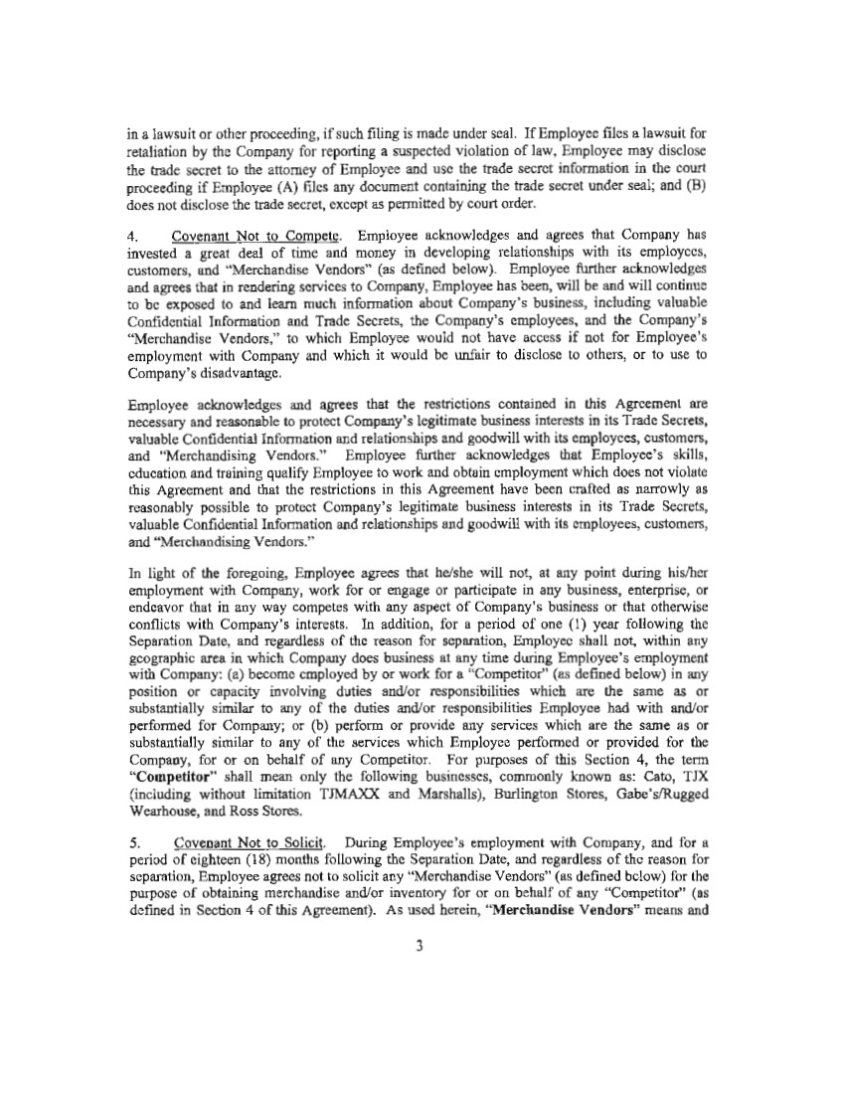 | in a lawsuit or other proceeding, if such filing is made under seal. If Employee files a lawsuit for retaliation by the Company for reporting a suspected violation of law, Employee may disclose the trade secret to the attorney of Employee and use the trade secret information in the court proceeding if Employee (A) files any document containing the trade secret under seal; and (B) does not disclose the trade secret, except as permitted by court order. 4. Covenant Not to Compete. Employee acknowledges and agrees that Company has invested a great deal of time and money in developing relationships with its employees, customers, and "Merchandise Vendors" (as defined below). Employee further acknowledges and agrees that in rendering services to Company, Employee has been, will be and will continue to be exposed to and learn much information about Company's business, including valuable Confidential Information and Trade Secrets, the Company's employees, and the Company's "Merchandise Vendors," to which Employee would not have access if not for Employee's employment with Company and which it would be unfair to disclose to others, or to use to Company's disadvantage. Employee acknowledges and agrees that the restncttons contained in this Agreement are necessary and reasonable to protect Company's legitimate business interests in its Trade Secrets, valuable Confidential Information and relationships and goodwill with its employees, customers, and "Merchandising Vendors." Employee further acknowledges that Employee's skills, education and training qualify Employee to work and obtain employment which does not violate this Agreement and that the restrictions in this Agreement have been crafted as narrowly as reasonably possible to protect Company's legitimate business interests in its Trade Secrets, valuable Confidential Infonnation and relationships and goodwill with its employees, customers, and "Merchandising Vendors.'' In light of the foregoing, Employee agrees that he/she will not, at any point during his/her employment with Company, work for or engage or participate in any business, enterprise, or endeavor that in any way competes with any aspect of Company's business or that otherwise conflicts with Company's interests. In addition, for a period of one (l) year following the Separation Date, and regardless of the reason for separation, Employee shall not, within any geographic area in which Company does business at any time during Employee's employment with Company: (a) become employed by or work for a "Competitor" (as defined below) in any position or capacity involving duties and/or responsibilities which are the same as or substantially similar to any of the duties and/or responsibilities Employee had with and/or performed for Company; or (b) perform or provide any services which are the same as or substantially similar to any of the services which Employee performed or provided for the Company, for or on behalf of any Competitor. For purposes of this Section 4, the tenn "Competitor" shall mean only the following businesses, commonly known as: Cato, TJX (including without limitation TJMAXX and Marshalls), Burlington Stores, Gabe's/Rugged Wearhouse, and Ross Stores. 5. Covenant Not to Solicit. During Employee's employment with Company, and for a period of eighteen (18) months following the Separation Date, and regardless of the reason for separation, Employee agrees not to solicit any "Merchandise Vendors" (as defined below) for the purpose of obtaining merchandise and/or inventory for or on behalf of any "Competitor" (as defined in Section 4 of this Agreement). As used herein, "Merchandise Vendors" means and 3
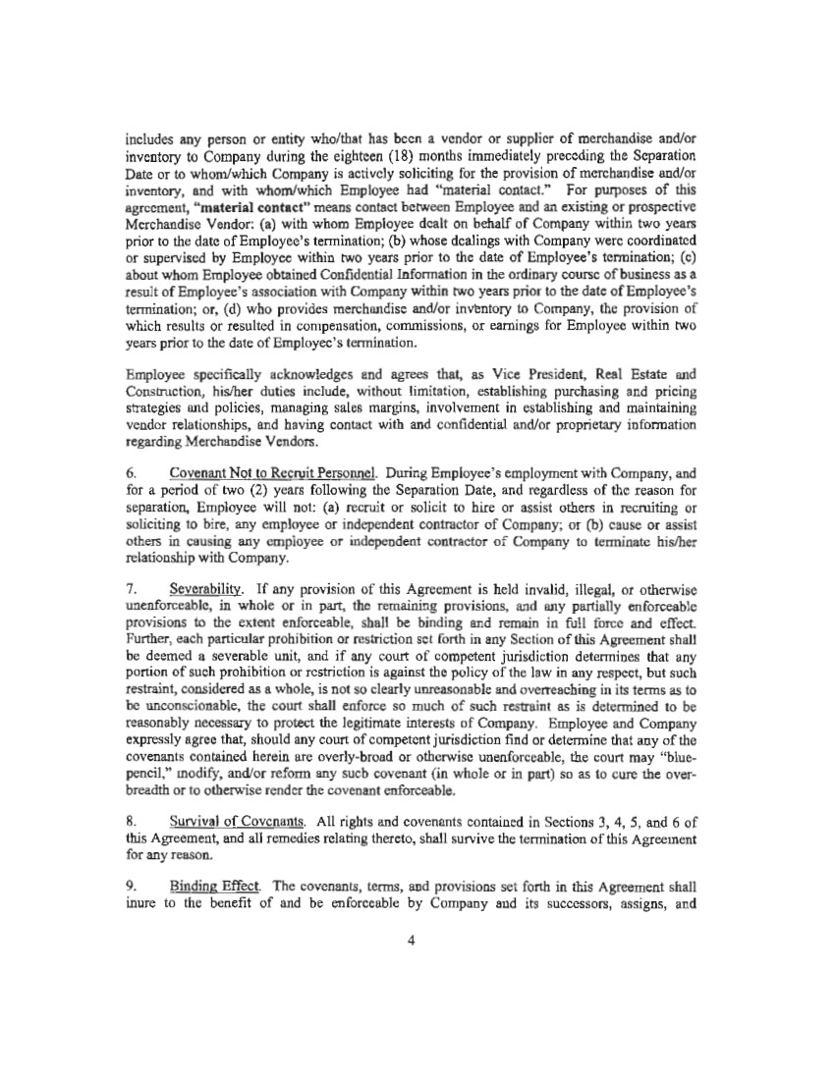 | includes any person or entity who/that has been a vendor or supplier of merchandise and/or inventory to Company during the eighteen (18) months immediately preceding the Separation Date or to whom/which Company is actively soliciting for the provision of merchandise and/or inventory, and with whom/which Employee had "material contact." For purposes of this agreement, "material contact" means contact between Employee and an existing or prospective Merchandise Vendor: (a) with whom Employee dealt on behalf of Company within two years prior to the date of Employee's termination; (b) whose dealings with Company were coordinated or supervised by Employee within two years prior to the date of Employee's termination; (c) about whom Employee obtained Confidential Information in the ordinary course of business as a result of Employee's association with Company within two years prior to the date of Employee's tennination; or, (d) who provides merchandise and/or inventory to Company, the provision of which results or resulted in compensation, commissions, or earnings for Employee within two years prior to the date of Employee's termination. Employee specifically acknowledges and agrees that, as Vice President, Real Estate and Construction, his/her duties include, without limitation, establishing purchasing and pricing strategies and policies, managing sales margins, involvement in establishing and maintaining vendor relationships, and having contact with and confidential and/or proprietary information regarding Merchandise Vendors. 6. Covenant Not to Recruit Personnel. During Employee's employment with Company, and for a period of two (2) years following the Separation Date, and regardless of the reason for separation, Employee will not (a) recruit or solicit to hire or assist others in recruiting or soliciting to hire, any employee or independent contractor of Company; or (b) cause or assist others in causing any employee or independent contractor of Company to terminate his/her relationship with Company. 7. Severability. If any provision of this Agreement is held invalid, illegal, or othetwise unenforceable, in whole or in part, the remaining provisions, and any partially enforceable provisions to the extent enforceable, shall be binding and remain in full force and effect. Further, each particular prohibition or restriction set forth in any Section of this Agreement shall be deemed a severable unit, and if any court of competent jurisdiction detennines that any portion of such prohibition or restriction is against the policy of the law in any respect, but such restraint, considered as a whole, is not so clearly unreasonable and overreaching in its terms as to be unconscionable, the court shall enforce so much of such restraint as is determined to be reasonably necessary to protect the legitimate interests of Company. Employee and Company expressly agree that, should any court of competent jurisdiction find or detennine that any of the covenants contained herein are overly-broad or otherwise unenforceable, the court may "blue-pencil," modify, and/or refonn any such covenant (in whole or in part) so as to cure the over-breadth or to otherwise render the covenant enforceable. 8. Survival of Covenants. All rights and covenants contained in Sections 3, 4, 5, and 6 of this Agreement, and all remedies relating thereto, shall suIVive the termination of this Agreement for any reason. 9. Binding Effect. The covenants, terms, and provisions set forth in this Agreement shall inure to the benefit of and be enforceable by Company and its successors, assigns, and 4
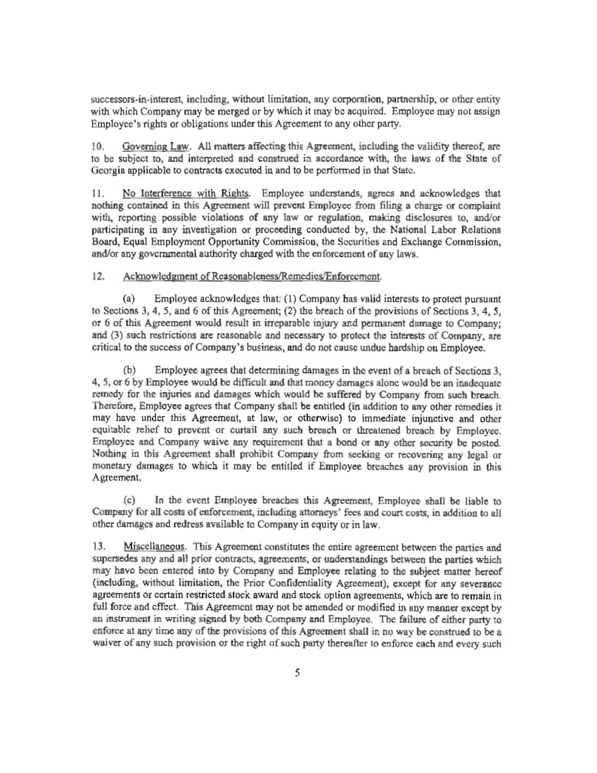 | successors-in-interest, including, without limitation, any corporation, partncrsltip, or other entity with which Company may be merged or by which it may be acquired. Employee may not assign Employee's rights or obligations under this Agreement to any other party. 10. Governing Law. All matters affecting this Agreement, including the validity thereof, are to be subject to, and interpreted and construed in accordance with, the laws of the State of Georgia appl.icable to contracts executed in and to be performed in that State. 11. No Interference with Rights. Employee understands, agrees and acknowledges that nothing contained in this Agreement will prevent Employee from filing a charge or complaint with, reporting possible violations of any law or regulation, making disclosures to, and/or participating in any investigation or proceeding conducted by, the National Labor Relations Board, Equal Employment Opportunity Commission, the Securities and Exchange Commission, and/or any governmental authority charged with the enforcement of any laws. 12. Acknowledgment of Reasonableness/Remedies/Enforcement. (a) Employee acknowledges that: (1) Company has valid interests to protect pursuant to Sections 3, 4, 5, and 6 of this Agreement; (2) the breach of the provisions of Sections 3, 4, S, or 6 of this Agreement would result in irreparable injury and permanent damage to Company; and (3) such restrictions are reasonable and necessary to protect the interests of Company, are critical to the success of Company's business, and do not cause undue hardship on Employee. (b) Employee agrees that detennining damages in the event of a breach of Sections 3, 4, S, or 6 by Employee would be difficult and that money damages alone would be an inadequate remedy for the injuries and damages which would be suffered by Company from such breach. Therefore, Employee agrees that Company shall be entitled (in addition to any other remedies it may have under this Agreement, at law, or otherwise) to immediate injunctive and other equitable relief to prevent or curtail any such breach or threatened breach by Employee. Employee and Company waive any requirement that a bond or any other security be posted. Nothing in this Agreement shall prohibit Company from seeking or recovering any legal or monetary damages to which it may be entitled if Employee breaches any provision in this Agreement. (c) In the event Employee breaches this Agreement, Employee shall be liable to Company for all costs of enforcement, including attorneys' fees and court costs, in addition to all other damages and redress available to Company in equity or in law. 13. Miscellaneous. This Agreement constitutes the entire agreement between the parties and supersedes any and all prior contracts, agreements, or understandings between the parties which may have been entered into by Company and Employee relating to the subject matter hereof (including, without limitation, the Prior Confidentiality Agreement), except for any severance agreements or certain restricted stock award and stock option agreements, which are to remain in full force and effect. This Agreement may not be amended or modi tied in any manner except by an instrument in writing signed by both Company and Employee. The failure of either party to enforce at any time any of the provisions of this Agreement shall in no way be construed to be a waiver of any such provision or the right of such party thereafter to enforce each and every such 5
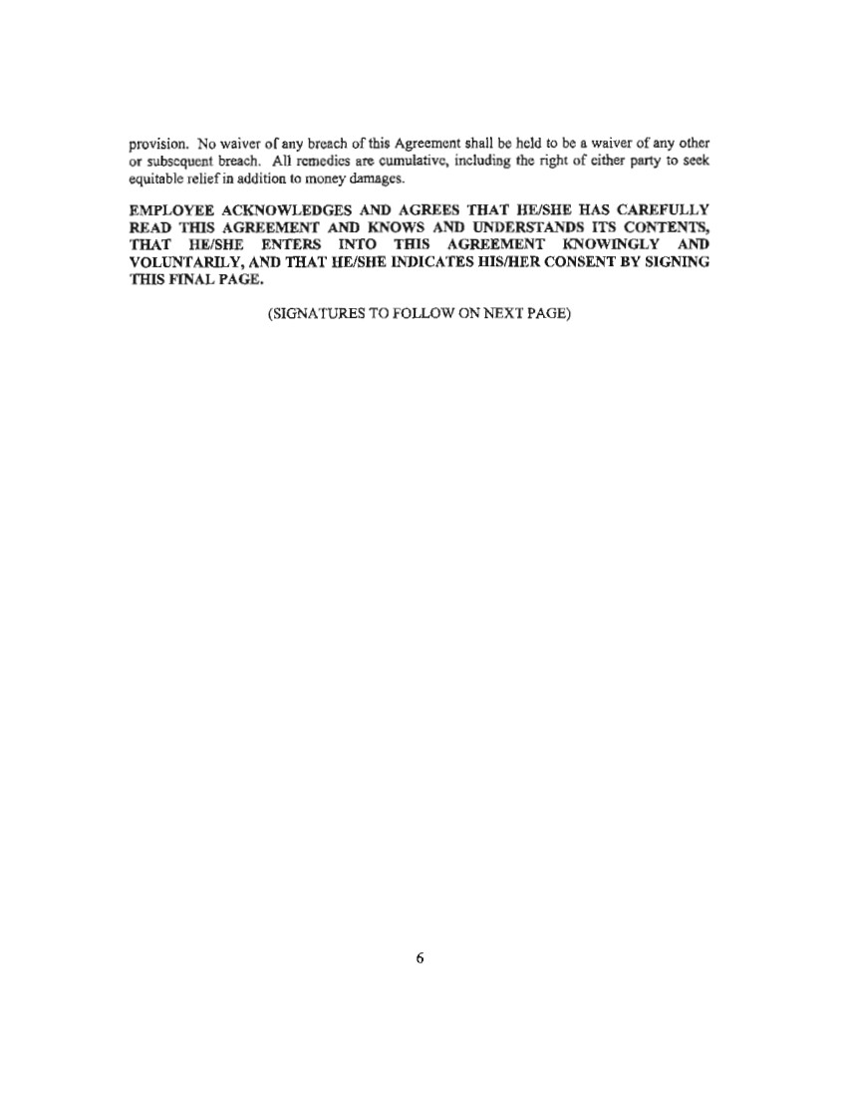 | provision. No waiver of any breach of this Agreement shall be held to be a waiver of any other or subsequent breach. All remedies are cumulative, including the right of either party to seek equitable relief in addition to money damages. EMPLOYEE ACKNOWLEDGES AND AGREES THAT HE/SHE HAS CAREFULLY READ TlllS AGREEMENT AND KNOWS AND UNDERSTANDS ITS CONTENTS, THAT HE/SHE ENTERS INTO THIS AGREEMENT KNOWINGLY AND VOLUNTARILY, AND THAT HE/SHE INDICATES HIS/HER CONSENT BY SIGNING THIS FINAL PAGE. (SIGNATURES TO FOLLOW ON NEXT PAGE) 6
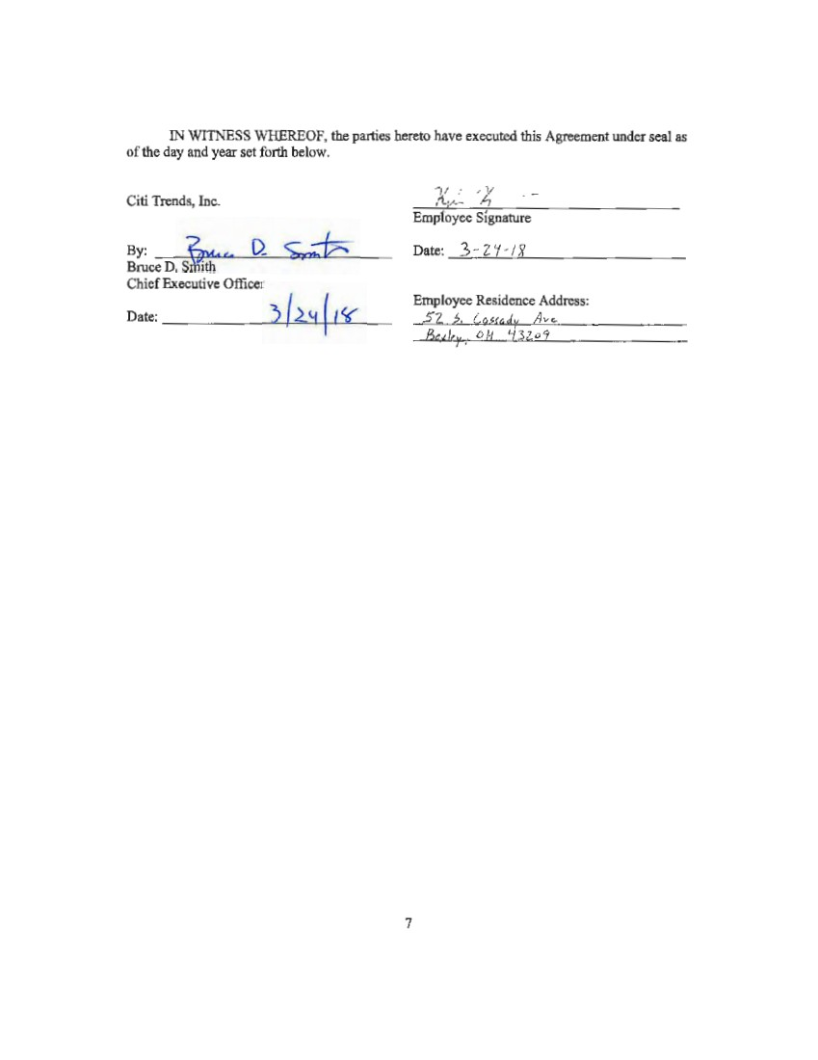 | IN WITNESS WHEREOF, the parties hereto have executed this Agreement under seal as of the day and year set forth below. Citi Trends, Inc. Bruce By: D. Sith ~ d<, D. ~ Chief Executive Officer Date: ) ./2_ t( ( I¥' 7 7(L ~ -- Empfoyec Signature Date: 3 - 2 'C I~ Employee Residence Address: 5Z ~- l1wdu A,,.,.
Exhibit 10.4
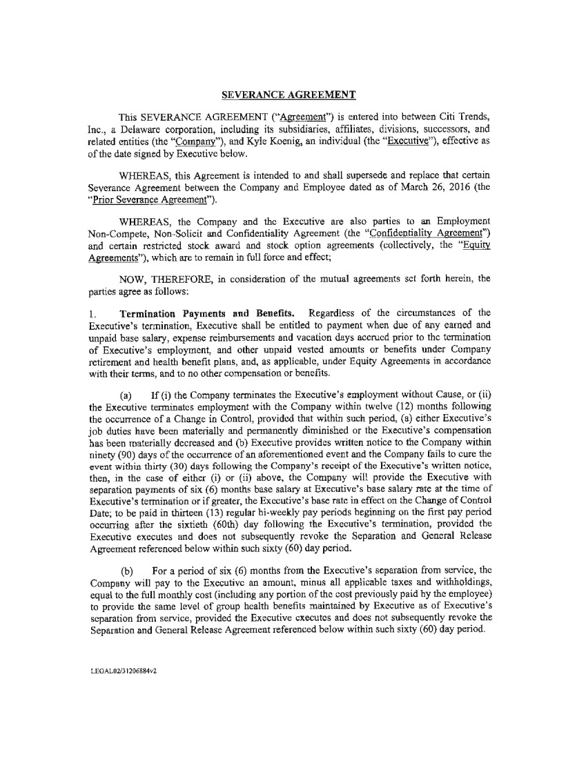 | SEVERANCE AGREEMENT This SEVERANCE AGREEMENT ("Agreement") is entered into between Citi Trends, Inc., a Delaware corporation, including its subsidiaries, affiliates, divisions, successors, and related entities (the ''Company"), and Kyle Koenig, an individual (the "Executive"), effective as of the date signed by Executive below. WHEREAS, this Agreement is intended to and shall supersede and replace that certain Severance Agreement bet:\veen the Company and Employee dated as of March 26, 2016 (the "Prior Severance Agreement"). WHEREAS, the Company and the Executive are also parties to an Employment Non-Compete, Non-Solicit and Confidentiality Agreement (the "Confidentiality Agreement") and certain restricted stock award and stock option agreements ( collectively, the "Equity Agreements"), which are to remain in full force and effect; NOW, THEREFORE, in consideration of the mutual agreements set forth herein, the parties agree as follows: l . Termination Payments and Benefits. Regardless of the circumstances of the Executive's termination, Executive shall be entitled to payment when due of any earned and unpaid base salary, expense reimbursements and vacation days accrued prior to the termination of Executive's employment, and other unpaid vested amounts or benefits under Company retirement and health benefit plans, and, as applicable, under Equity Agreements in accordance with their tenns, and to no other compensation or benefits. (a) If (i) the Company terminates the Executive's employment without Cause, or (ii) the Executive terminates employment with the Company within twelve (12) months following the occurrence of a Change in Control, provided that within such period, (a) either Executive's job duties have been materially and permanently diminished or the Executive's compensation has been materially decreased and (b) Executive provides written notice to the Company within ninety (90) days of the occurrence of an aforementioned event and the Company fails to cure the event within thirty (30) days following the Company's receipt of the Executive's written notice, then, in the case of either (i) or (ii) above, the Company will provide the Executive with separation payments of six (6) months base salary at Executive's base salary rate at the time of Executive's termination or if greater, the Executive's base rate in effect on the Change of Control Date; to be paid in thirteen (13) regular bi•weekly pay periods beginning on the first pay period occurring after the sixtieth (60th) day following the Executive's termination, provided the Executive executes and does not subsequently revoke the Separation and General Release Agreement referenced below within such sixty (60) day period. (b) For a period of six (6) months from the Executive's separation from service, the Company will pay to the Executive an amount, minus all applicable taxes and withholdings, equal to the full monthly cost (including any portion of the cost previously paid by the employee) to provide the same level of group health benefits maintained by Executive as of Executive's separation from service, provided the Executive executes and does not subsequently revoke the Separation and General Release Agreement referenced below within such sixty ( 60) day period. LEGAL02/31206884v2
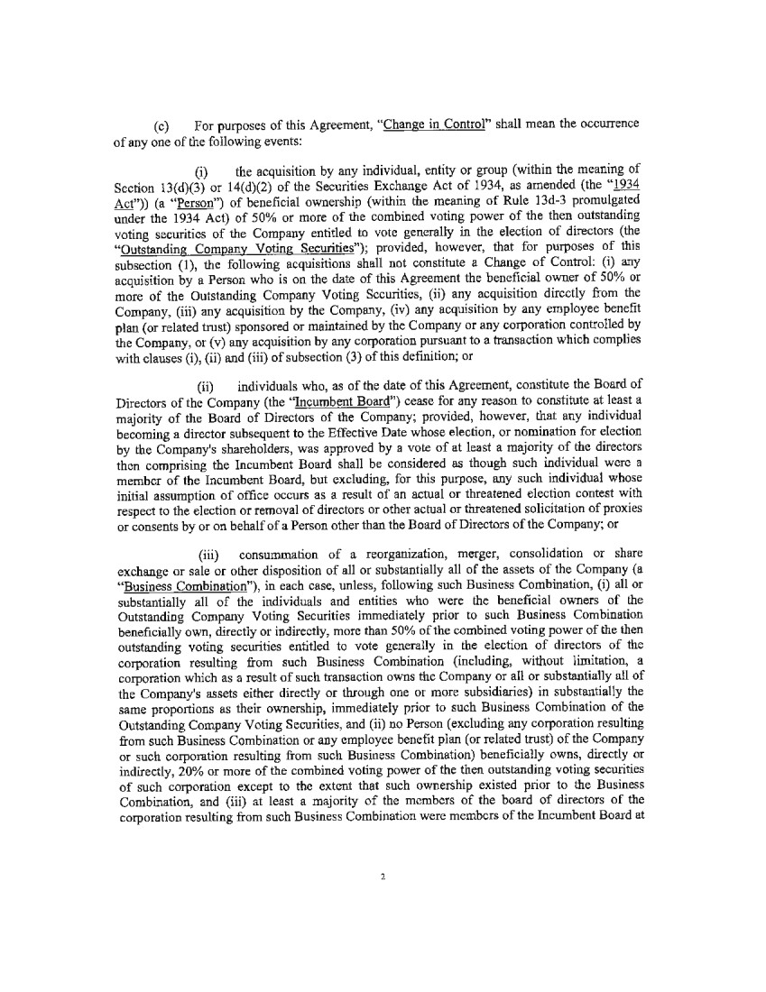 | (c) For purposes of this Agreement, "Change in Control" shall mean the occurrence of any one of the following events: (i) the acquisition by any individual, entity or group (within the meaning of Section 13(d)(3) or 14(d)(2) of the Securities Exchange Act of 1934, as amended (the "1934 Act")) (a "Person") of beneficial ownership (within the meaning of Rule 13d-3 promulgated under the 1934 Act) of 50% or more of the combined voting power of the then outstanding voting securities of the Company entitled to vote generally in the election of directors (the "Outstanding Company Voting Securities"); provided, however, that for purposes of this subsection (I), the following acquisitions shall not constitute a Change of Control: (i) any acquisition by a Person who is on the date of this Agreement the beneficial owner of 50% or more of the Outstanding Company Voting Securities, (ii) any acquisition directly from the Company, (iii) any acquisition by the Company, (iv) any acquisition by any employee benefit plan (or related trust) sponsored or maintained by the Company or any corporation controlled by the Company, or (v) any acquisition by any corporation pursuant to a transaction which complies with clauses (i), (ii) and (iii) of subsection (3) of this definition; or (ii) individuals who, as of the date of this Agreement, constitute the Board of Directors of the Company (the "Incumbent Board") cease for any reason to constitute at least a majority of the Board of Directors of the Company; provided, however, that any individual becoming a director subsequent to the Effective Date whose election, or nomination for election by the Company's shareholders, was approved by a vote of at least a majority of the directors then comprising the Incumbent Board shall be considered as though such individual were a member of the Incumbent Board, but excluding, for this purpose, any such individual whose initial assumption of office occurs as a result of an actual or threatened election contest with respect to the election or removal of directors or other actual or threatened solicitation of proxies or consents by or on behalf of a Person other than the Board of Directors of the Company; or (iii) consummation of a reorganization, merger, consolidation or share exchange or sale or other disposition of all or substantially all of the assets of the Company (a "Business Combination"), in each case, unless, following such Business Combination, (i) all or substantially all of the individuals and entities who were the beneficial owners of the Outstanding Company Voting Securities immediately prior to such Business Combination beneficially own, directly or indirectly, more than 50% of the combined voting power of the then outstanding voting securities entitled to vote generally in the election of directors of the corporation resulting from such Business Combination (including, without limitation, a corporation which as a result of such transaction owns the Company or all or substantially all of the Company's assets either directly or through one or more subsidiaries) in substantially the same proportions as their ownership, immediately prior to such Business Combination of the Outstanding Company Voting Securities, and (ii) no Person ( excluding any corporation resulting from such Business Combination or any employee benefit plan ( or related trust) of the Company or such corporation resulting from such Business Combination) beneficially owns, directly or indirectly, 20% or more of the combined voting power of the then outstanding voting securities of such corporation except to the extent that such ownership existed prior to the Business Combination, and (iii) at least a majority of the members of the board of directors of the corporation resulting from such Business Combination were members of the Incumbent Board at 2
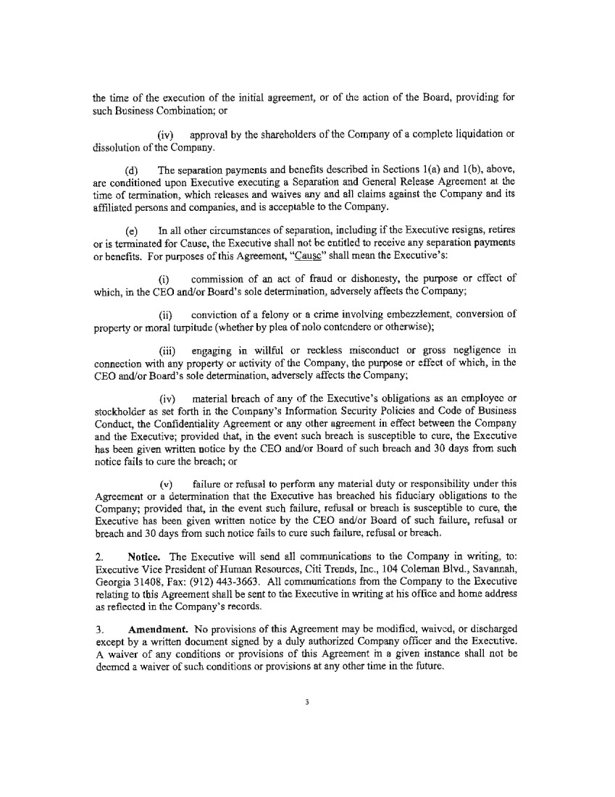 | the time of the execution of the initial agreement, or of the action of the Board, providing for such Business Combination; or (iv) approval by the shareholders of the Company of a complete liquidation or dissolution of the Company. (d) The separation payments and benefits described in Sections l(a) and l(b), above, are conditioned upon Executive executing a Separation and General Release Agreement at the time of termination, which releases and waives any and all claims against the Company and its affiliated persons and companies, and is acceptable to the Company. ( e) In all other circumstances of separation, including if the Executive resigns, retires or is terminated for Cause, the Executive shall not be entitled to receive any separation payments or benefits. For purposes of this Agreement, "Cause" shall mean the Executive's: (i) commission of an act of fraud or dishonesty, the purpose or effect of which, in the CEO and/or Board's sole determination, adversely affects the Company; (ii) conviction of a felony or a crime involving embezzlement, conversion of property or moral turpitude ( whether by plea of nolo contend ere or otherwise); (iii) engaging in willful or reckless misconduct or gross negligence in connection with any property or activity of the Company, the purpose or effect of which, in the CEO and/or Board's sole determination, adversely affects the Company; (iv) material breach of any of the Executive's obligations as an employee or stockholder as set forth in the Company's Information Security Policies and Code of Business Conduct, the Confidentiality Agreement or any other agreement in effect between the Company and the Executive; provided that, in the event such breach is susceptible to cure, the Executive has been given written notice by the CEO and/or Board of such breach and 30 days from such notice fails to cure the breach; or (v) failure or refusal to perform any material duty or responsibility under this Agreement or a detennination that the Executive has breached his fiduciary obligations to the Company; provided that, in the event such failure, refusal or breach is susceptible to cure, the Executive has been given written notice by the CEO and/or Board of such failure, refusal or breach and 30 days from such notice fails to cure such failure, refusal or breach. 2. Notice. The Executive will send all communications to the Company in writing, to: Executive Vice President of Human Resources, Citi Trends, Inc., 104 Coleman Blvd., Savannah, Georgia 31408, Fax: (912) 443-3663. All communications from the Company to the Executive relating to this Agreement shall be sent to the Executive in writing at his office and home address as reflected in the Company's records. 3. Amendment. No provisions of this Agreement may be modified, waived, or discharged except by a written document signed by a duly authorized Company officer and the Executive. A waiver of any conditions or provisions of this Agreement in a given instance shall not be deemed a waiver of such conditions or provisions at any other time in the future. 3
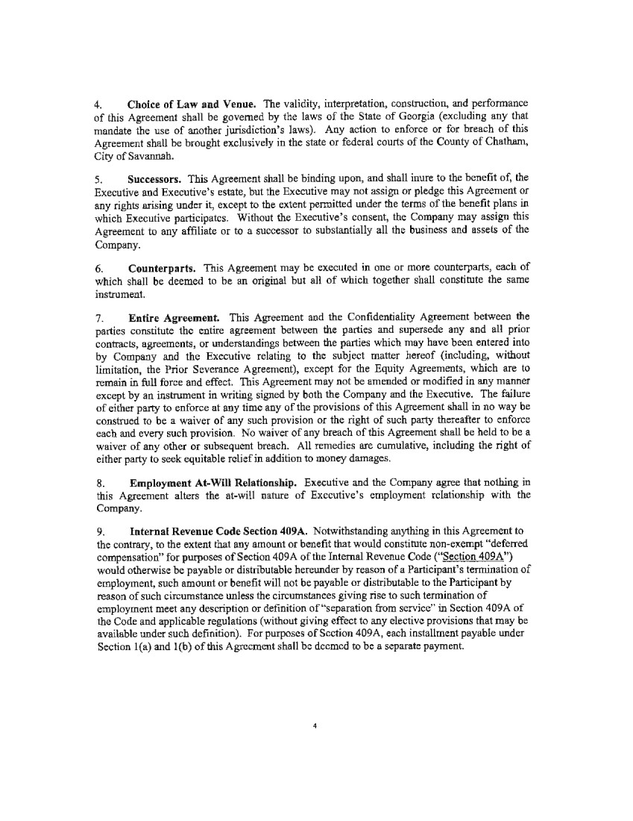 | 4. Choice of Law and Venue. The validity, interpretation, construction, and performance of this Agreement shall be governed by the laws of the State of Georgia ( excluding any that mandate the use of another jurisdiction's laws). Any action to enforce or for breach of this Agreement shall be brought exclusively in the state or federal courts of the County of Chatham, City of Savannah. 5. Successors. This Agreement shall be binding upon, and shall inure to the benefit of, the Executive and Executive's estate, but the Executive may not assign or pledge this Agreement or any rights arising under it, except to the extent permitted under the terms of the benefit plans in which Executive participates. Without the Executive's consent, the Company may assign this Agreement to any affiliate or to a successor to substantially all the business and assets of the Company. 6. Counterparts. This Agreement may be executed in one or more counterparts, each of which shall be deemed to be an original but all of which together shall constirute the same instrument. 7. Entire Agreement. This Agreement and the Confidentiality Agreement between the parties constitute the entire agreement between the parties and supersede any and all prior contracts, agreements, or understandings between the parties which may have been entered into by Company and the Executive relating to the subject matter hereof (including, without limitation, the Prior Severance Agreement), except for the Equity Agreements, which are to remain in full force and effect. This Agreement may not be amended or modified in any manner except by an instrument in writing signed by both the Company and the Executive. The failure of either party to enforce at any time any of the provisions of this Agreement shall in no way be construed to be a waiver of any such provision or the right of such party thereafter to enforce each and every such provision. No waiver of any breach of this Agreeme11t shall be held to be a waiver of any other or subsequent breach. All remedies are cumulative, including the right of either party to seek equitable relief in addition to money damages. 8. Employment At-Will Relationship. Executive and the Company agree that nothing in this Agreement alters the at-will nature of Executive's employment relationship with the Company. 9. Internal Revenue Code Section 409A. Notwithstanding anything in this Agreement to the contrary, to the extent that any amount or benefit that would constitute non-exempt "deferred compensation" for purposes of Section 409A of the Internal Revenue Code ("Section 409A") would otherwise be payable or distributable hereunder by reason of a Participant's termination of employment, such amount or benefit will not be payable or distributable to the Participant by reason of such circumstance unless the circumstances giving rise to such termination of employment meet any description or definition of"separation from service" in Section 409A of the Code and applicable regulations (without giving effect to any elective provisions that may be available under such definition). For purposes of Section 409A, each installment payable under Section l{a) and l(b) of this Agreement shall be deemed to be a separate payment. 4
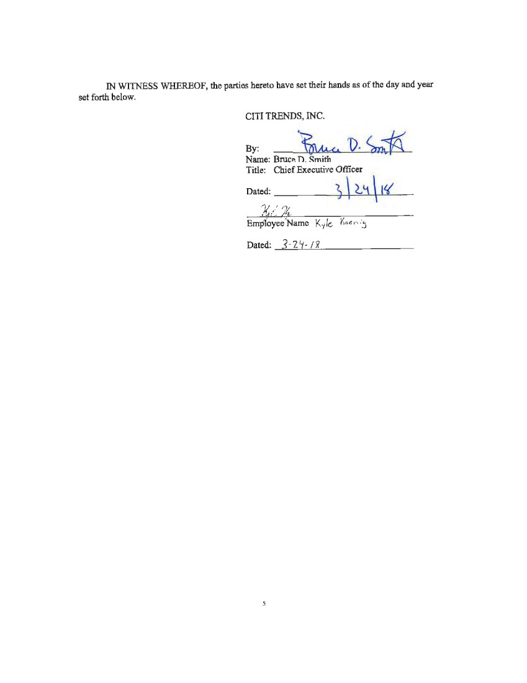 | IN WITNESS WHEREOF, the parties hereto have set their hands as of the day and year set forth below. CITI TRENDS, INC. By Name: : Bruce • D. ~M/4 Smith 1). ~ Title: Chief Executive Officer Dated: ) \ ~ j ~ I{ XI%.- ,-- Employee Name l<yfc:. l<oe."'•j Dated: 3- 211- I 'i 5
EMPLOYMENT NON-COMPETE, NON-SOLICIT AND CONFIDENTIALITY AGREEMENT
This Employment Non-Compete, Non-Solicit and Confidentiality Agreement (“Agreement”) is entered into between Citi Trends, Inc., including its subsidiaries, affiliates, divisions, successors, and related entities (“Company”), and Katrina George (“Employee”), effective as of the date signed by Employee below.
For and in consideration of the mutual covenants and agreements contained herein, including, but not limited to, Company agreeing to employ and/or continuing to employ Employee, and other good and valuable consideration, the receipt and sufficiency of which are hereby acknowledged, the parties agree:
1.Employment; Scope of Services. Company shall employ and/or continue to employ Employee, and Employee shall be employed and/or continue to be employed by Company, as Vice President, Human Resources. Employee shall use his/her best efforts and shall devote his/her full time, attention, knowledge and skills to the faithful performance of his/her duties and responsibilities as a Company employee. Employee shall have such authority and such other duties and responsibilities as assigned by the Board of Directors. Employee shall comply with Company’s policies and procedures, shall conduct him/herself as an ethical business professional, and shall comply with federal, state and local laws.
2.At-Will Employment. Nothing in this Agreement alters the at-will employment relationship between Employee and Company or limits Company’s right to alter or modify Employee’s job title or job duties and responsibilities any time at Company’s discretion. Employment with Company is “at-will” which means that either Employee or Company may terminate the employment relationship at any time, with or without notice, with or without cause. The date of Employee’s cessation of employment for any reason is the “Separation Date.”
3.Confidentiality.
(a)Employee acknowledges and agrees that: (1) the retail sale of value-priced/off-price family apparel is an extremely competitive industry; (2) Company has an ongoing strategy for expansion of its business in the United States; (3) Company’s major competitors operate throughout the United States and some internationally; and (4) because of Employee’s position as Vice President, Human Resources he/she will have access to, knowledge of, and be entrusted with, highly sensitive and competitive Confidential Information and Trade Secrets (as defined in subsection (b) below) of Company, including without limitation information regarding sales margins, purchasing and pricing strategies, marketing strategies, vendors and suppliers, plans for expansion and placement of stores, and also specific information about Company’s districts and stores, such as staffing, budgets, profits and the financial success of individual districts and stores, which Company has developed and will continue to develop and the disclosure or use of which would cause Company great and irreparable harm.
(b)As used herein, “Confidential Information” means and includes any and all Company data and information in any form whatsoever (tangible or intangible) which: (1) relates to the business of Company, irrespective of whether the data or information constitutes a “trade
1Initials ______
‌

secret” (as defined below); (2) is disclosed to Employee or which Employee obtains or becomes aware of as a consequence of Employee’s relationship with Company; (3) has value to Company; and (4) is not generally known to Company’s competitors. “Confidential Information” includes (but is not limited to) technical or sales data, formulas, patterns, compilations, programs, devices, methods, techniques, drawings, processes, financial data and statements, financial plans and strategies, product plans, sales or advertising information and plans, marketing information and plans, pricing information, the identity or lists of employees, vendors and suppliers of Company, and confidential or proprietary information of such employees, vendors and suppliers. “Trade Secret” means any and all information, knowledge or data in any form whatsoever, tangible or intangible, that is considered a trade secret under applicable law. Employee acknowledges and agrees that all Confidential Information and Trade Secrets are and remain the sole and exclusive property of Company.
(c)Employee agrees that he/she shall hold all Confidential Information and Trade Secrets in strictest confidence, and that he/she shall protect such Confidential Information and Trade Secrets from disclosure by or to others. Employee further agrees that he/she shall not at any time (except as authorized by Company in connection with Employee’s duties and responsibilities as an employee): (1) disclose, publish, transfer, or communicate Confidential Information or Trade Secrets to any person or entity, other than authorized Company personnel; (2) use or reproduce Confidential Information or Trade Secrets for personal benefit or for any purpose or reason other than furthering the legitimate business interest of Company within the scope of Employee’s duties with Company; or (3) remove or transfer any Confidential Information or Trade Secrets from Company’s premises or systems (by any method or means) except for use in Company’s business and consistent with Employee’s duties with the Company. The foregoing covenants and obligations are in addition to, and do not limit, any common law or statutory rights and/or protections afforded to Company.
(d)Employee acknowledges that Company has provided or will provide Employee with Company property, including without limitation, employee handbooks, policy manuals, price lists, financial reports, and vendor and supplier information, among other items. Upon the Separation Date, or upon the request of Company, Employee shall immediately deliver to Company all property belonging to Company, including without limitation, all Confidential Information, Trade Secrets, and any property related to Company, whether in electronic or other format, as well as any copies thereof, then in Employee’s custody, control, or possession. Upon the Separation Date, Employee shall provide Company with a declaration certifying that all Confidential Information and any other Company property have been returned to Company, that Employee has not kept any copies of such items or distributed such items to any third party, and that Employee has otherwise complied with the terms of Section 3 of this Agreement.
(e)Employee shall not be held criminally or civilly liable under any federal or state trade secret law for the disclosure of a trade secret (as defined in section 1839 of title 18, United States Code) that (A) is made (i) in confidence to a federal, state, or local government official, either directly or indirectly, or to an attorney; and (ii) solely for the purpose of reporting or investigating a suspected violation of law; or (B) is made in a complaint or other document filed in a lawsuit or other proceeding, if such filing is made under seal. If Employee files a lawsuit for retaliation by the Company for reporting a suspected violation of law, Employee may disclose the trade secret to the attorney of Employee and use the trade secret information in the court
2Initials ______
‌

proceeding if Employee (A) files any document containing the trade secret under seal; and (B) does not disclose the trade secret, except as permitted by court order.
4.Covenant Not to Compete. Employee acknowledges and agrees that Company has invested a great deal of time and money in developing relationships with its employees, customers, and “Merchandise Vendors” (as defined below). Employee further acknowledges and agrees that in rendering services to Company, Employee has been, will be and will continue to be exposed to and learn much information about Company’s business, including valuable Confidential Information and Trade Secrets, the Company’s employees, and the Company’s “Merchandise Vendors,” to which Employee would not have access if not for Employee’s employment with Company and which it would be unfair to disclose to others, or to use to Company’s disadvantage.
Employee acknowledges and agrees that the restrictions contained in this Agreement are necessary and reasonable to protect Company’s legitimate business interests in its Trade Secrets, valuable Confidential Information and relationships and goodwill with its employees, customers, and “Merchandising Vendors.” Employee further acknowledges that Employee’s skills, education and training qualify Employee to work and obtain employment which does not violate this Agreement and that the restrictions in this Agreement have been crafted as narrowly as reasonably possible to protect Company’s legitimate business interests in its Trade Secrets, valuable Confidential Information and relationships and goodwill with its employees, customers, and “Merchandising Vendors.”
In light of the foregoing, Employee agrees that he/she will not, at any point during his/her employment with Company, work for or engage or participate in any business, enterprise, or endeavor that in any way competes with any aspect of Company’s business or that otherwise conflicts with Company’s interests. In addition, for a period of one (1) year following the Separation Date, and regardless of the reason for separation, Employee shall not, within any geographic area in which Company does business at any time during Employee’s employment with Company: (a) become employed by or work for a “Competitor” (as defined below) in any position or capacity involving duties and/or responsibilities which are the same as or substantially similar to any of the duties and/or responsibilities Employee had with and/or performed for Company; or (b) perform or provide any services which are the same as or substantially similar to any of the services which Employee performed or provided for the Company, for or on behalf of any Competitor. For purposes of this Section 4, the term “Competitor” shall mean only the following businesses, commonly known as: Cato, TJX (including without limitation TJMAXX and Marshalls), Burlington Stores, Gabe’s/Rugged Wearhouse, and Ross Stores.
5.Covenant Not to Solicit. During Employee’s employment with Company, and for a period of eighteen (18) months following the Separation Date, and regardless of the reason for separation, Employee agrees not to solicit any “Merchandise Vendors” (as defined below) for the purpose of obtaining merchandise and/or inventory for or on behalf of any “Competitor” (as defined in Section 4 of this Agreement). As used herein, “Merchandise Vendors” means and includes any person or entity who/that has been a vendor or supplier of merchandise and/or inventory to Company during the eighteen (18) months immediately preceding the Separation Date or to whom/which Company is actively soliciting for the provision of merchandise and/or inventory, and with whom/which Employee had “material contact.” For purposes of this agreement, “material contact” means contact between Employee and an existing or prospective Merchandise
3Initials ______
‌

Vendor: (a) with whom Employee dealt on behalf of Company within two years prior to the date of Employee’s termination; (b) whose dealings with Company were coordinated or supervised by Employee within two years prior to the date of Employee’s termination; (c) about whom Employee obtained Confidential Information in the ordinary course of business as a result of Employee’s association with Company within two years prior to the date of Employee’s termination; or, (d) who provides merchandise and/or inventory to Company, the provision of which results or resulted in compensation, commissions, or earnings for Employee within two years prior to the date of Employee’s termination.
6.Covenant Not to Recruit Personnel. During Employee’s employment with Company, and for a period of two (2) years following the Separation Date, and regardless of the reason for separation, Employee will not: (a) recruit or solicit to hire or assist others in recruiting or soliciting to hire, any employee or independent contractor of Company; or (b) cause or assist others in causing any employee or independent contractor of Company to terminate his/her relationship with Company.
7.Severability. If any provision of this Agreement is held invalid, illegal, or otherwise unenforceable, in whole or in part, the remaining provisions, and any partially enforceable provisions to the extent enforceable, shall be binding and remain in full force and effect. Further, each particular prohibition or restriction set forth in any Section of this Agreement shall be deemed a severable unit, and if any court of competent jurisdiction determines that any portion of such prohibition or restriction is against the policy of the law in any respect, but such restraint, considered as a whole, is not so clearly unreasonable and overreaching in its terms as to be unconscionable, the court shall enforce so much of such restraint as is determined to be reasonably necessary to protect the legitimate interests of Company. Employee and Company expressly agree that, should any court of competent jurisdiction find or determine that any of the covenants contained herein are overly-broad or otherwise unenforceable, the court may “blue-pencil,” modify, and/or reform any such covenant (in whole or in part) so as to cure the over-breadth or to otherwise render the covenant enforceable.
8.Survival of Covenants. All rights and covenants contained in Sections 3, 4, 5, and 6 of this Agreement, and all remedies relating thereto, shall survive the termination of this Agreement for any reason.
9.Binding Effect. The covenants, terms, and provisions set forth in this Agreement shall inure to the benefit of and be enforceable by Company and its successors, assigns, and successors-in-interest, including, without limitation, any corporation, partnership, or other entity with which Company may be merged or by which it may be acquired. Employee may not assign Employee’s rights or obligations under this Agreement to any other party.
10.Governing Law. All matters affecting this Agreement, including the validity thereof, are to be subject to, and interpreted and construed in accordance with, the laws of the State of Georgia applicable to contracts executed in and to be performed in that State.
11.No Interference with Rights. Employee understands, agrees and acknowledges that nothing contained in this Agreement will prevent Employee from filing a charge or complaint with, reporting possible violations of any law or regulation, making disclosures to, and/or
4Initials ______
‌

participating in any investigation or proceeding conducted by, the National Labor Relations Board, Equal Employment Opportunity Commission, the Securities and Exchange Commission, and/or any governmental authority charged with the enforcement of any laws.
12.Acknowledgment of Reasonableness/Remedies/Enforcement.
(a)Employee acknowledges that: (1) Company has valid interests to protect pursuant to Sections 3, 4, 5, and 6 of this Agreement; (2) the breach of the provisions of Sections 3, 4, 5, or 6 of this Agreement would result in irreparable injury and permanent damage to Company; and (3) such restrictions are reasonable and necessary to protect the interests of Company, are critical to the success of Company’s business, and do not cause undue hardship on Employee.
(b)Employee agrees that determining damages in the event of a breach of Sections 3, 4, 5, or 6 by Employee would be difficult and that money damages alone would be an inadequate remedy for the injuries and damages which would be suffered by Company from such breach. Therefore, Employee agrees that Company shall be entitled (in addition to any other remedies it may have under this Agreement, at law, or otherwise) to immediate injunctive and other equitable relief to prevent or curtail any such breach or threatened breach by Employee. Employee and Company waive any requirement that a bond or any other security be posted. Nothing in this Agreement shall prohibit Company from seeking or recovering any legal or monetary damages to which it may be entitled if Employee breaches any provision in this Agreement.
(c)In the event Employee breaches this Agreement, Employee shall be liable to Company for all costs of enforcement, including attorneys’ fees and court costs, in addition to all other damages and redress available to Company in equity or in law.
13.Miscellaneous. This Agreement constitutes the entire agreement between the parties and supersedes any and all prior contracts, agreements, or understandings between the parties which may have been entered into by Company and Employee relating to the subject matter hereof (including, without limitation, the Prior Confidentiality Agreement), except for any severance agreements or certain restricted stock award and stock option agreements, which are to remain in full force and effect. This Agreement may not be amended or modified in any manner except by an instrument in writing signed by both Company and Employee. The failure of either party to enforce at any time any of the provisions of this Agreement shall in no way be construed to be a waiver of any such provision or the right of such party thereafter to enforce each and every such provision. No waiver of any breach of this Agreement shall be held to be a waiver of any other or subsequent breach. All remedies are cumulative, including the right of either party to seek equitable relief in addition to money damages.
​
​
EMPLOYEE ACKNOWLEDGES AND AGREES THAT HE/SHE HAS CAREFULLY READ THIS AGREEMENT AND KNOWS AND UNDERSTANDS ITS CONTENTS, THAT HE/SHE ENTERS INTO THIS AGREEMENT KNOWINGLY AND VOLUNTARILY, AND THAT HE/SHE INDICATES HIS/HER CONSENT BY SIGNING THIS FINAL PAGE.
5Initials ______
‌

​
​
​
​
IN WITNESS WHEREOF, the parties hereto have executed this Agreement under seal as of the day and year set forth below.
​
​  ​  ​  ​  ​  ​  ​  ​  ​ | ​  ​  ​  ​  ​  ​  ​  ​  ​  ​  ​  ​  ​
Citi Trends, Inc.  ​  ​  ​  By: /s/ Kenneth Seipel  Kenneth Seipel  Chief Executive Officer (Interim)  ​  Date: September 6, 2024 | /s/ Katrina George  Katrina George  (Employee Signature)  ​  Date: September 6, 2024  ​  Employee Residence Address:  ​  ______________________________________  ​  ______________________________________  ​  ______________________________________
​
​
​
​
​

​
6Initials ______
‌

SEVERANCE AGREEMENT
This SEVERANCE AGREEMENT (“Agreement”) is entered into between Citi Trends, Inc., a Delaware corporation, including its subsidiaries, affiliates, divisions, successors, and related entities (the “Company”), and Katrina George, an individual (the “Executive”), effective as of the date signed by Executive below.
WHEREAS, the Company and the Executive are also parties to an Employment Non-Compete, Non-Solicit and Confidentiality Agreement (the “Confidentiality Agreement”) and certain restricted stock award and stock option agreements (collectively, the “Equity Agreements”), which are to remain in full force and effect;
NOW, THEREFORE, in consideration of the mutual agreements set forth herein, the parties agree as follows:
1.Termination Payments and Benefits. Regardless of the circumstances of the Executive’s termination, Executive shall be entitled to payment when due of any earned and unpaid base salary, expense reimbursements and vacation days accrued prior to the termination of Executive’s employment, and other unpaid vested amounts or benefits under Company retirement and health benefit plans, and, as applicable, under Equity Agreements in accordance with their terms, and to no other compensation or benefits.
(a)If (i) the Company terminates the Executive’s employment without Cause, or (ii) the Executive terminates employment with the Company within twelve (12) months following the occurrence of a Change in Control, provided that within such period, (a) either Executive’s job duties have been materially and permanently diminished or the Executive’s compensation has been materially decreased and (b) Executive provides written notice to the Company within ninety (90) days of the occurrence of an aforementioned event and the Company fails to cure the event within thirty (30) days following the Company’s receipt of the Executive’s written notice, then, in the case of either (i) or (ii) above, the Company will provide the Executive with separation payments of six (6) months base salary at Executive’s base salary rate at the time of Executive’s termination or if greater, the Executive’s base rate in effect on the Change of Control Date; to be paid in thirteen (13) regular bi-weekly pay periods beginning on the first pay period occurring after the thirtieth (30th) day following the Executive’s termination, provided the Executive executes and does not subsequently revoke the Separation and General Release Agreement referenced below within such sixty (60) day period.
(b)For a period of six (6) months from the Executive’s separation from service, the Company will pay to the Executive an amount, minus all applicable taxes and withholdings, equal to the full monthly cost (including any portion of the cost previously paid by the employee) to provide the same level of group health benefits maintained by Executive as of Executive’s separation from service, provided the Executive executes and does not subsequently revoke the Separation and General Release Agreement referenced below within such thirty (30) day period.
(c)For purposes of this Agreement, “Change in Control” shall mean the occurrence of any one of the following events:
LEGAL02/31206884v2 Initials _______

(i)the acquisition by any individual, entity or group (within the meaning of Section 13(d)(3) or 14(d)(2) of the Securities Exchange Act of 1934, as amended (the “1934 Act”)) (a “Person”) of beneficial ownership (within the meaning of Rule 13d-3 promulgated under the 1934 Act) of 50% or more of the combined voting power of the then outstanding voting securities of the Company entitled to vote generally in the election of directors (the “Outstanding Company Voting Securities”); provided, however, that for purposes of this subsection (1), the following acquisitions shall not constitute a Change of Control: (i) any acquisition by a Person who is on the date of this Agreement the beneficial owner of 50% or more of the Outstanding Company Voting Securities, (ii) any acquisition directly from the Company, (iii) any acquisition by the Company, (iv) any acquisition by any employee benefit plan (or related trust) sponsored or maintained by the Company or any corporation controlled by the Company, or (v) any acquisition by any corporation pursuant to a transaction which complies with clauses (i), (ii) and (iii) of subsection (3) of this definition; or
(ii)individuals who, as of the date of this Agreement, constitute the Board of Directors of the Company (the “Incumbent Board”) cease for any reason to constitute at least a majority of the Board of Directors of the Company; provided, however, that any individual becoming a director subsequent to the Effective Date whose election, or nomination for election by the Company's shareholders, was approved by a vote of at least a majority of the directors then comprising the Incumbent Board shall be considered as though such individual were a member of the Incumbent Board, but excluding, for this purpose, any such individual whose initial assumption of office occurs as a result of an actual or threatened election contest with respect to the election or removal of directors or other actual or threatened solicitation of proxies or consents by or on behalf of a Person other than the Board of Directors of the Company; or
(iii)consummation of a reorganization, merger, consolidation or share exchange or sale or other disposition of all or substantially all of the assets of the Company (a “Business Combination”), in each case, unless, following such Business Combination, (i) all or substantially all of the individuals and entities who were the beneficial owners of the Outstanding Company Voting Securities immediately prior to such Business Combination beneficially own, directly or indirectly, more than 50% of the combined voting power of the then outstanding voting securities entitled to vote generally in the election of directors of the corporation resulting from such Business Combination (including, without limitation, a corporation which as a result of such transaction owns the Company or all or substantially all of the Company's assets either directly or through one or more subsidiaries) in substantially the same proportions as their ownership, immediately prior to such Business Combination of the Outstanding Company Voting Securities, and (ii) no Person (excluding any corporation resulting from such Business Combination or any employee benefit plan (or related trust) of the Company or such corporation resulting from such Business Combination) beneficially owns, directly or indirectly, 20% or more of the combined voting power of the then outstanding voting securities of such corporation except to the extent that such ownership existed prior to the Business Combination, and (iii) at least a majority of the members of the board of directors of the corporation resulting from such Business Combination were members of the Incumbent Board at the time of the execution of the initial agreement, or of the action of the Board, providing for such Business Combination; or
(iv)approval by the shareholders of the Company of a complete liquidation or dissolution of the Company.
2Initials _______

(d)The separation payments and benefits described in Sections 1(a) and 1(b), above, are conditioned upon Executive executing a Separation and General Release Agreement at the time of termination, which releases and waives any and all claims against the Company and its affiliated persons and companies, and is acceptable to the Company.
(e)In all other circumstances of separation, including if the Executive resigns, retires or is terminated for Cause, the Executive shall not be entitled to receive any separation payments or benefits. For purposes of this Agreement, “Cause” shall mean the Executive’s:
(i)commission of an act of fraud or dishonesty, the purpose or effect of which, in the CEO and/or Board’s sole determination, adversely affects the Company;
(ii)conviction of a felony or a crime involving embezzlement, conversion of property or moral turpitude (whether by plea of nolo contendere or otherwise);
(iii)engaging in willful or reckless misconduct or gross negligence in connection with any property or activity of the Company, the purpose or effect of which, in the CEO and/or Board’s sole determination, adversely affects the Company;
(iv)material breach of any of the Executive’s obligations as an employee or stockholder as set forth in the Company’s Information Security Policies and Code of Business Conduct, the Confidentiality Agreement or any other agreement in effect between the Company and the Executive; provided that, in the event such breach is susceptible to cure, the Executive has been given written notice by the CEO and/or Board of such breach and 30 days from such notice fails to cure the breach; or
(v)failure or refusal to perform any material duty or responsibility under this Agreement or a determination that the Executive has breached his fiduciary obligations to the Company; provided that, in the event such failure, refusal or breach is susceptible to cure, the Executive has been given written notice by the CEO and/or Board of such failure, refusal or breach and 30 days from such notice fails to cure such failure, refusal or breach.
2.Notice. The Executive will send all communications to the Company in writing, to: Executive Vice President of Human Resources, Citi Trends, Inc., 104 Coleman Blvd., Savannah, Georgia 31408, Fax: (912) 443-3663. All communications from the Company to the Executive relating to this Agreement shall be sent to the Executive in writing at his office and home address as reflected in the Company’s records.
3.Amendment. No provisions of this Agreement may be modified, waived, or discharged except by a written document signed by a duly authorized Company officer and the Executive. A waiver of any conditions or provisions of this Agreement in a given instance shall not be deemed a waiver of such conditions or provisions at any other time in the future.
4.Choice of Law and Venue. The validity, interpretation, construction, and performance of this Agreement shall be governed by the laws of the State of Georgia (excluding any that mandate the use of another jurisdiction’s laws). Any action to enforce or for breach of this Agreement shall be brought exclusively in the state or federal courts of the County of Chatham, City of Savannah.
3Initials _______

5.Successors. This Agreement shall be binding upon, and shall inure to the benefit of, the Executive and Executive’s estate, but the Executive may not assign or pledge this Agreement or any rights arising under it, except to the extent permitted under the terms of the benefit plans in which Executive participates. Without the Executive’s consent, the Company may assign this Agreement to any affiliate or to a successor to substantially all the business and assets of the Company.
6.Counterparts. This Agreement may be executed in one or more counterparts, each of which shall be deemed to be an original but all of which together shall constitute the same instrument.
7.Entire Agreement. This Agreement and the Confidentiality Agreement between the parties constitute the entire agreement between the parties and supersede any and all prior contracts, agreements, or understandings between the parties which may have been entered into by Company and the Executive relating to the subject matter hereof (including, without limitation, the Prior Severance Agreement), except for the Equity Agreements, which are to remain in full force and effect. This Agreement may not be amended or modified in any manner except by an instrument in writing signed by both the Company and the Executive. The failure of either party to enforce at any time any of the provisions of this Agreement shall in no way be construed to be a waiver of any such provision or the right of such party thereafter to enforce each and every such provision. No waiver of any breach of this Agreement shall be held to be a waiver of any other or subsequent breach. All remedies are cumulative, including the right of either party to seek equitable relief in addition to money damages.
8.Employment At-Will Relationship. Executive and the Company agree that nothing in this Agreement alters the at-will nature of Executive’s employment relationship with the Company.
9.Internal Revenue Code Section 409A. Notwithstanding anything in this Agreement to the contrary, to the extent that any amount or benefit that would constitute non-exempt “deferred compensation” for purposes of Section 409A of the Internal Revenue Code (“Section 409A”) would otherwise be payable or distributable hereunder by reason of a Participant’s termination of employment, such amount or benefit will not be payable or distributable to the Participant by reason of such circumstance unless the circumstances giving rise to such termination of employment meet any description or definition of “separation from service” in Section 409A of the Code and applicable regulations (without giving effect to any elective provisions that may be available under such definition). For purposes of Section 409A, each installment payable under Section 1(a) and 1(b) of this Agreement shall be deemed to be a separate payment.
​
​
​
​
​
4Initials _______

IN WITNESS WHEREOF, the parties hereto have set their hands as of the day and year set forth below.
​
​
​
​  ​  ​  ​  ​  ​  ​  ​ | ​  ​  ​  ​  ​  ​  ​  ​  ​  ​  ​
Citi Trends, Inc.  ​  ​  By:  /s/Kenneth Seipel  Kenneth Seipel  Chief Executive Officer (Interim)  ​  Date: September 6, 2024 | ​  ​  ​  ​  /s/ Katrina George  Katrina George  (Employee Signature)  ​  Date: September 6, 2024  ​
​

​
5Initials _______

Exhibit 31.1
​
CERTIFICATION
​
I, Kenneth D. Seipel, certify that:
​
1. | I have reviewed this Quarterly Report on Form 10-Q for the period ended August 3, 2024 of Citi Trends, Inc.;
​
2. | Based on my knowledge, this report does not contain any untrue statement of a material fact or omit to state a material fact necessary to make the statements made, in light of the circumstances under which such statements were made, not misleading with respect to the period covered by this report;
​
3. | Based on my knowledge, the financial statements, and other financial information included in this report, fairly present in all material respects the financial condition, results of operations and cash flows of the registrant as of, and for, the periods presented in this report;
​
4. | The registrant’s other certifying officer and I are responsible for establishing and maintaining disclosure controls and procedures (as defined in Exchange Act Rules 13a-15(e) and 15d-15(e)) and internal control over financial reporting (as defined in Exchange Act Rules 13a-15(f) and 15d-15(f)) for the registrant and have:
​
 | a) | designed such disclosure controls and procedures, or caused such disclosure controls and procedures to be designed under our supervision, to ensure that material information relating to the registrant, including its consolidated subsidiaries, is made known to us by others within those entities, particularly during the period in which this report is being prepared;
​
 | b) | designed such internal control over financial reporting, or caused such internal control over financial reporting to be designed under our supervision, to provide reasonable assurance regarding the reliability of financial reporting and the preparation of financial statements for external purposes in accordance with generally accepted accounting principles;
​
 | c) | evaluated the effectiveness of the registrant’s disclosure controls and procedures and presented in this report our conclusions about the effectiveness of the disclosure controls and procedures, as of the end of the period covered by this report based on such evaluation; and
​
 | d) | disclosed in this report any change in the registrant’s internal control over financial reporting that occurred during the registrant’s most recent fiscal quarter (the registrant’s fourth fiscal quarter in the case of an annual report) that has materially affected, or is reasonably likely to materially affect, the registrant’s internal control over financial reporting; and
​
5. | The registrant’s other certifying officer and I have disclosed, based on our most recent evaluation of internal control over financial reporting, to the registrant’s auditors and the audit committee of the registrant’s board of directors (or persons performing the equivalent functions):
​
 | a) | all significant deficiencies and material weaknesses in the design or operation of internal control over financial reporting which are reasonably likely to adversely affect the registrant’s ability to record, process, summarize and report financial information; and
​
 | b) | any fraud, whether or not material, that involves management or other employees who have a significant role in the registrant’s internal control over financial reporting.
​
Date: September 11, 2024
​
​
​
​
/s/ Kenneth D. Seipel
Kenneth D. Seipel
Interim Chief Executive Officer
(Principal Executive Officer)
​

Exhibit 31.2
​
CERTIFICATION
​
I, Heather Plutino, certify that:
​
1. | I have reviewed this Quarterly Report on Form 10-Q for the period ended August 3, 2024 of Citi Trends, Inc.;
​
2. | Based on my knowledge, this report does not contain any untrue statement of a material fact or omit to state a material fact necessary to make the statements made, in light of the circumstances under which such statements were made, not misleading with respect to the period covered by this report;
​
3. | Based on my knowledge, the financial statements, and other financial information included in this report, fairly present in all material respects the financial condition, results of operations and cash flows of the registrant as of, and for, the periods presented in this report;
​
4. | The registrant’s other certifying officer and I are responsible for establishing and maintaining disclosure controls and procedures (as defined in Exchange Act Rules 13a-15(e) and 15d-15(e)) and internal control over financial reporting (as defined in Exchange Act Rules 13a-15(f) and 15d-15(f)) for the registrant and have:
​
 | a) | designed such disclosure controls and procedures, or caused such disclosure controls and procedures to be designed under our supervision, to ensure that material information relating to the registrant, including its consolidated subsidiaries, is made known to us by others within those entities, particularly during the period in which this report is being prepared;
​
 | b) | designed such internal control over financial reporting, or caused such internal control over financial reporting to be designed under our supervision, to provide reasonable assurance regarding the reliability of financial reporting and the preparation of financial statements for external purposes in accordance with generally accepted accounting principles;
​
 | c) | evaluated the effectiveness of the registrant’s disclosure controls and procedures and presented in this report our conclusions about the effectiveness of the disclosure controls and procedures, as of the end of the period covered by this report based on such evaluation; and
​
 | d) | disclosed in this report any change in the registrant’s internal control over financial reporting that occurred during the registrant’s most recent fiscal quarter (the registrant’s fourth fiscal quarter in the case of an annual report) that has materially affected, or is reasonably likely to materially affect, the registrant’s internal control over financial reporting; and
​
5. | The registrant’s other certifying officer and I have disclosed, based on our most recent evaluation of internal control over financial reporting, to the registrant’s auditors and the audit committee of the registrant’s board of directors (or persons performing the equivalent functions):
​
 | a) | all significant deficiencies and material weaknesses in the design or operation of internal control over financial reporting which are reasonably likely to adversely affect the registrant’s ability to record, process, summarize and report financial information; and
​
 | b) | any fraud, whether or not material, that involves management or other employees who have a significant role in the registrant’s internal control over financial reporting.
​
Date: September 11, 2024
​
​
​
​
/s/ Heather Plutino
Heather Plutino
Chief Financial Officer
(Principal Financial Officer)
​

Exhibit 32.1
​
Certifications pursuant to Section 906 of the Sarbanes-Oxley Act of 2002 (18 U.S.C. § 1350, as adopted).
​
I, Kenneth D. Seipel, Chief Executive Officer of Citi Trends, Inc.,
​
and
​
I, Heather Plutino, Chief Financial officer of Citi Trends, Inc., certify that:
​
1. We have reviewed this quarterly report on Form 10-Q of Citi Trends, Inc. for the period ended August 3, 2024;
​
2. Based on our knowledge, this quarterly report fully complies with the requirements of Section 13(a) or Section 15(d) of the Securities Exchange Act of 1934, as amended; and
​
3. Based on our knowledge, the financial statements, and other information included in this quarterly report, fairly present in all material respects the financial condition and results of operations of the registrant as of, and for, the periods presented in this quarterly report.
​
​ | ​
​ | ​
Date: September 11, 2024 | ​
​ | ​
​ | ​
​ | /s/ Kenneth D. Seipel
​ | Kenneth D. Seipel
​ | Interim Chief Executive Officer
​ | (Principal Executive Officer)
​ | ​
Date: September 11, 2024 | ​
​ | ​
​ | ​
​ | /s/ Heather Plutino
​ | Heather Plutino
​ | Chief Financial Officer
​ | (Principal Financial Officer)
​
​
A signed original of this written statement required by Section 906 has been provided to Citi Trends, Inc. and will be retained by Citi Trends, Inc. and furnished to the Securities and Exchange Commission or its staff upon request.

